USDOS-CTB Project: *Social Media for Deradicalization in Kyrgyzstan: A Model for Central Asia*

**MAKING DERADICALIZATION WORK:**

Case Study - Kyrgyzstan

By Mirgul Karimova and Sheradil Baktygulov

horizontal line

# DSC_0469.JPG

# Courtesy: Mirgul Karimova | Field visit to Aravan, stop by Imam Al-Buhariy (male) Madrasah, April 2017

# 

# Foreword

This case study was carried out in the framework of the “Social Media for Deradicalization in Kyrgyzstan: A Model for Central Asia” 12-month pilot project (later, “pilot”), funded by the US State Department’s Counterterrorism Bureau in October 2016. It was self-initiated by the pilot’s two team members: the coordinator and monitoring and evaluation specialist. The goal for the study had solely been to identify the key factors for successful P/CVE campaigning via social media and share those with other (global) P/CVE practitioners. This work is unique and a pioneer attempt to conduct a baseline assessment of the challenges and opportunities in conducting social media campaigns to counter violent extremism.

# Introduction

Preventing and countering violent extremism (P/CVE) has become the most significant development in worldwide counterterrorism efforts in recent years. Ideologically driven, violent extremists are a primary threat to national and human security in developed  
and developing parts of the world. Reports from both national governments and international organizations indicate that P/CVE will remain on the counterterrorism agenda in the short and medium terms.

Governments across the world accumulated much experience “doing P/CVE” and in discerning the different approaches on “how to do it” during 2013-2017. The main lesson learned is that there are many diverse drivers of violent extremism. While one group stands for “Muslims,” the other - ‘advocates’ the cleansing of Islam (of ‘unfaithful’ Muslims). Both are ideologically and politically polar in their status and even antagonistic to each other. On the other hand, organizations with specialized missions, i.e. focusing on issues related to women, youth, refugees, prisoners, and im/migrants, offer different techniques and tactics to P/CVE. Sometimes the combination of the diverse approaches leads to varying degrees of success in P/CVE. Thus Search for Common Ground’s case study resulted in the following major findings:

1. Social media is a tool, which has become a contemporary instrument to increase the impact of P/CVE practices. However, P/CVE practitioners treat online platforms as means for communications only, even though it already serves as a powerful tool for the opposite side, VEs;
2. It is essential to recognize that social media is a political regime-dependent tool; thus, even if doing P/CVE via social media in Kyrgyzstan is manageable given the openness and accessibility of the Internet space, such practices are impossible to implement in neighboring Tajikistan, or Kazakhstan, due to stricter policies put in place by the governments of those countries;
3. To be effective in P/CVE via social media, more precision and specificity in defining, classifying and evaluating messaging is required. This entails more challenges. For instance, in order to design a message to P/CVE, one has to learn all about its target audience, i.e. a portrait, dis/likes, how to engage them and keep their interest in the campaign, etc.;
4. Contextualized assessments and stakeholder consultations are critical to effective messaging. Each interested party can bring a unique expertise and perspective to help design a better targeted, and therefore more effective, narrative to P/CVE;
5. There is a great need for regular investment in data collection and analysis processes. Since quantitative and qualitative research about radicalization to VE remains inconclusive, ongoing monitoring represents a more scientific approach to applying incoming data to improve future programming;
6. Lastly, P/CVE practitioner networks (i.e. I/NGOs, governments, civil society, academia, etc.) themselves require a permanent influx of financing to minimize knowledge and skills constraints, close experience gaps, inspire peer-to-peer learning and evolving, and support one another with empowering contacts.

## P/CVE in Kyrgyzstan

While Kyrgyzstan may look like a stable and democratic state in a region prone to instability, in reality though, “national unity is a brittle façade.”[[1]](#footnote-1) This disunity derives from a set of problems: from economic woes and unresponsive government policies on poverty (with 38 percent of the population living under the official United Nations (UN) poverty line[[2]](#footnote-2), and a higher proportion of individuals in extreme poverty among woman-headed households[[3]](#footnote-3)), to unresolved religious tensions and marginalized ethnic-minority communities. Young women and men -- who already grapple with high rates of unemployment (over 10 percent[[4]](#footnote-4)) -- are especially vulnerable to such challenges.

As a result, the unsteady environment creates opportunities for various forms of radicalization to occur. Because of a lack of programs or facilities for extracurricular activities, most young people find entertainment online. Lack of critical thinking skills among Kyrgyz[[5]](#footnote-5) youth due to a collapsing public education system fuels extremists and increases their chances of success in recruiting youth. Until October 2016, Kyrgyzstan did not consider using social media for deradicalization purposes. As the Chair of Kyrgyzstan’s People Assembly, General Lieutenant Tokon Mamytov, then supported the pilot, stating, *“P/CVE work via social media is new not only for Kyrgyzstan, but for the entire Commonwealth of Independent States. So, others in the region should take the time and learn from the Kyrgyz experience.”*

This current initiative mentioned by the General Lieutenant was designed by Search for Common Ground’s Kyrgyzstan office and received funding from the US Department of State’s Counterterrorism Bureau. To address the growing issue of radicalization to VE, Search pioneered P/CVE in eight hotspots of Kyrgyzstan (Aravan, Bazar-Korgon, Jeti-Oguz, Kara-Balta, Kara-Suu, Nookat, Uzgen, Suzak), engaging 50 young leaders from those communities in close partnership with local media, security agencies, and religious experts. It was believed that “*if youth have platforms to express their grievances constructively AND popular culture is saturated with messaging around pluralism and diversity, led by young voices in social media, then the youth who are most vulnerable to online recruitment into violent extremist groups will have both the analytical skills to avoid manipulation and the outlets to act constructively on their motivating grievances.”*

### Search’s Approach

Violent extremism -- whether Islamist or ethno-nationalist -- poses a real and serious threat to Kyrgyzstan and the wider region, given that youth fulfil a key demographic for extremist recruiters to prey on. Extremist recruiters seek to exploit the following: the grievances faced by Kyrgyz youth, including those identified by Search’s research[[6]](#footnote-6); the politicization of Islam; the lack of economic, political, and social opportunities; the discrimination of ethnic minority groups, especially in southern Kyrgyzstan; the lack of social cohesion; the lack of understanding of the core grievances among law enforcement; and the heavy-handed approaches to CVE. In this context, the possibility that extremist ideologies and recruitment will gain more traction is ever present, with online recruitment through platforms used by youth increasingly common.

Search employs a multi-faceted approach based on four integrated pillars:

**1) Prevention:** Empowering vulnerable communities to use nonviolent means to address their grievances and self-realize.

**2) Disengagement:** Supporting people currently or previously engaged in violent extremism to choose alternative non-violent pathways going forward.

**3) Enabling effective state responses:** Assisting governments to work collaboratively with non-state actors to expand the portfolio of approaches and policy options available to them.

**4) Amplifying credible and constructive narratives:** Amplifying perspectives that reduce the appeal of violence as an option and increasing the appeal of alternative and constructive pathways (following the Common Ground approach[[7]](#footnote-7)).

In addition, every action Search deploys on the ground seeks and exercises the DO NO HARM principle, where safety and security of participants is above all targets, and where needed, its activities are to stop and resume only after the above is guaranteed. Such an approach to P/CVE enables Search to carefully pilot deradicalization through social media.

### Deradicalization of Kyrgyz youth: ‘*Universal’ is Diverse*

When it comes to P/CVE, each province in Kyrgyzstan offers a different approach and achieves corresponding outcomes. Some provinces prefer to ‘wait and see,’ while others may take anything from hard measures -- via law enforcement agencies -- to soft ones, engaging community leaders and media, listening to young voices, and considering women’s views on deradicalization. Within the pilot, Search worked in Chui, Jalal-Abad, Issyk-Kul, and Osh provinces, where the eight hotbeds for recruitment are located. Each target province took a unique path to P/CVE, even though the pilot provided them all with similar tools and training. Despite that fact, 50 youth leaders from the provinces selected still implemented unique initiatives in their own communities. Their outcomes were as unique as their approaches.

Of the four, Jalal-Abad and Osh, or even smaller districts within them -- Aravan, Bazar-Korgon, Suzak, and Uzgen -- were able to achieve better results from participatory social media campaigns than Chui and Issyk-Kul were. For instance, in the Jeti-Oguz district and Kara-Balta town communities, Osh and Jalal-Abad youth built common ground between themselves and local public authorities, who could replicate their ideas and strengthen them, ensuring a realistic approach to P/CVE in Aravan, Bazar-Korgon, Suzak, and Uzgen. Unlike their southern peers, youth in Chui and Issyk-Kul could not create a united front for deradicalization due to the preconception that it would be impossible for all stakeholders (i.e. religious groups, media, and women) to work as a team. They could not even imagine that such diverse and oppositional groups could come together.

Despite Search’s attempts to help Chui and Issyk-Kul youth overcome their differences and focus on commonalities by discussing shared issues and goals, the overall sentiment between the different groups did not change throughout the pilot. Each group worked alone. Although youth in northern Kyrgyzstan are seen as more proactive and mobile, the P/CVE work highlighted weak intercommunal relations and agreement on common problems. The Jeti-Oguz and Kara-Balta were represented by young activists who acted independently, without the support of anyone from law enforcement to religious groups to local state governments. A woman-led team from Jeti-Oguz conducted a high school VE awareness raising campaign by organizing a video contest on human values, fears, and dreams. Two teams from Kara-Balta focused on initiatives (i.e. video lectures on the history of Islamic science, P/CVE presentations in local public schools) also leading implementations partnering with other isolated state and non-state stakeholders.

### Success Stories: Aravan, Suzak

It is critical to develop skills of cultural and religious leaders which are necessary to challenge extremist ideologies with clear and credible alternative narratives based on theological justification. Such capacity building provides a cornerstone to break down deep-seated misunderstandings and stereotypes. The case of Aravan witnessed empowered religious leaders effectively using media platforms to counter faith-based hate speech and narratives which were responsible for prejudice, extremism and ethnic-based conflict.

“*We had been looking for [economic] resources to carry out our ideas to save [local] youth from violent extremism*, *and then we heard about you [Search].*” With such a statement, Jamaliddin Sultanov, Deputy Imam-Khatib (i.e. a district structural subunits of the Muftiate - executive branch of the Spiritual Administration of Muslims of Kyrgyzstan) of Aravan district, shared this strong need of his community for an effective process of deradicalization. Kyrgyz Security had flagged Aravan as one of the hotbeds t for VE recruitment in Kyrgyzstan. Over the period of 2011-2016, the number of Kyrgyz foreign fighters (FF) increased twentyfold and it was estimated by the Ministry of Interior as 811, as of October 2016.

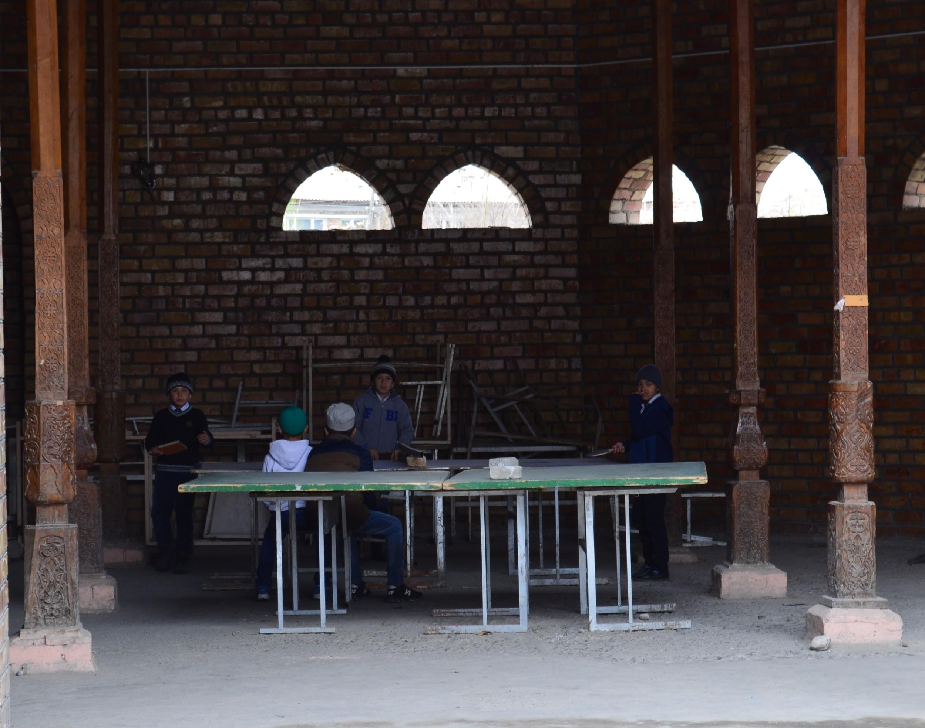Within the last several years Mr. Sultanov’s team -- comprised of civil society actors, students from Aravan male and female madrasahs, and many religious leaders -- have researched radicalization trends and push and pull factors driving local men into VE and out to war zones.

Courtesy: Mirgul Karimova | Local boys playing ping pong at Aravan Madrasah, April 2017

Their findings highlighted the presence of gaps in religious education and in local practices of cultural norms, socio-economic insecurities, and an ideological vacuum which, together, serve as an opportunity for susceptible youth to radicalize and act out of a desire for self-identification and realization, away from family, community, and government pressures. To raise awareness and address some of those issues, the Aravan team designed a film - based on a true story, exhibiting the misunderstandings and lack of attention to the vitality of the family, community, and government’s roles in a child’s upbringing.

However, even the predominant involvement of religious leaders, putting an emphasis on preaching, will not immediately transform or change communities into cohesive units relegating tensions and grievances. In order to successfully sustain community-based approaches and build resiliency, practical measures should be taken. A successful practical measure was observed in Suzak district (just two and a half hours away from Aravan), where representatives of the most vulnerable to recruitment youth -- teenagers -- united the conservative community around the idea that sports could serve as an effective tool against the growing common threat. “*Thank you for supporting our initiative. The only workout area we have built will be a comfortable platform for our imams and local youngsters to discuss own concerns and find peaceful solutions*,” exclaimed Bobur Abdulazizov, a young grantee, who coordinated the entire construction process. Together with his peers, he believes that if there is a safe and open place for young people to meet and express their anger and seek reliable support, then they will not have to look for the answers in violent extremism. The workout platform is a unique spot in other terms as well: it creates a shared space where all youth in the community (including non-believers) could casually interact with each other and local imams. The learning from these interactions can prepare youth to oppose VE ideology.

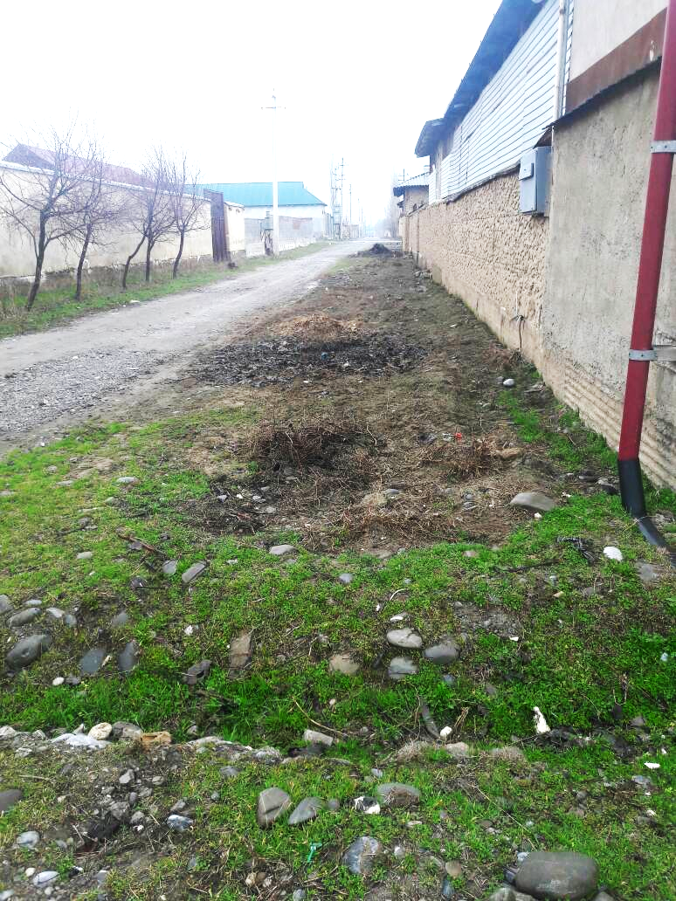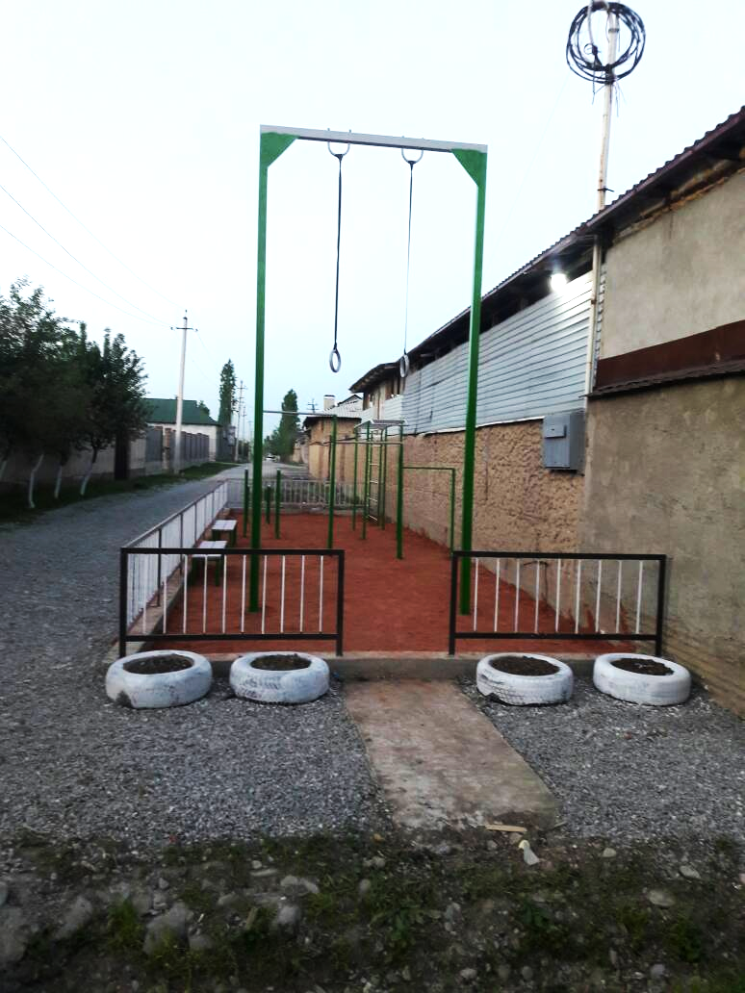Courtesy: Bobur Abdulazizov | “Before” and “After” looks at the workout area for deradicalization in Suzak, April 2017

Enacting the UN Resolution 2250 (2015), on the importance of increasing youth representation in decision-making at all levels, Aravan and Suzak youth have proved their positive role in deradicalization as managers of local initiatives, and not subordinates to culturally-endorsed seniors. Where the latter fail to achieve effectiveness through introducing forceful measures and limiting rights for online speech, assembly, and the pursuit of happiness (if it takes religious practices), local youth have chosen a different path -- mutually benefiting cooperation and inclusive dialogue.

### Main Barriers for Deradicalization:

### Culture

Mainstream culture in Kyrgyzstan does not accommodate positive messaging and can barely offer appealing alternative narratives. In the midst of competing ideologies, youth often struggle to understand their own identity. They are pulled in different directions by increasingly radical religious forces, life in a secular state, and the expectations of their patriarchal communities. So they do not want to identify themselves exclusively with any one side. Some leave the country to look for opportunities elsewhere, even if it is at a greater risk for their safety. Others choose to live in closed communities, or small microcosms, away from contemporary challenges. In either scenario, youth avoid intervening in decision-making processes within the state, and only minimally trust or even recognize different (non-religious) agencies.

There is a shortage of communication and collaborative education among the Kyrgyz. Experts in the area are not interested in volunteering their time to equip religious youth with better understanding of religious scripts, and religious youth prefer living offline and consuming online VE content without doubting its credibility and authenticity. In the meantime, traditional media does a poor job preventing violent extremism and covering sensitive topics professionally, worrying more about the circulation, rather than the quality and credibility of content. Thus, the more secular youth, who consume this media, tend to equate radicalism and extremism with terrorism, which adds to growing tension within society.

### II. Time and Cadre Management

Young leaders P/CVE campaigning in their local communities came across challenges they did not expect: management of time and human resources among their senior partners. However, every grantee faced irresponsibility from experts’ side, which in addition to constant postponing of meetings would also require bureaucratic barriers to be overcome first. Each expert, including religious ones, would offer a varying solution to P/CVE and not support other cadres’ ideas. Finding a consensus between them, given high turnover rate within stakeholder agencies, was another obstacle for youth’s efficient social media campaigning to P/CVE.

### III. Mentorship

During monitoring meetings with young leaders engaged in the pilot, most would mention the lack of support from senior leaders (i.e. religious, state, and informal) in their communities. Seeking the right mentor to help design an appropriate P/CVE narrative was another challenge. Some of the possible mentors, for instance from the State Committee for National Security, the Ministry of Interior’s 10th Department addressing terrorism, or Local State Governments have their own agenda which does not fit the positive messaging concept and instead heavily focuses on punitive measures. Also, some stakeholders prioritize other issues such as bride kidnapping and child marriages, or school bullying, alcoholism, and smoking, leaving P/CVE young activists without the necessary support on the ground.

### IV. Technology

The Internet is a double-edged sword: on one hand, it provides opportunities for flexible and remote work; on the other hand, the flexibility requires a different skillset in order to produce online narratives and disseminate the messages. Although the technology smooths and speeds up telecommunication, many young leaders highlighted their observations that local state and non-state leaders (i.e. religious and informal) do not utilize the resource. For instance, over 90% of Aravan district’s imams do not know how to use the Internet or design and spread alternative narratives. Until recently, the district had had a radio station, which was the key distributor of the developments in Aravan. However, it closed after running out of volunteers.

Another issue was the lack of understanding of smartphone functionality among different generations of local community dwellers. Despite the fact that 40-80% (young to older, respectively) of the targeted residents owned easy to navigate / upgraded phones, many were not be aware of the filming, audio recording, and mapping functions, using the tool for basic needs such as making and receiving calls and text messages.

Young grantees also faced challenges trying to navigate between a lack of understanding of key concepts as “radicalism”, “extremism”, “terrorism”, and “deradicalization” among local community representatives and introducing many to YouTube, Facebook, and Instagram. Given the lack of technology on the ground, most of the young P/CVE activists conducted offline campaigns and then communicated the outcomes online.

### V. Communication

Communication between local and national actors in Kyrgyzstan resembles a broken chain, where the ‘bottom’ is not heard in the ‘up’ echelons. This applies to schools, local self-government institutions, at district or national levels, leading to higher skepticism among teenagers regarding their need to cooperate with subordinated police and undereducated imams. The implications of this -- the lack of communication -- has made the stakeholders at lower levels feel disenfranchised and disconnected from the decision-making.

Looking for knowledge and experience, the youth is prone to Google search for answers, but they are not properly trained in assessing a source’s credibility. It is essential to speak P/CVE language in order to identify it online. Even if there was a consensus on P/CVE concepts and terminology, the threat keeps changing. Islamic missioners, called *davaatchy,* are constantly modernizing. They keep modifying their looks -- shaving off beards and wearing secular-styled suits -- and language -- using soft tone and polite vocabulary -- while adeptly spreading VE content.

### VI. Safety and Security

A desire of safety and security is crucial for P/CVE campaigners. Many young leaders indicated that during their awareness raising campaigns they did not feel the support and provision of safety and security by the state. The risks of engaging in P/CVE campaigns, given no protection, prevented many supporters from joining the cause. If one day a violent extremist walks into the campaigner’s house, there will be no agency to safeguard her/him and her/his family. Violent extremists coordinate their missions with local organized criminal gangs, so chances of surviving the unequal fight are low. In addition, for such VE groups everyone except religious Muslims has been seen as kafirs (from Arabic, “non-believers”), automatically justifying use of violence against them.

Both traditional and social media could serve as an external power to flag the issue, but media experts themselves lack understanding and a sense of security regarding P/CVE.

## Conclusion

This case study solidified the observations made by young leaders P/CVE campaigning at grassroots level: there is an evident gap between local and national governments in Kyrgyzstan which creates additional obstacles for effective deradicalization projects. While law enforcement agencies concentrate their effort on promoting and pushing forward “hard” measures to P/CVE, there is no clear policy to prevent young Kyrgyz from being radicalized at home and through (labor) migration abroad. The international community has not yet come up with a universal formula for successful deradicalization. Recruitment is increasingly complex and artful. The biggest lesson learned from the pilot thus far is that P/CVE should target communities and even individual families, unlike in classic counterterrorism “hard” techniques which lack targeted approaches. P/CVE should be a tool to empower young community members most susceptible to recruitment - and to invest in (re)building trust among key stakeholders, who can in turn serve as a critical group in the fight against violent extremism in the long run.

### Lessons Learned:

1. To achieve higher effect from P/CVE campaigning, the work should be conducted both online and offline; online social media should be complemented by online traditional media engagement;
2. P/CVE campaigning resonates with wider audience once it involves trusted opinion leaders with a large number of followers (co-thinkers) to replicate the effort;
3. Count on your project activists and a pool of volunteers, but first equip them with up-to-date social media and production skills
4. Given that P/CVE is a highly dynamic area in itself, it is essential to equip media production experts with subject area knowledge and media experts with analytical depth in current P/CVE trends;
5. Classic social media marketing (SMM) tactics do NOT work in P/CVE campaigning; therefore, allocate necessary resources (i.e. time, money, people, etc.) to design material specific to your reality SMM strategy and tactics and recognize the area is understudied as is and requires trial-and-error momentum prior to dissemination;
6. Protect sensitive project data (esp. when related to individuals, groups, and locations) anywhere to ensure safety and security of people involved and effectiveness of anonymous campaigning during the active phase of your initiative. That approach will offer you a chance to build credibility

## Sources:

1. Design, Monitoring and Evaluation for Peace, <http://dmeforpeace.org/online-field-guide>
2. Search: *Accomodating Religious Identity in Youth Peacebuilding Programs*, <https://www.sfcg.org/wp-content/uploads/2017/05/Accomodating-Religious-Identity-in-Youth-Peacebuilding-Programs-050917-dr3.pdf>
3. Does CVE Work? Lessons Learned from the Global Effort to Counter Violent Extremism, *Global Center on Cooperative Security* by Peter Romaniuk. Sept, 2015.
4. US State Department: Diplomacy in Action, Countering Violent Extremism Initiatives, <https://www.state.gov/j/cve/>
5. DipNote: US Department of State Official Blog, *The Role of Cities in Countering Violent Extremism*, <https://blogs.state.gov/stories/2017/05/17/en/role-cities-countering-violent-extremism>
6. UN Resolution 2250, *A Youth Toolkit*, <http://unoy.org/en/2250-toolkit/>
7. Kyrgyz President’s Press Conference, *Kyrgyzstan-2016: Figures and Facts*, pg. 43
8. Crisis Group, 2016, *Tracing Political Circles in Kyrgyzstan*
9. The UNDP, *Country Profile,* <http://www.kg.undp.org/content/kyrgyzstan/en/home/countryinfo.html>
10. The World Bank, 2011, *The Kyrgyz Republic: Poverty Profile and Overview of Living Conditions*.
11. News Agency, 24.kg, *Youth unemployment rate reaches 10.1 percent in Kyrgyzstan*, <http://www.eng.24.kg/community/168809-news24.html>

1. Crisis Group, 2016, [*Tracing Political Circles in Kyrgyzstan*](https://www.crisisgroup.org/europe-central-asia/central-asia/kyrgyzstan/tracing-political-circles-kyrgyzstan) [↑](#footnote-ref-1)
2. The UNDP, 2016, The Kyrgyz Republic: Country Overview, <http://www.kg.undp.org/content/kyrgyzstan/en/home/countryinfo.html> [↑](#footnote-ref-2)
3. The World Bank, 2011, The Kyrgyz Republic: Poverty Profile and Overview of Living Conditions. [↑](#footnote-ref-3)
4. Youth unemployment rate reaches 10.1 percent in Kyrgyzstan,<http://www.eng.24.kg/community/168809-news24.html> [↑](#footnote-ref-4)
5. This Case Study chose “Kyrgyz” to refer to the citizenship, rather than an ethnic background. [↑](#footnote-ref-5)
6. For more details see more https://www.sfcg.org/wp-content/uploads/2017/05/Kyrgyzstan-radicalization-social-media-report-ENG.pdf [↑](#footnote-ref-6)
7. The CGA is a set of principles and practices, derived from over three decades of practical experience of Search around the world. It aims at causing a fundamental shift in people's relationship with conflict - away from adversarial approaches toward cooperative solutions. See:<http://www.sfcg.org/sfcg/sfcg_intro.html#4> [↑](#footnote-ref-7)