**An Evaluation Summary of SFCG’s Project:**

***“Engaging Children and Youth as Partners in Preventing Violence against Children”***

This is a brief summary of the project, its evaluation, and evaluation findings and recommendations.

This European Commission funded project was planned to last 18-months. However, it ended up lasting nearly three years, primarily because of the Ebola crisis and financial delays. The project aimed at “contributing to the eradication of all sorts of violence against children” in three border-sharing post-conflict countries of West Africa: Guinea, Liberia and Sierra Leone.

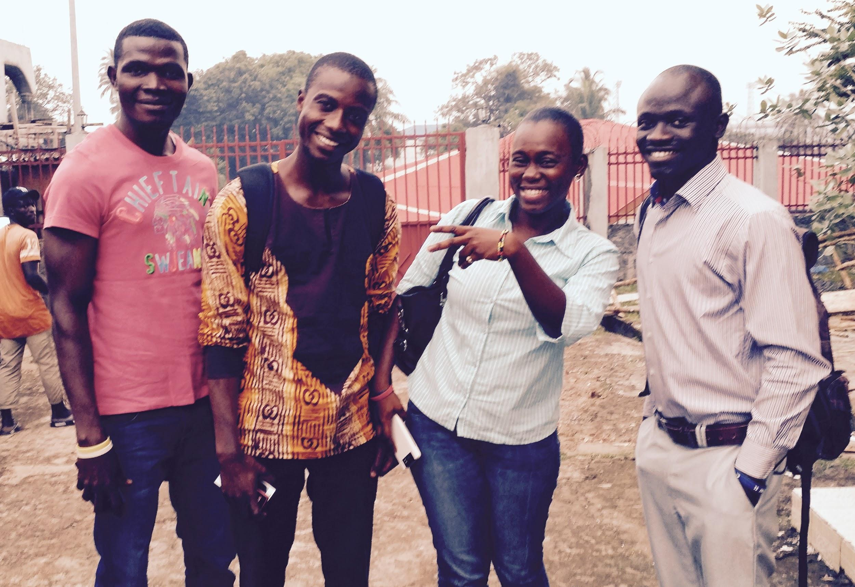

*Four Youth Researchers from Sierra Leone in Freetown.*

***What were the project’s objectives?***

1. Identify the worst forms of violence against children and understand the impact of current approaches addressing them;
2. Utilize children and youth recommendations to influence country level program and policy actions to involve children and youth;
3. Share findings to enable communities to prevent worst forms of violence;
4. Build children and youths’ ability to advocate for their needs and prevent violence against their peers.

***What did we do to evaluate the project?***

The evaluation included 114 participants in interviews (79) or in group discussions (35). Overall 44 Youth Researchers (YRs) participated in the evaluation along with 35 key stakeholders. Research focused in or around the country capitals of Monrovia, Liberia, Conakry, Guinea, and Freetown, Sierra Leone. The evaluation gathered 386 radio-listener surveys in Liberia, 393 in Guinea, and 383 in Sierra Leone.

**TABLE: Summary of Evaluation Participants by Type Country**

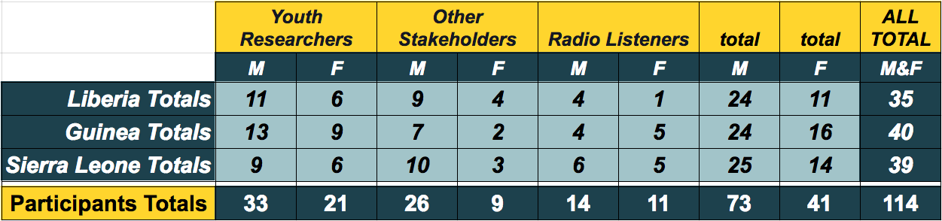

**Summary of Key Findings**

***To what extent was the participation of youth beneficial and meaningful for them and for the project?***

YRs grew personally and professionally. Their participation was deeply meaningful to them and to the project. They provided credibility, commitment, perseverance, energy, compassion, and creativity that helped this project succeed despite many obstacles.

***To what degree did the project vary in involvement and effects with regards to women vs. men/ girls vs. boys?***

Male and female involvement in the project was similar. Some YRs noted that occasionally female YRs were less respected than were males in leadership positions during field research and in other key stakeholder meetings.

***To what extent were the project activities implemented adequately?***

Phase One focused on equipping YRs to conduct research to identify worst forms of violence against children and youth. Phase Two focused on drawing conclusions and recommendations from the research findings. And Phase Three aimed to mainstream research results and recommendations in order to influence national policy. Phase One of the project was successfully implemented in all three countries, Guinea, Sierra Leone and Liberia. Phase Two and Three were less smoothly implemented; but were still effective despite taking place on a relatively smaller scale.

***How useful are the 'Manuals on Prevention of Violence Against Children' and 'Research Reports on Worst form of Violence Against Children'?***

Research Reports were widely believed to have been very useful in all three countries. It’s usefulness for education, inspiration, and providing a supportive evidence base was expressed by YRs and stakeholders alike. Though much progress was made in Guinea and Liberia, the Guiding Manual was only fully completed in Sierra Leone. There it was a helpful tool for awareness and prevention.

***How well were the objectives and expected results achieved?***

The worst forms of violence against children were successfully identified and quality Research Reports were completed in all three countries despite delays. Recommendations from children and youth were more successfully shared in Sierra Leone as the Guiding Manual was fully completed in that context. In all three countries, recommendations were shared with key stakeholders. There was little to no evidence of changes in country level program or policy actions related to children and youth.

Beyond the YRs themselves, and some radio-listener survey evidence, there was little evidence that the project built the capacity of children and youth to advocate for their needs and prevent violence against their peers. In each country there was evidence that the SFCG youth-led radio programs did help adults to prevent violence against children and youth.

Around Monrovia, Liberia the radio show had little reach compared to Conakry, Guinea where 27% of radio-listeners recalled hearing the show and in Freetown, Sierra Leone where 55.4% recalled hearing to the radio show. Following are the percentages of radio listeners around each city who stated that youth-led radio program improved their knowledge and awareness of the worst forms of violence against children and youth: Monrovia 87.5% (7 of 8), Conakry 92.4% (98 of 106), and Freetown 94.3% (200 of 212).

**TABLE: Numbers of Radio-listener by if They Recalled Hearing the Program**

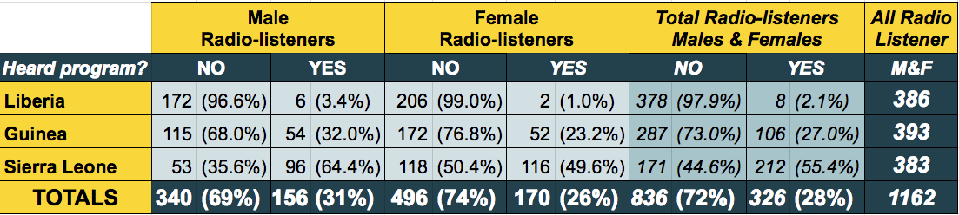

***What factors helped the project’s success?***

* YR were key to the project’s success and were the most impacted by the project. YRs were trusted by their peers. YRs were personally committed and persevered despite many challenges.
* Many children and youth felt their voice was valued for the first time. This reality helped motivate their participation and sharing of their stories.
* The project’s youth-led and participatory innovation drew attention from diverse stakeholders.

***What factors hindered the project’s success?***

* Between 2013 and 2016 Liberia, Guinea, and Sierra Leone experienced the worst Ebola outbreak in history. Ebola took 11,297 lives in these three countries alone. For part of the epidemic, schools, offices, universities, organizations, borders, and other public services were ordered closed. This project was stopped during the height of the Ebola crisis between August 2014 and March 2015.
* Financial challenges also hindered the project’s success. This included delays resulting from new accounting protocols, adjustments in support to partners, and satisfying donor reporting requirements, among other things.
* Poor communication and coordination hindered the project’s success, particularly in phases Two and Three. For example, YRs sometimes struggled to find someone to respond knowledgeably to their desire to continue supporting the project. Many staffing changes throughout the project hindered communications. Project partners and consultants noted sometimes receiving information very late, only second hand, or not at all.

**Summary of Key Recommendations**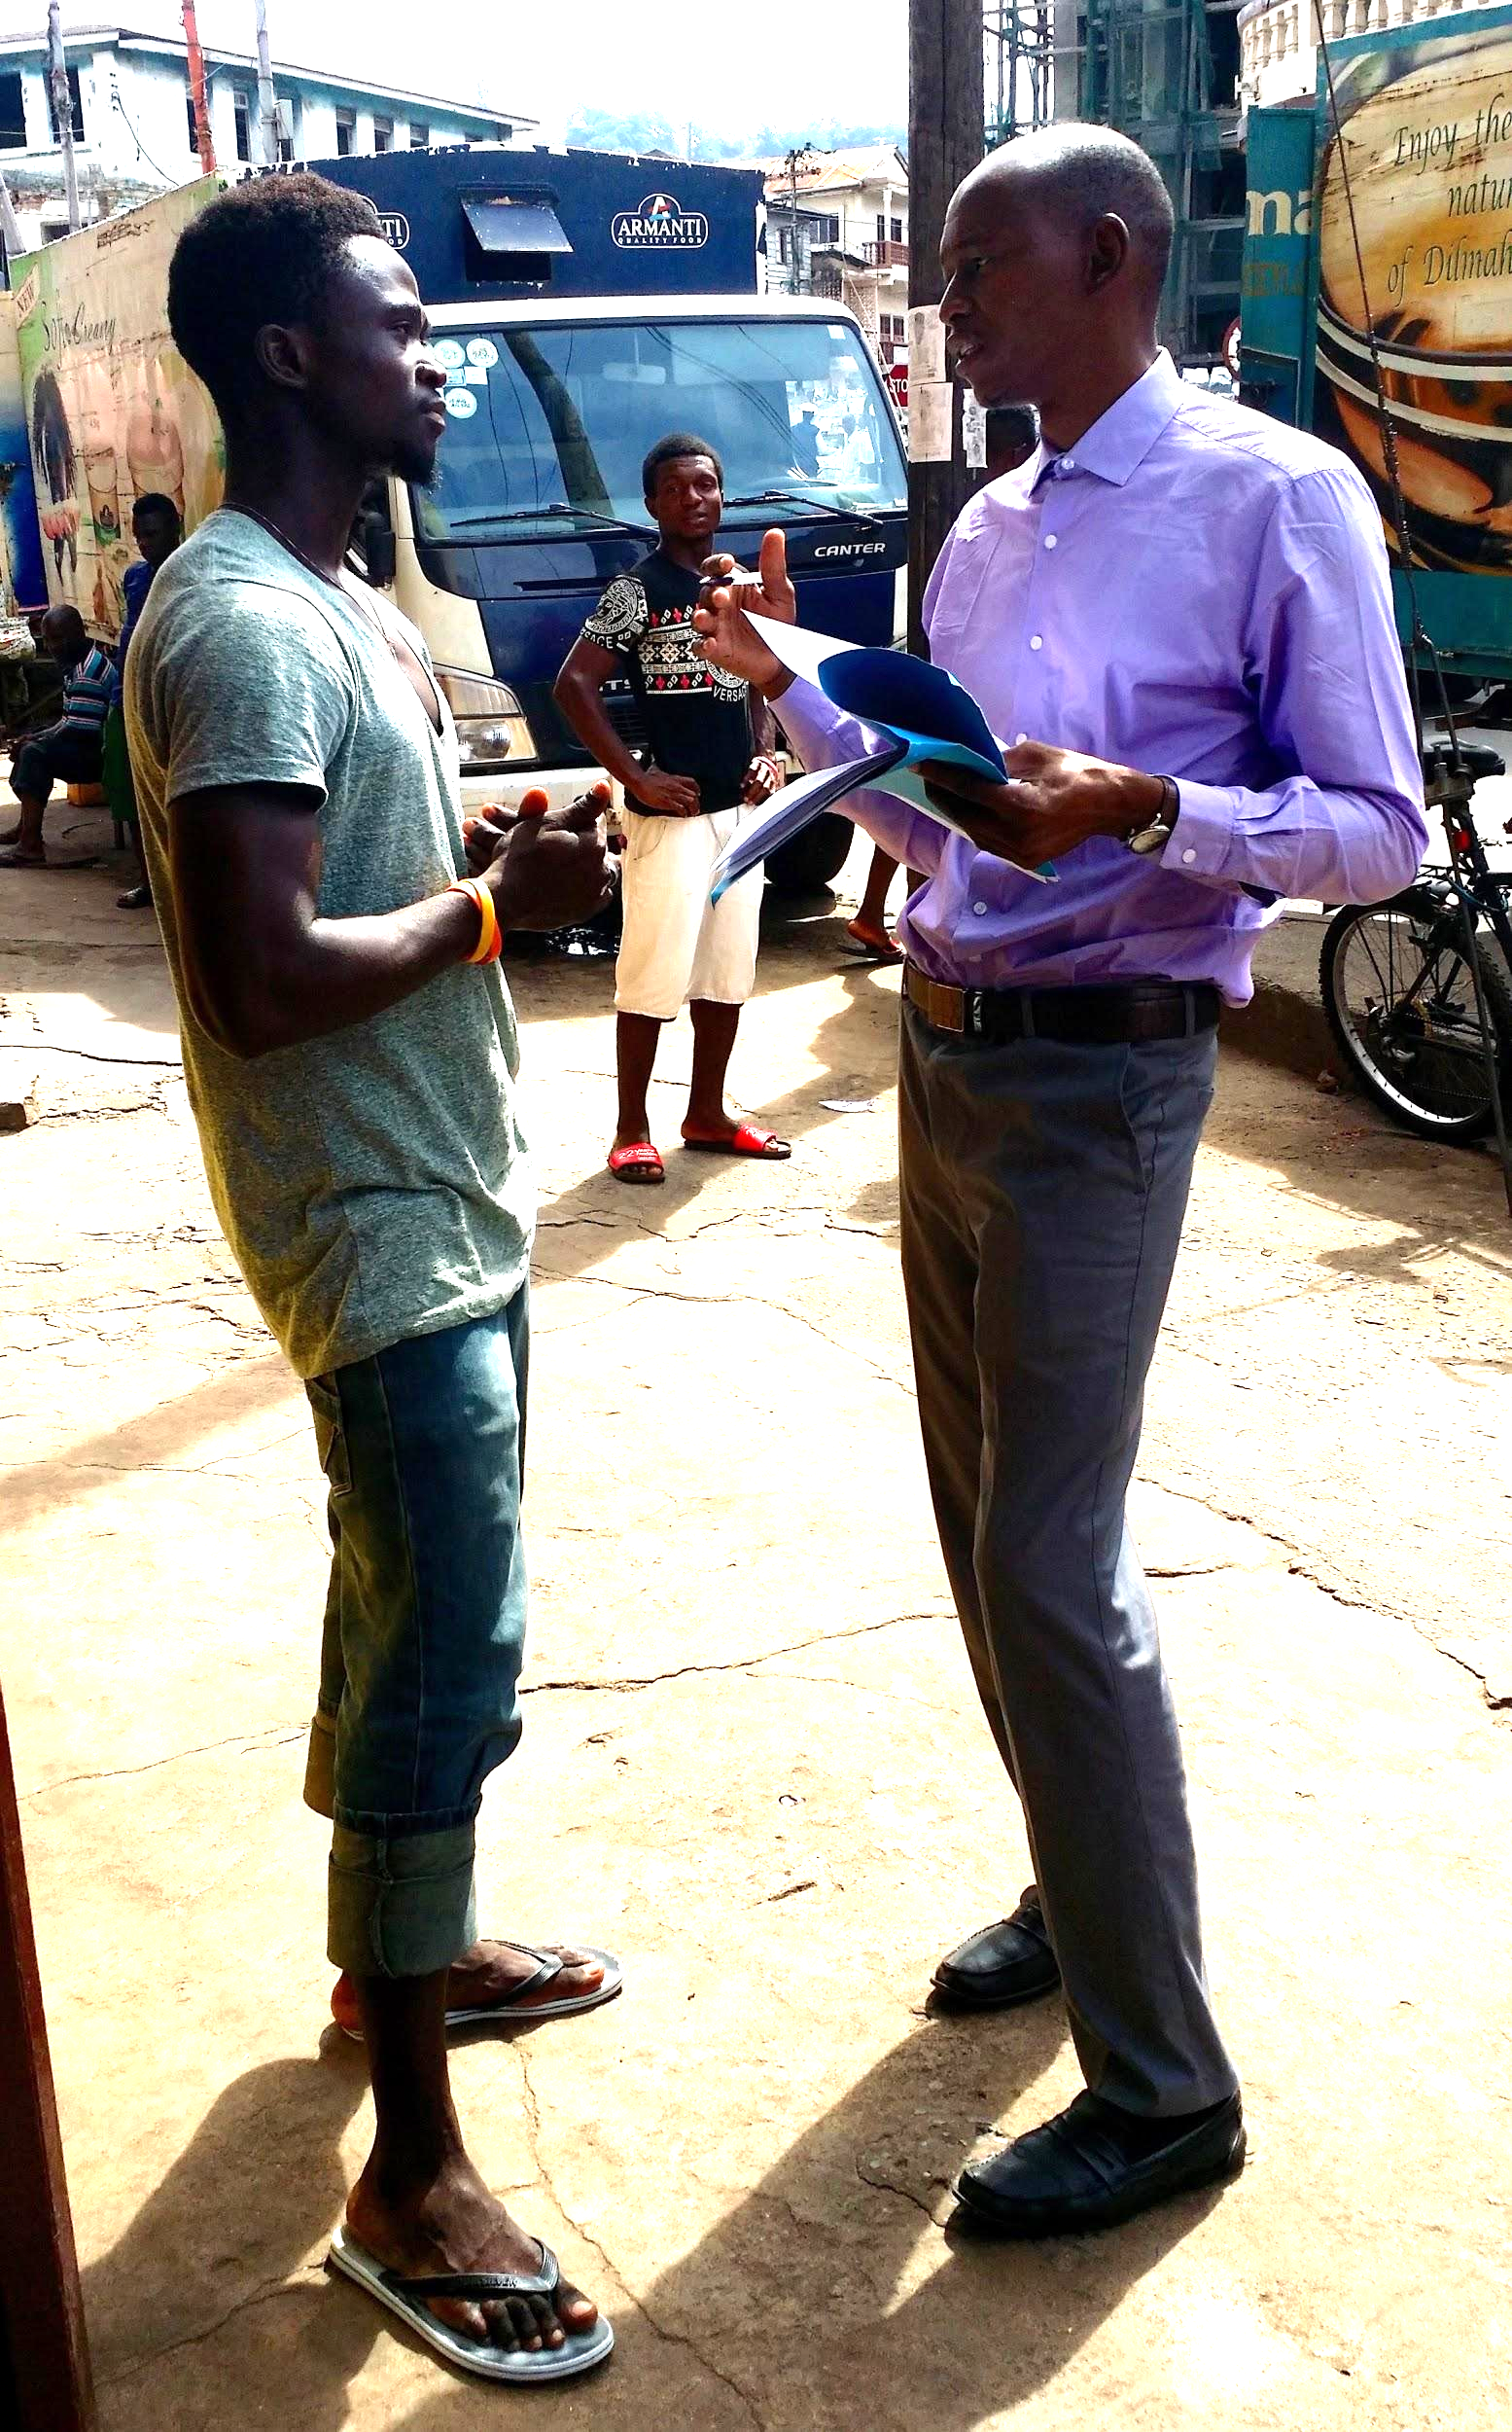

Recommendations are intended to provide guidance for any reproduction of this project or projects having similar attributes.

***What should be done for Youth Researchers?***

1. Give symbolic rewards to YRs, like certificates and physical reports, in order to show appreciation.
2. Anticipate YRs wanting to volunteer more of their time and energy. Prepare an additional optional list of meaningful peacebuilding activities and challenges for YRs that require minimal support.
3. Help YRs contribute the vision and objectives of the organization in an ongoing way.

*Young Peacebuilders Evaluation Coordinator, Ali Abouba, conducting a radio-listener survey in Freetown.*

1. YRs should be well prepared emotionally and psychologically before going to the field, while in the field, and after returning from the field.
2. Ensure better preparation and coordination for responding to abuse disclosures during Phase One data gathering.

***What should Key Stakeholders do?***

1. Increase the usefulness of Research Reports and Guiding Manuals by expanding awareness, distribution, and use.
2. Hire a dedicated staff in each country where it is implemented to improve communication and coordination.

***What would improve Media and Community outreach?***

1. Create additional radio shows and increase coverage and interactive opportunities to better leverage the potential impact of the Research Reports and Guiding Manuals.
2. Expand participatory community theater activities in all three countries.

***What should Other Community Members do?***

1. Work toward consistent follow up with and meaningful inclusion of all involved in the research process. This includes interviewees, summit participants, key stakeholders. For example, give research participants cards that help them advertise the youth-led radio program; and give them updates on the report and actions taken post research.

