Evaluation of the SFCG Project

“Engaging Children and Youth as Partners in Preventing Violence against Children”

in Liberia, Guinea, and Sierra Leone

by
Dr. Michael McGill, PhD
&
Pauline Zerla, MA
February 2017

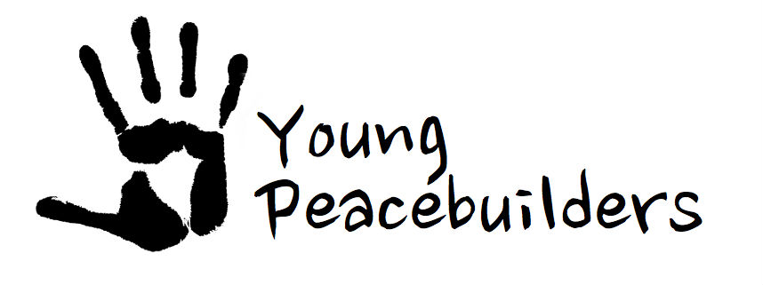

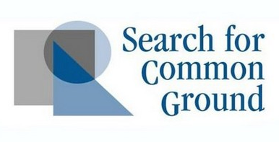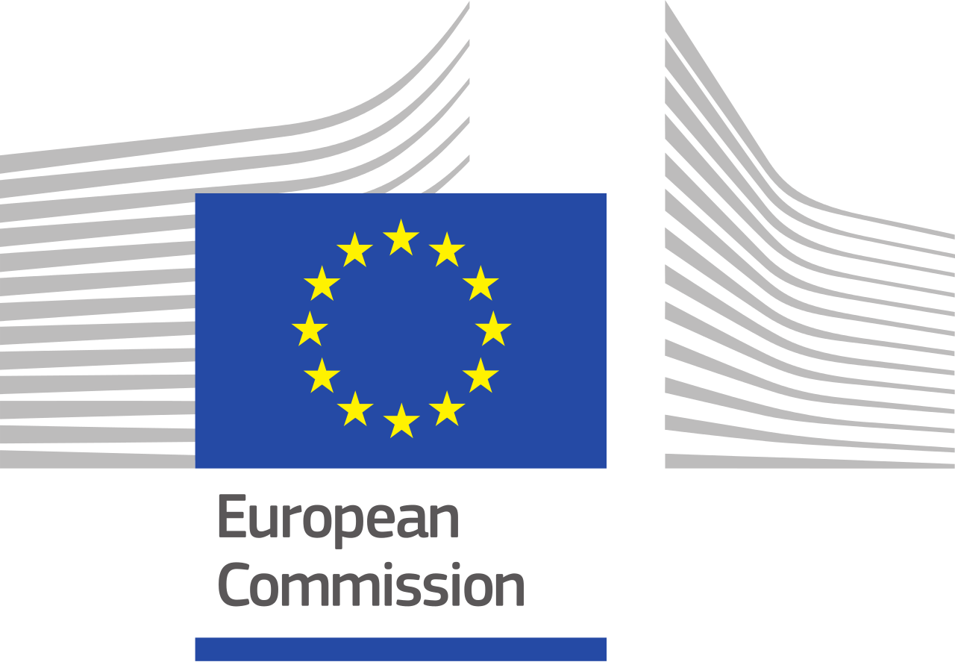

Table of Contents

Table of Contents 1
Abbreviations and Acronyms 4
Executive Summary 5
1. Introduction 12
1.1 Organization Overview 12
1.2 Intervention Summary 12
2. Evaluation Methodology 15
2.1 Objectives 15
2.2 Methods Overview 15
2.3 Quantity of Data Collected 21
2.3.1 TABLE: Numbers of Radio and Non-radio Listeners by if They Recalled Hearing the Program 21
2.3.2 TABLE: Evaluation Participants by Type, Gender, and Evaluation Method Used 22
3. Overarching Findings 23
3.0.1 FIGURE: Spheres of Project Impact 23
3.0.2 TABLE: Number of Youth Researchers (YRs) by Country and Gender 24
3.1 Overarching Factors That Helped the Project’s Success 24
3.2 Overarching Factors Hindering the Project’s Success 28
3.3 Vicarious Trauma and Likely Child and Youth Interviewee Retraumatization 32
3.4 Research Reports Represented Valuable Resources for Child Protection Actors 33
3.5 Underleveraged Opportunity for Advocacy and Community Influence 34
4. Liberia 36
4.1 The Youth Peacebuilding Context 36
4.2 Applying the Methodology in Liberia 37
4.3 Quantity and Quality of Data Collected in Liberia 37
4.4 Findings 38
4.4.2 TABLE: Summary of Resonance, Reach, and Results among Youth Researchers 43
4.4.3 TABLE: Summary of Reach, Resonance, and Results among Key Stakeholders 43
4.4.4 TABLE: Summary of Reach, Resonance, and Results in the Community 45
4.4.6 TABLE: Survey Responses of Liberia radio-listeners Who Recalled Hearing the Youth Talk Radio Program 48
4.5 Summary of Lessons Learned in Liberia 50
5. Guinea 54
5.1 The Youth Peacebuilding Context 54
5.2 Applying the Methodology in Guinea 54
5.3 Quantity and Quality of Data Collected in Guinea 55
5.3.1 TABLE: Guinea Evaluation Participants by Type and Evaluation Method Used 55
5.4 Findings 55
5.4.1 FIGURE: Guinea Project Phases; Timing, Type, and Quantity of Activities 57
5.4.2 TABLE: Summary of Reach, Resonance and Results among Youth Researchers 61
5.4.3 TABLE: Summary of Reach, Resonance and Results among Key Stakeholders 62
5.4.4 TABLE: Summary of Reach, Resonance and Results in the Community 63
5.5 Guinea Radio-listeners Surveys Findings 64
5.5.1 TABLE: Numbers of Guinea Radio-listener Survey Participants by If They Recalled the Program 65
5.5.2 TABLE: Summary of Responses from Participants Who Recalled the Radio Program 66
5.6 Summary of Lessons Learned In Guinea 67
7. Sierra Leone 70
7.1 The Youth Peacebuilding Context 70
7.2 Applying the Methodology in Sierra Leone 70
7.3 Quantity and Quality of Data Collected in Sierra Leone 71
7.3.1 TABLE: Sierra Leone Evaluation Participants by Type, Country, Gender, and Evaluation Method Used 71
7.4 Findings 72
7.4.1 FIGURE: Sierra Leone Project Phases; Timing, Type, and Quantity of Activities 73
7.4.2 TABLE: Summary of Reach, Resonance, and Results among Youth Researchers 75
7.4.3 TABLE: Summary of Reach, Resonance, and Results among Key Stakeholders 76
7.4.4 TABLE: Summary of Reach, Resonance, and Results in the Community 77
7.5 Sierra Leone Radio-listeners Survey Findings 79
7.5.1 TABLE: Numbers of Sierra Leone Radio-listener Survey Participants by If They Recalled the Program 80
7.5.2 TABLE: Summary of Responses from Participants Who Recalled the Radio Program 81
7.6 Summary of Lessons Learned In Sierra Leone 81
8. Conclusions 85
8.1 Participation 85
8.2 Effectiveness 85
9. Overarching Recommendations 90
Appendices 94
Code Of Conduct And Evaluator’s Behavior Protocol 94
Participant Information and Consent Form 95
Standard Observation Form 97
Radio-listener Survey (Liberia example) 98
TABLE: Survey Responses of Guinea radio-listeners Who Recalled Hearing the Youth Talk Radio Program 99
List of Interview and Focus Group Participants 104
Lists of Youth Researchers 109
Participants at 2014 Training of Trainers Event in Sierra Leone (per event report) 110
Biographies of Evaluators 111
Dr. Michael McGill, PhD 111
Pauline Zerla, MA 111

Abbreviations and Acronyms

- CCYA Center for Coordination of Youth Activities (partner in Sierra Leone)
- CBO Community-based organization
- EC Evaluation Coordinator
- EU European Union
- FBO faith-based organization
- FGD focus group discussion
- FGM female genital mutilation
- FLY Federation of Liberia Youth
- FSU The Family Support Unit
- IV interview
- ICF Information and Informed Consent Form
- KII key informant interview
- M&E monitoring and evaluation
- NGO nongovernmental organization
- PJUFM Parlement des Jeunes de l’Union du Fleuve Mano (represented WAYN in
Guinea)
- PEG Parlement des Enfants de Guinée (partner in Guinea)
- SFCG Search for Common Ground
- SLYEO Society for Learning and Yearning Equal Opportunities (partner in Sierra
Leone)
- SOF Standard Observation Form
- TOR Terms of Reference
- ToT training of trainers
- VT Vicarious Trauma
- YMCA Young Men’s Christian Association (partner in Liberia)
- YR Youth Researcher
- WAYN West African Youth Network (partner represented by PJUFM in Guinea)
- 3R SFCG’s Reach, Resonance, and Response framework

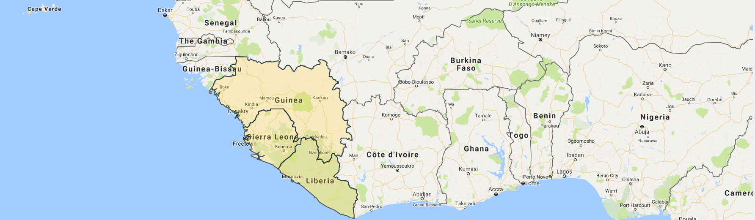
Executive Summary

Project Description
“Engaging Children and Youth as Partners in Preventing Violence against Children” was a project funded by the European Commission intended to last 18-months with each of the three phases lasting six months. The project ended up lasting nearly three years, primarily because of the Ebola crisis and financial delays. The project aimed at “contributing to the eradication of all sorts of violence against children” in three border-sharing post-conflict countries of West Africa: Guinea, Liberia and Sierra Leone.
Project’s Theory of Change. If youth have the research skills and the knowledge related to the status of violations against rights, then they are more likely to advocate for an eradication and prevention of human rights or child rights violation in their community.
Project Objectives. (1) Identify the worst forms of violence against children and understand the cumulative impact of current approaches addressing them; (2) Utilize children and youth recommendations to influence country level programmatic and policy actions to involve children and youth; (3) Mainstream findings at a societal level to enable communities to prevent worst forms of violence; (4) Cross Cutting: build capacity of children and youth to advocate for their needs and prevent violence against their peers
Project’s Expected Results. (1) Target groups have a clear understanding of the worst forms of violence against children and youth; (2) Recommendations allow for programs and policy in each country to be more children and youth friendly; (3) Children and youth play an active role in ensuring their rights while a society-wide understanding of the issues helps prevent future violence against children and youth.
Project Beneficiaries were children, youth, and key stakeholders comprised of different groups that supported program implementation on the ground as well as those impacted by the project.

Summary of Evaluation Methodology
The evaluation included a mixed methodology approach comprised of both qualitative and quantitative methods, but with emphasis on qualitative methods. In each country the methodology included document review, surveys, semi-structured focus group discussions, and key informant interviews. This report evaluates the effectiveness of the project and the quality of young people's participation. Evaluation findings are intended to provide helpful analysis and guidance useful for improving the projects of groups working to better support children and youth as peacebuilders and pro-social civic participants. Findings will also help to improve design and achieve enhanced results of youth-led programs going forward.
The evaluation answers the following questions:
- To what extent were project activities implemented adequately?
- What is the level of usefulness of the 'Manuals on Prevention of Violence Against Children' and 'Research Reports on Worst Forms of Violence Against Children'?
- Were expected results and specific objectives achieved satisfactorily?
- Which internal and external factors facilitated or hindered the achievements of expected results/ specific objectives?
- To what extent was the participation of youth beneficial and meaningful for them and for the project?
- To what degree did the project vary in involvement and effects with regards to women vs. men/ girls vs. boys?
- What was the resonance, reach, and results of the youth-led radio program following the report in each country?
The survey focused on collecting data from radio listeners in order to analyze the 3 key indicators in the M&E Plan that refer to radio listeners. Theses 3 M&E Plan indicators are: (1) “% of radio listeners reached by our radio programs,” (2) “% of SFCG programs radio listeners who state that SFCG-supported mainstreaming activities contributed to their better knowledge and awareness of the worst forms of violence against C&Y and attitudes favorable to preventing it,” (3) “% of radio listeners with a clear understanding of the worst forms of violence (male/female).”
Quantity of Data Collected. Through field research in Guinea, Sierra Leone and Liberia, the evaluation included 114 participants in interviews (79) or FGDs (35). Overall 44 Youth Researchers were involved in the evaluation along with 35 key stakeholders. This second group comprised of SFCG staff, local partners to the project, representative of international and national institutions and NGOs. Twenty-five radio listeners were interviewed despite challenges in initially locating and inspiring them to take part in the evaluation. Data collection focused in or around the country capitals of Monrovia, Liberia, Conakry, Guinea, and Freetown, Sierra Leone.

TABLE: Summary of Evaluation Participants by Type Country
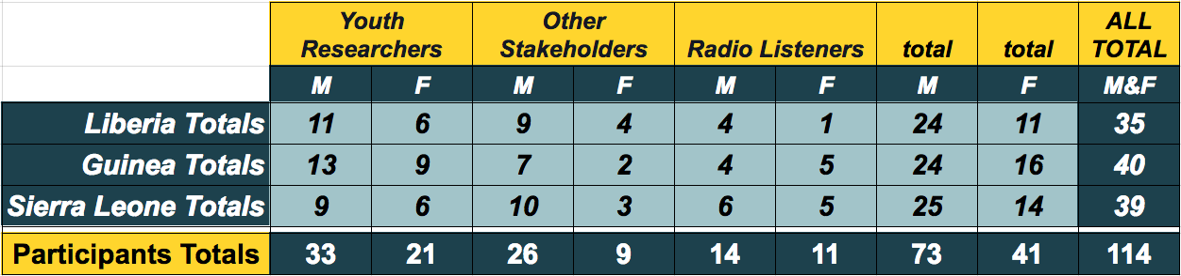

In Guinea, Sierra Leone and Liberia, numbers of women and men listening to the radio varied greatly. The evaluation gathered 386 radio-listener surveys in Liberia, 393 in Guinea, and 383 in Sierra Leone. Around Monrovia, Liberia the radio show had little reach compared to Conakry, Guinea where 27% of radio-listeners recalled hearing the show and in Freetown, Sierra Leone where 55.4% recalled hearing to the radio show.

TABLE: Numbers of Radio-listener by if They Recalled Hearing the Program
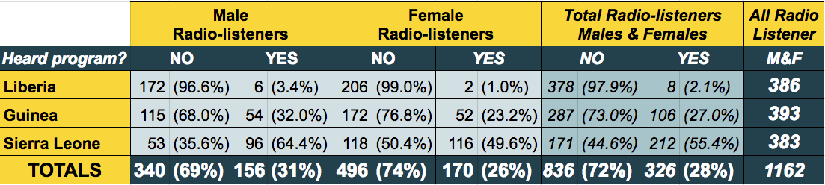

Summary of Key Findings
To what extent was the participation of youth beneficial and meaningful for them and for the project? One key success of this project has been the involvement of Youth Researchers (YRs). It has both ensured the successful implementation of the project activities as well as had a strong impact on the YRs themselves. YRs grew personally and professionally. Their participation was deeply meaningful to them and to the project. They provided credibility, commitment, perseverance, energy, compassion, and creativity that helped this project succeed despite many obstacles. Not the least of which was the worst Ebola Crisis in history.
To what degree did the project vary in involvement and effects with regards to women vs. men/ girls vs. boys? Male and female involvement in the project was similar. Some YRs noted that occasionally female YRs were less respected than were males in leadership positions during field research and in other key stakeholder meetings. Though the dataset was too small to be conclusive in Liberia and the margin was small in Guinea and Sierra Leone, it was interesting that males were consistently more likely to have heard the radio program than were females. In Liberia, females were much less likely than were males to listen to the radio at all.
To what extent were the project activities implemented adequately? Phase One focused on equipping YRs to conduct research to identify worst forms of violence against children and youth. Phase Two focused on drawing conclusions and recommendations from the research findings. And Phase Three aimed to mainstream research results and recommendations in order to influence national policy. Phase One of the project was successfully implemented in all three countries, Guinea, Sierra Leone and Liberia. Due to implementation challenges, Phase Two and Three were less smoothly implemented; but were still effective despite taking place on a relatively smaller scale. The project created strong resources to develop new strategies addressing the worst forms of violence against children and youth.
What is the level of usefulness of the 'Manuals on Prevention of Violence Against Children' and 'Research Reports on Worst form of Violence Against Children'? The Research Report was widely believed to have been very useful in all three countries. It’s usefulness for education, inspiration, and providing a supportive evidence base was expressed by YRs and stakeholders alike.
Though much progress was made in Guinea and Liberia, the Guiding Manual was only completed in Sierra Leone. It was identified as useful by most stakeholders interviewed there as a tool to foster awareness and prevention. This was largely due to the dissemination strategy adopted by the YRs, local partners and SFCG team. They were able to organize events in schools, churches and mosques in the Summer of 2016.
Were the objectives and expected results adequately achieved? The worst forms of violence against children were successfully identified and quality Research Reports were completed in all three countries despite delays due to multiple challenges. Recommendations from children and youth were more successfully shared in Sierra Leone as the Guiding Manual was completed in that context. In all three countries, recommendations were shared with key stakeholders. Unfortunately, as a result of the project, there was little to no evidence of changes in country level programmatic or policy actions related to children and youth. However, there was significant evidence of some project activities catalyzing significant community action projects to prevent violence against children.
Beyond the YRs themselves, and some radio-listener survey evidence, there was limited evidence of having built the capacity of children and youth to advocate for their needs and prevent violence against their peers. In each country there was evidence that the SFCG youth-led radio programs did help adults to prevent violence against children and youth. In Liberia, this evidence was quite limited as listenership was very low. In Sierra Leone, the radio-listener survey provided significant evidence that the radio program motivated children to prevent violence against peers.
Following are the percentages of radio listeners around the capital cities of each country who recall hearing the youth-led radio program reflecting on worst forms of violence against children and youth: Monrovia, Liberia 2.1%, Conakry, Guinea 27%, and Freetown, Sierra Leone 55.4%. Following are the percentages of radio listeners around each city who stated that youth-led radio program improved their knowledge and awareness of the worst forms of violence against children and youth: Monrovia, Liberia 87.5% (7 of 8), Conakry, Guinea 92.4% (98 of 106), and Freetown, Sierra Leone 94.3% (200 of 212). Note the extremely small sample size in Monrovia which is unlikely to be representative.
Which internal and external factors facilitated or hindered the achievements of expected results or objectives?
The following factors helped the project succeed.
- Youth Researchers (YR) were key to the project’s success and were the most impacted by the project. YRs were trusted by their peers. YRs were personally committed and persevered despite many challenges. YRs offered credibility to the findings and recommendations. The project increased YRs’ experiences, expanded their transferable skills, and informed and strengthened their commitment to peacebuilding action. YR’s knowledge, skills, and experience were strongly improved by their participation in this project. YRs represented both an internal and, at times, an external factor (when acting on their own accord), that proof to be the greatest factor helping the project’s success.
- Many children and youth felt their voice was valued for the first time. This reality helped motivate their participation and sharing of their stories. In particular, it helped the youth-led Listening and Learning Methodology to successfully glean authentic stories.
- The project’s youth-led and participatory innovation drew attention from diverse stakeholders.
The following challenges consistently influenced the project’s success.
- Between 2014 and 2016 Liberia, Guinea, and Sierra Leone experienced the brunt of the worst Ebola outbreak in history. This epidemic extended from 2013 and 2016 and, according to the WHO, took 11,297 lives in these three countries alone. For part of the epidemic, schools, offices, universities, organizations, borders, and other public services were ordered closed in response to health protocols. This project was also shut down during the height of the Ebola crisis between August 2014 and March 2015.
- Maybe second only to the Ebola crisis, was evaluation participants’ mention of financial challenges as the primary internal hinderance to the project’s success throughout the project. This included delays resulting from new accounting protocols, adjustments in support to partners, and satisfying donor reporting requirements, among other things. SFCG’s lack of access to capital in 2015 was referred to by multiple evaluation participants as a financial “crisis” that shut down the project for a period of time.
- Poor communication and coordination hindered the project’s success, particularly in phases Two and Three. For example, YRs sometimes struggled to find someone to respond knowledgeably to their desire to continue supporting the project. Many staffing changes throughout the project hindered communications. Project partners and consultants noted sometimes receiving information very late, only second hand, or not at all. In Guinea the converse was true and SFCG felt it received insufficient information from its partner. At least some regional SFCG staff believed the Liberia and Guinea manuals were completed despite evaluator's finding no evidence of this at the time of the evaluation. This further emphasized the project’s communication challenges. The degree to which the EVD crisis exacerbated communication challenges should not be underestimated.

Summary of Key Recommendations
The following recommendations are aimed at improving the project’s ability to build children and youth’s capacity to advocate for their needs and prevent violence against their peers. Recommendations are also intended to provide guidance for any reproduction of this project or projects having similar attributes.

Youth Researchers
- Give symbolic rewards to YRs, like certificates and physical reports, in order to show appreciation.
- Anticipate YRs wanting to volunteer more of their time and energy. Prepare an additional optional list of meaningful peacebuilding activities and challenges for YRs that require minimal support from SFCG.
- Develop a process within the project that allows the knowledge, experiences, and skills that YRs gain through their participation in the project to contribute the vision and objectives of SFCG in an ongoing way. For example, through the project YRs could be given the opportunity to become Certified SFCG Youth Advocates with a clear set of responsibilities and privileges.
- YRs should be well prepared emotionally and psychologically before going to the field, while in the field, and after returning from the field. (1) The potential risks of Vicarious Trauma (VT) and other harms should be assessed, identified, and addressed during the project design phase. (2) All future SFCG project proposals related to child and youth participation in peacebuilding, violence reduction, research on violence, and the like, should be reviewed by a qualified mental health professional with contextually relevant child and youth participation experience. (3) Traumatic impact always varies from one person to the next. In projects where young researchers are gathering information about extreme violence, an assessment should be conducted to identify researchers who may need additional psychological support.
- Ensure better preparation and coordination for responding to abuse disclosures during Phase One data gathering. For example, before conducting similar research, collaborate with other government agencies, NGOs, FBOs, and CBOs to prepare for likely referrals resulting from the research process. Prepare YRs to refer appropriately.

Key Stakeholders
- Increase the usefulness of Research Reports on Worst form of Violence Against Children by expanding awareness, distribution, and use.
- Rely on the report for advocacy and policy-making as well as build upon the Guiding Manual for further awareness raising campaigns.
- In similar cross-border projects, hire a staff dedicated to this project in each country to better address communication and coordination challenges.

Media Related Recommendations
Create additional radio shows and increase coverage and interactive opportunities to better leverage the potential impact of the Research Reports and Guiding Manuals. Expand further participatory community theater activities in all three countries based on materials and project activities developed through this program. The reach and resonance can be increased through expanding the number of participants or locations visited. For this, potentially develop further partnerships with educational institutions in Guinea and Liberia based on events organized in Freetown where media produced in correlation with the project was shared in schools and universities as a strategy to raise awareness on violence faced by children and youth in Sierra Leone.

Other Community Members
Work toward consistent follow up with and meaningful inclusion of all involved in the research process (e.g. interviewees, summit participants, key stakeholders). Many of the hundreds of children and youth who offered their stories in Phase One did so, at least in part, because they wanted to help prevent worst forms of violence against children and youth. During the research phase these young people could be given low-cost tools for ongoing participation in the process. For example: (a) Give them small cards that help them advertise the youth-led radio program in their community; (b) Give them a list of peacebuilding activities they could undertake; (c) Give a small booklet on how to start a child peace club in their community; (d) Collect their contact information and via text, email, imo, or other application, deliver group messages such as: where to access the research report, when and where to listen to the radio program, how to organize a community conversation on the report, how to start a child peace club preventing violence against peers, excerpts from the Guiding Manual and link to access it online, and so forth.
Providing research participants with updates on the report, actions taken post research, and so forth, could also assist with diminishing effects of potential retraumatization experienced by participants from disclosing violence and and abuse they experienced while receiving limited support. Some evaluation participants suggested this helpful support was received in Guinea via the radio updates.

Gender Related Recommendations
Consider additional culturally appropriate methods for physically and verbally highlighting the leadership roles of young females as female YR were sometimes less respected.

1. Introduction

1.1 Organization Overview
Search for Common Ground (SFCG) is a non-governmental organization working to transform the way societies deal with conflicts. They have acquired over 30 years of experience in peacebuilding and are based in 53 local offices worldwide.
Vision: While conflict is inevitable, violence is not! Therefore we work to achieve social change through transforming the way people deal with conflicts – away from violent and adversarial approaches, towards collaborative problem solving. For more information, visit www.sfcg.org.

1.2 Intervention Summary
“Engaging Children and Youth as Partners in Preventing Violence against Children” was a project funded by the European Commission intended to last 18-months with each of the three phases lasting six months. The project ended up lasting nearly three years, primarily because of the Ebola crisis and financial delays. The project aimed at “contributing to the eradication of all sorts of violence against children” in three border-sharing post-conflict countries of West Africa: Guinea, Liberia and Sierra Leone. Violence against children is prevalent in each of those countries and all three societies put children at risk by exposing them to dangerous practices such as child labor, trafficking, sexual exploitation and female genital mutilation. In order to meaningfully contribute to eradicating the worst forms of violence against children, the project engaged youth themselves in minimizing and preventing violence, and designed strategies to increase their protection and promote their own rights. The youth-led action analyzed and exposed the worst forms of violence they saw, and presented solutions in which the youth themselves could participate.

Project’s Theory of Change
If youth have the research skills and the knowledge related to the status of violations against rights, then they are more likely to advocate for an eradication and prevention of human rights or child rights violation in their community.

Project Objectives
- Identify the worst forms of violence against children and understand the cumulative impact of current approaches addressing them;
- Utilize children and youth recommendations to influence country level programmatic and policy actions to involve children and youth;
- Mainstream findings at a societal level to enable communities to prevent worst forms of violence;
- Cross Cutting: build capacity of children and youth to advocate for their needs and prevent violence against their peers

Project’s Expected Results
- Target groups have a clear understanding of the worst forms of violence against children and youth;
- Recommendations allow for programs and policy in each country to be more children and youth friendly;
- Children and youth play an active role in ensuring their rights while a society-wide understanding of the issues helps prevent future violence against children and youth.

Project Phases
The project’s activities were divided into three phases that were originally intended to be equally important and interdependent. The phases are stated below as they were originally planned. Adaptations made in each country are discussed in the country findings sections below.
Phase One focused on youth-led research to identify the worst forms of violence in each country and the impact of abuse. It consisted of a desk review related to each country contexts, selection of diverse and representative groups of youth, in-country trainings on research using “Listening and Learning” methodology followed by youth-led data collection.
Phase Two focused on drawing conclusions and recommendations from the research findings. Three Curriculum Summits, or Guiding Manual Summits, per country were intended to be hosted and led by Youth Researchers to present results to the project’s target group and collectively work to develop customized tools based on key findings and recommendations.
Phase Three focused on mainstreaming of research results and recommendations. Weekly youth-produced radio shows were planned to be produced and broadcasted over a six month period to reach a broad portion of the population and share research findings and discuss issues surrounding violence against children and youth in the three countries.

Project Beneficiaries
The beneficiaries of the project were children, youth, and key stakeholders comprised of different groups that supported program implementation on the ground as well as those impacted by the project. This included donor agencies, government agencies, policy makers, international and local NGOs, civil society individuals, practitioners, community members, caretakers, as well as the children and youth who participated in the action.

1.2.1 MAP: Region of Project Implementation: Liberia, Guinea, and Sierra Leone

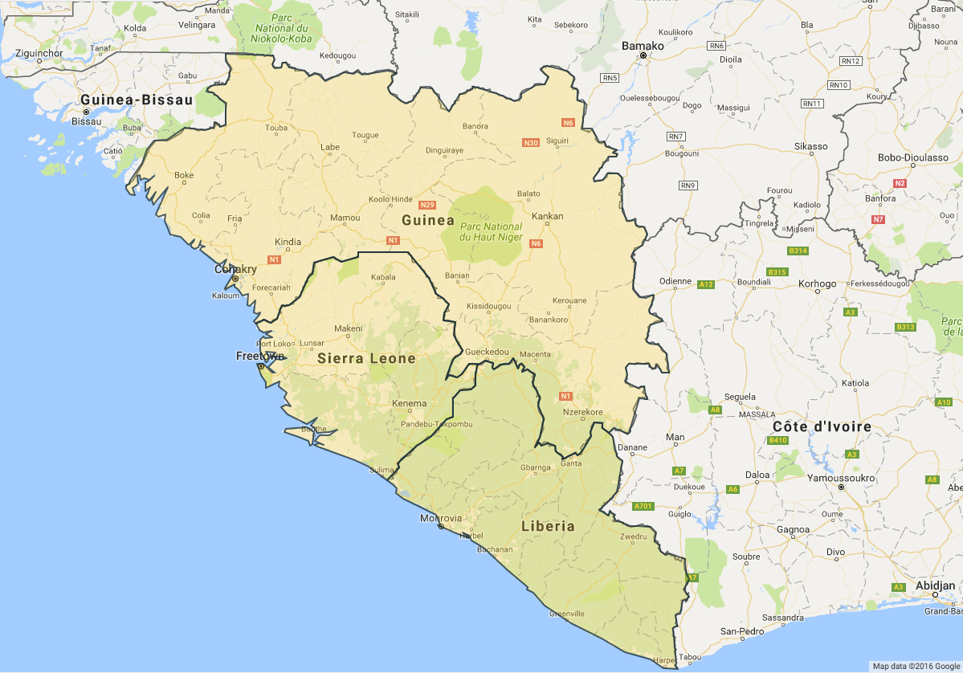

2. Evaluation Methodology

2.1 Objectives
This report evaluates the effectiveness of the project and the quality of young people's participation. The evaluation answers the following questions:
- To what extent were project activities implemented adequately?
- What is the level of usefulness of the 'Manuals on Prevention of Violence Against Children' and 'Research Reports on Worst Forms of Violence Against Children'?
- Were expected results and specific objectives achieved satisfactorily?
- Which internal and external factors facilitated or hindered the achievements of expected results/ specific objectives?
- To what extent was the participation of youth beneficial and meaningful for them and for the project?
- To what degree did the project vary in involvement and effects with regards to women vs. men/ girls vs. boys?
- What was the resonance, reach, and results of the youth-led radio program following the report in each country?

2.2 Methods Overview
The evaluation includes a mixed methodology approach comprising of both qualitative and quantitative methods, but with emphasis on qualitative methods. In each country the methodology included document review, surveys, semi-structured focus group discussions, and key informant interviews. Data from each country was analyzed separately, and also, comparative analysis was conducted between countries to consider overarching and discrete findings. The methodology captured the in-depth opinions, views, and experiences of children and youth.
Evaluation findings are intended to provide helpful analysis and guidance useful for improving the projects of groups working to better support children and youth as peacebuilders and pro-social civic participants.
Dr. McGill, Pauline Zerla, and the selected Liberia Evaluation Coordinator first collected data together in Liberia. At that time, we also made any necessary refinements to the research tools, and/or data collection or storage processes, that remained as consistent as possible between countries. Then Zerla will continue on to work with the Country Evaluation Coordinators in Guinea and in Sierra Leone in order to ensure methodological uniformity between each country, while allowing for necessary contextualization. This will allow for reliable comparative analysis between each country.

Summary of Limitations
In addition to time and financial constraints, and potential changes in the security situation or health crises, the following limited the evaluation. The evaluation timeline was delayed and the scope limited by SFCG’s delayed provision of information and introductions. Data collection was limited to each country's urban center and surrounding area. Some attempt was made to collect data from those outside this area using web forms, Skype, and phone. Though the radio-listener survey allowed desegregation of data by gender and age, the sample size only allowed for suggestive rather than determinative claims based on respondent sub-groupings.

Summary of Safety and Ethical Behavior Protocol
Interview and FGD participants signed informed consent forms confirming they accepted having interviews or FGDs recorded. Evaluation Coordinators signed a behavior protocol including a commitment to the principle of “Do No Harm." Young Peacebuilder’s consent form and behavior protocol are located in the Appendix. A SFCG child protection focal point was identified to whom Evaluation Coordinators or consultants could refer to whenever there is reason to do so.
If tokens of appreciation should be offered to any evaluation participants, and if so, what should be offered, was discussed and agreed with the appropriate SFCG representatives in each country. Tokens to participants were something participants could fairly easily reject, but, were nevertheless valuable. In each country a non-alcoholic drink and $5 USD (or the equivalent in local currency) for transportation was offered only if a evaluation participant came to meeting location.

Document Review
Document review included: project proposal, logframe, monitoring and evaluation plan, monitoring documents, reports as well as Youth-led Research Papers and Manuals from the three countries.

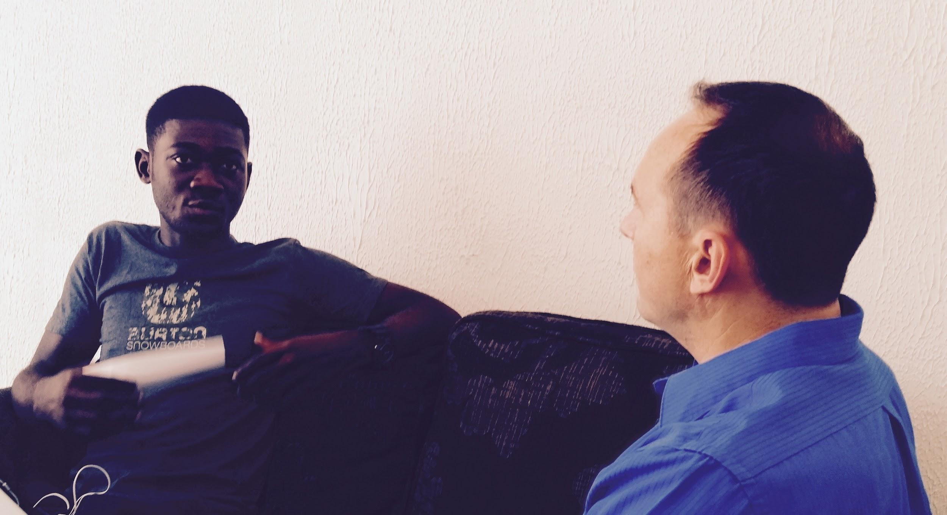
Dr McGill interviewing a Youth Researcher in Monrovia.

Interviews
Interviews were conducted with partners, CSOs, SFCG staff, children, youth, caretakers, community members, government agencies, policy makers, international and local NGOs, civil society individuals, practitioners, the donor, and radio-listeners who have heard the program produced by the Youth Researchers. Interviews will be approximately 20 to 30 minutes long. Interviews were recorded for analysis. It was explicitly confirmed with all participants that they accept having the interview recorded. Questions were pretested with at least two interviewees in each country and adjusted as needed to ensure appropriate contextualization and question clarity and consistency. Women interviewed women and vice-versa to the extent that it is practically possible.

Focus Group Discussions
Semi-structured focus group discussions were conducted with 3-5 Youth Researchers, partnering CSOs, and SFCG staff. FGDs were 50 to 90 minutes long. FGDs were recorded for analysis. It explicitly confirmed with all participants that they accept having the FGD recorded. FGD questions were pretested with 1 program participant FGD in each country to ensure appropriate contextualization and question clarity and consistency. It was determined if FGDs were mixed gender or single gender after receiving recommendations from SFCG local staff and Country Directors in each country. YRs were already very comfortable working collaboratively on the project with males and females present. Key Stakeholders in each context also normally worked with males and females together. Thus, FGDs were mixed gender in each country.

Questions Asked of Youth Researchers and other Key Stakeholders
The questions listed below were asked during interviews and FGDs with Youth Researchers and others involved in this project. We aimed to get responses from 80% of the primary youth participants (n=85) via FGDs, interviews, and/or the online form including the questions below. Respondents were encouraged to give specific examples in their responses. For example, follow up questions frequently included, “Is there one specific real story of a youth from the community preventing violence? Or a story of a Youth Researcher preventing violence?”

How successful was this project in building children and youth's’ capacity to advocate for their needs and prevent violence against their peers? Please give specific examples.

How useful was the 'Research Report on Worst form of Violence against children'?

To what extent did this project enable communities to prevent worst forms of violence against young people?

Which internal and external factors helped or hindered the project’s success?

How did children and youth’s recommendations from the research report influence country level programmatic and policy actions?

To what extent was the Youth Researcher’s participation in this project beneficial and meaningful, both for them, and for the project?

Is there anything else you would like to add related to this project?

Radio-listener Survey Questions
SFCG’s 3R framework focuses on considering an effort’s reach, its resonance with beneficiaries, and their response. Survey questions were developed ensuring alignment with (a) SFCG’s 3R framework and (b) three key indicators in SFCG’s monitoring and evaluation plan that specifically referred to radio-listeners. These three indicators in the plan were:
- (reach) “% of radio-listeners reached by our radio programs.”
- (results) “% of SFCG programs radio-listeners who state that SFCG-supported mainstreaming activities contributed to their better knowledge and awareness of the worst forms of violence against children and youth and attitudes favorable to preventing it.”
- (results) “% of radio-listeners with a clear understanding of the worst forms of violence (male/female).”
Surveys were available via paper and an online form. Surveys were pretested with at least 10 respondents in each country and adjusted as needed to ensure appropriate contextualization and question clarity and consistency.

1. Do you remember hearing the Search for Common Ground (SFCG) Youth Talk radio program?
YES NO (Go directly to question #6)

2. How much did the SFCG Youth Talk radio program improve your knowledge and awareness of the worst forms of violence against children and youth?
not at all a little very much

3. Did the SFCG Youth Talk radio program increase your desire to help prevent worst forms of violence against children and youth?
not at all yes, a little yes, very much so

4. Did the SFCG Youth Talk radio program cause you to take action to prevent violence against children and youth?
Any actions you choose below must have been taken both after you listened to Youth Talk and because you listened to Youth Talk. If you took actions to prevent violence because you listened to Youth Talk, please briefly describe what actions you took and when and where you took them in the comments section below.
not at all yes, 1 to 2 actions yes, 3 to 4 actions
yes, more than 4 actions

5. To what extent did you resonate with or relate to the SFCG youth radio program?
not at all a little very much

6. Gender: female male other 7. Age

8. email (optional) 9. phone number (optional)

10. Where are you completing this form right now?

11. Please add any other comments below.

Ensuring Accurate Capturing of radio-listenership
A rigorous process was undergone of testing, confirming, and then pretesting the survey explanations of the youth-led radio programs, in order to ensure (a) all survey participants who recalled hearing the program were accurately recorded and (b) false positives were prevented. In surveyors’ conversations with socioeconomically diverse participants:
- Multiple names for both the program and distributor were explained.
- The stations and times of distribution were clearly articulated. If the radio-listener was certain s/he never listened to a station on which the program was aired, then surveyors could conclude that s/he had not heard the program. In these cases, common in Liberia, surveyors recorded the station(s) the radio-listener did listen in order to provide the data necessary for increasing the reach of future broadcasts.
- Surveyors offered descriptions of the content beyond what was written on the survey.
- Care was taken so as not to lead participants to respond one way or the other.
- Surveyors required that a participant remembered at least something of the radio program in order to validate that s/he truly recalled hearing the program. However, the bar was very low. S/he just needed to remember something that aligned with the program. Following is a fictional example of the type of dialogue acceptable for confirming a radio-listener heard the program.
Radio-listener: “Yeah, I remember that program.”
Surveyor: “Great, do you remember anything about the program?”
Radio-listener: “I think maybe something about parents beating their kids?”
Surveyor: “That’s right. Do you recall if it was youth who were talking about it?”
Radio-listener: “Yeah, I think so.”
- Surveyors also learned about other programs SFCG or Talking Drum Studios produced in each country. Thus, they were able to prevent false positive responses by describing other programs, when appropriate, and confirming if a radio-listener was actually recalling a different radio program.
Below is an example of what was included on the Liberia survey:
Do you remember hearing the Search for Common Ground (SFCG) Youth Talk radio program?
Youth Talk was produced by Search for Common Ground"s (SFCG)Talking Drum Studios and YMCA. The program was always focused on violence against children. It aired June through September 2016 in Montserrado on:
ELBC 99.9 FM Saturday 8:15-8:45 Sunday 12:15-12:45
TRUTH FM 96.1 Tuesday 1:00-1:30 Sunday 6:15-6:45
Youth Talk is NOT: Blay-Tahnla radio drama soap opera nor the Learning By Radio show with a teacher and students in a classroom aired March - August 2015.
Youth Talk broadcast outside Montserrado on: Radio Gbezohn, radio Cape Mount, radio Kergheamahn, radio Nimba, and Smile FM and radio Kintoma.

Sampling
Gender balance was aimed for in FGDs and in interview distribution. We pursued diverse socio-economic representation among survey respondents and radio-listener interviews. Stakeholder interview and FGD participants focused on the project’s primary beneficiaries, the Youth Researchers. SFCG recommend key stakeholders for interviews and FGDs. However, the consultant reserved the right to choose additional, or other, participants in order to limit respondent bias. This was a purposeful sampling method. When evaluation participants claimed a government official or community member was significantly impacted by the project, where possible, further evidence was pursued to substantiate the claim.

2.3 Quantity of Data Collected
In Guinea, Sierra Leone and Liberia, numbers of women and men listening to the radio varied greatly. Through gathering 386 radio-listener surveys in Liberia, 393 in Guinea, and 383 in Sierra Leone, the evaluation found few Liberian women listen to the radio overall and few overall evaluation participants recall the show in Liberia. Furthermore, around Monrovia, Liberia the radio show had little reach compared to Conakry, Guinea where 27% of radio-listeners recalled hearing the show and in Freetown, Sierra Leone where 55.4% recalled hearing to the radio show.

2.3.1 TABLE: Numbers of Radio and Non-radio Listeners by if They Recalled Hearing the Program
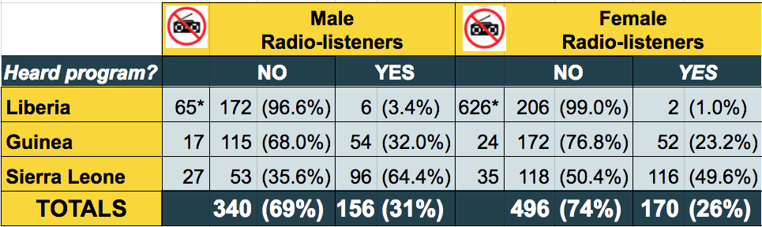
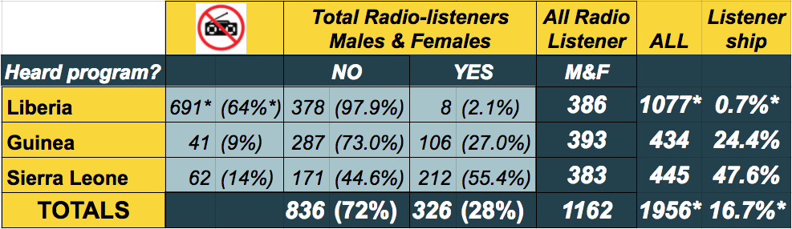

Through field research in Guinea, Sierra Leone and Liberia, the evaluation interacted with 114 participants, among which 79 took part in one-to-one interviews. Overall 44 Youth Researchers were involved in the evaluation along with 35 key stakeholders. This second group comprised of SFCG staff, local partners to the project, representative of international and national institutions and NGOs. In addition, 25 radio listeners were interviewed despite challenges in initially locating and inspiring them to take part in the evaluation.

2.3.2 TABLE: Evaluation Participants by Type, Gender, and Evaluation Method Used
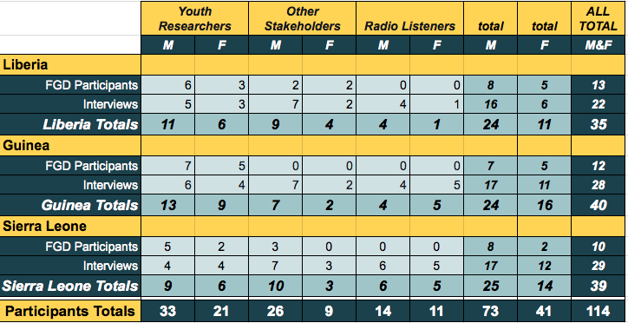

3. Overarching Findings
Findings are organized separately by country in the following three sections. In each country analysis, the reach, resonance and results of the project are assessed for the three core constituencies it sought to impact: the Youth Researchers (YRs), key stakeholders, and the community at large. Special attention is paid to how the project impacted these stakeholders during each of the three phases of the project. The timing and activities associated with each of the three phases varied from country to country. Therefore, an appropriately adjusted figure is included near the start of each country section to clarify, to the best of the timing, type, and quantity of activities that occurred in that country. Some of these details conflict with some reports and testimonies of some evaluation participants. Much investigation occurred to ensure the activity maps are as accurate as possible.

3.0.1 FIGURE: Spheres of Project Impact

Community

Key Stakeholders
Youth Researchers

3.0.2 TABLE: Number of Youth Researchers (YRs) by Country and Gender
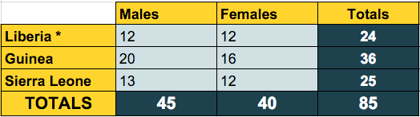
* One additional female in Liberia left the program and country immediately after data collection.

Before beginning the country by country analysis it is important to understand overarching factors impacting the project's success. Both internal and external factors that helped or hindered the project’s success are considered.

3.1 Overarching Factors That Helped the Project’s Success

Youth Researchers (YR) Were Key to the Project’s Success and were the Most Impacted by the Project.
YRs were trusted by peers. Child and youth interviewees were more likely to trust peers. During data collection in Phase One, YRs spent significant time talking, playing, and sometimes even working with the child and youth interviewees in order to connect with them personally, and thereby, help them feel more comfortable sharing their personal stories.
YRs were personally committed and persevered despite many challenges. In Phase One local adults sometimes supervised the YRs’ conversations with children or youth research participants. This hindered the young participant’s willingness to speak freely. However, the YRs had the persistence to stick with the young participant until the adult left, sometimes from boredom, and then the child/youth would speak more openly about abuse s/he experienced. YRs sometimes also helped a child/youth research participant with whatever chore s/he was doing until s/he felt comfortable sharing freely. YRs suggested that older researchers or hired consultants may not have had the patience and persistence that the YRs offered, and thus, YRs were particularly effective in getting more and authentic stories about the worst forms of violence experienced by children and youth.
YRs expressed that their personal commitment was also exemplified by their willingness to risk their lives to collect data during the Ebola Crisis. SFCG’s West Africa Regional Program Manager, Charline Burton, noted that, “data collection occurred during the initial outbreak of Ebola, when it was unclear whether the pandemic would spread or if it would remain limited to some regions. At SFCG we followed strict guidance with regards to respecting the sanitary recommendations and once the state of emergency was announced, we halted all activities in order to avoid putting anybody’s health at risk.” During project delays, or times when YRs had not heard from SFCG, YRs would stop by the SFCG office eagerly asking for updates and opportunities to help move the process forward. Of the 86 YRs who began serving in the project in June 2014, 85 continued until its completion over two years later. The only YR who left the project moved to the USA a few weeks after beginning and she had almost certainly planned to do so before she joined the project. This is an extremely low rate of attrition for a relatively long project, that faced many challenges and was largely led by youth, who are often known for making frequent and significant life changes and moves.
At least one stakeholder emphasized that the YR’s leadership and commitment was the reason for overlooking SFCG’s payment delays, and other challenges, in order to continue supporting these young Liberian changemakers.
YRs offered credibility to the findings and recommendations. It seemed to make sense to many receiving the Research Reports, that youth were quite likely to receive and understand the challenges faced by other children and youth and then accurately communicate these concerns and relevant recommendations. This was sometimes perceived as going to the source rather than an intermediary. In this way the YRs added credibility to the project and strengthened its impact.
The project increased YRs’ experiences, expanded their transferable skills, and informed and strengthened their commitment to peacebuilding action. Though not all YRs were interviewed, these themes were consistently present in interviews and FGDs with YRs and stakeholders alike across the three countries. YRs gained transferable skills that varied from research skills such as data collection and organization methods, analysis and report writing, to radio production and speaking skills. Some even noted improved texting, emailing, and other communications skills. They gained much greater knowledge of abuses against children in their country. One YR in Liberia highlighted that he was using these practical skills gained through his participation in this project in order to advance other peacebuilding efforts he is now involved in. This was a win-win relationship for the project. YR added capacity and gained experience, skills, and connections.
The project’s Research Consultant noted she was impressed by the many challenges YRs overcame and then offered the following confirming statement. “I was really amazed about the researchers… I met them really at the beginning of the project when they were recruited...to become young researchers…and I really, really, saw the evolution of those youths…and some of them have also been very successful at [advancing] their professional careers...you see how much involving them in this project and giving them the capacity to really do [the] work…because conducting research is not an easy process...and to see how they managed to do it is amazing. It’s nothing particular, but just to be able to see all the process and really their evolution, and also the way they feel that they had a role to play in preventing violence against children. Even if at the beginning they were recruited because they wanted to have experience with an NGO…most of their motivation was...having professional experience or voluntary experience. But at the end, they really felt that they were changed...In that way it was successful (SSHD00F@34:15).”
SFCG’s Research Consultant concisely reinforced many of these ideas noted above. She highlighted that at the National Data Analysis Workshops in each country the YRs “realized that they accomplished something really really great and they really did a great work despite the conditions [in which] they were working.” A YR in Guinea shared that through the process she realized she had “mistreated children around her, especially little brothers and sisters. And she [had] never realized that physical violence...could harm children. But the way the research was designed, and the way that we had to listen a lot [to] what was the experience of the children throughout the country, she really realized...what consequences could have this kind of violence, which is some kind of normal in Guinea, and this is an achievement...And we had this type of satisfaction [or disclosure] a lot during the National Analysis” (SSHD00F@17:30).
Providing youth with a start. YR’s knowledge, skills, and experience were strongly improved by their participation in this project. Eighty-Four percent of evaluated participants in Guinea outline the high-value added for YRs. Fanta Bah found employment based on her experience with this SFCG project. For her part, Fanta now works on female genital mutilation (FGM) issues with a local NGO based in Conakry. Furthermore, of the 36 YRs who participated in Guinea, 10 moved abroad to study, six found employment in Conakry, two created local NGOs, and two are employed with PJUFM.
Others also took initiative to bring change in their communities. One SFCG staff noted, “I met a young woman who was inspired by the success of the report and research project and she is now leading a group of youth to do their own research to support their advocacy to the Guinean government.” In addition to providing YRs with opportunities, 27% specified they felt more confident as researchers based on their first practical experience with SFCG. They were able to build self confidence due to this experience and learned to work independently and as part of a team.

“I found this initiative beautiful and I urge SFCG to continue.” ~ YR Aisha

In Sierra Leone, “SFCG has provided a great space for youth to actualise their role within Sierra Leone society” explains M.S. Kambeh, assistant inspector general for the National Police. This youth-led program allowed YRs to learn new skills and build confidence and for Rita Kamara from the Family Support Unit (FSU), “it was about broadening your horizon, to see from someone’s else perspective."
Youth Researchers became Young Leaders. In Guinea, every YR who was evaluated highlighted that the key value of this project was their personal development. Many learned to change their own behavior based on their participation in the project. “During the ToT, we learned that we had to be the first [to] change our behavior, as Youth Researchers and leaders, prior to going to the field for data collection,” said YR Mariam Kaba. Most YRs and stakeholders noted the participation of YRs in the project as a key factor in the project’s success. It allowed the project to gain a youth perspective. For this reason, it resonated with most interviewees as an innovative program. Djaka Camara, a YR, outlined that she changed her own behavior towards her younger siblings based on her participation in the project. She claimed to have stopped beating her sisters when an argument comes along. Another YR, Victor argued “we have the role to take actions in regards to violence against our peers." This trend was corroborated by data in Sierra Leone and Liberia as well.

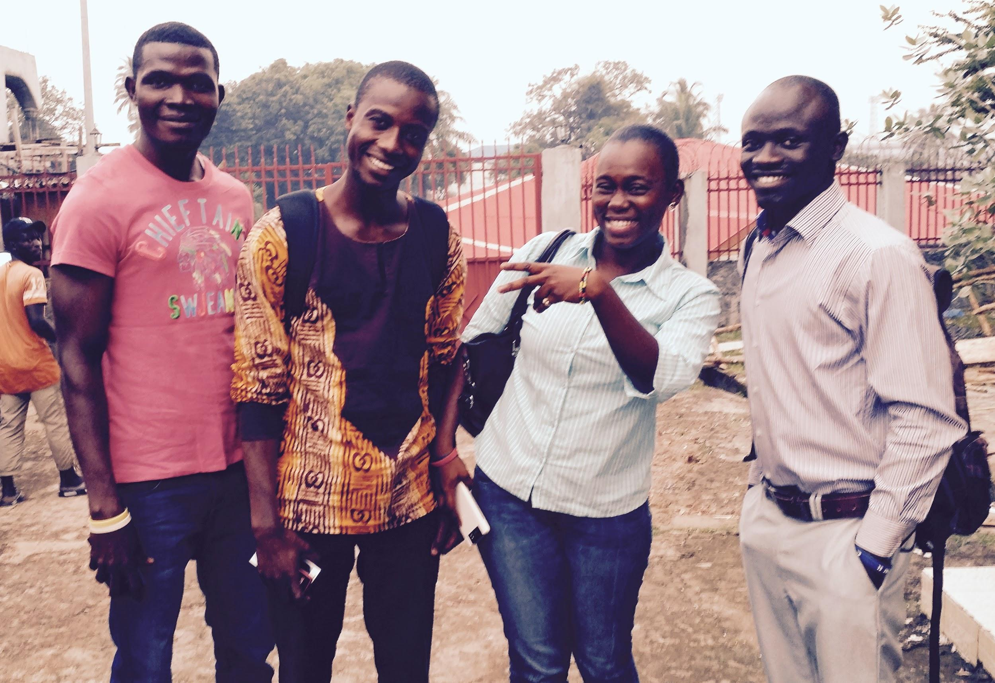
Four Youth Researchers from Sierra Leone in Freetown.

Many Children and Youth Felt Their Voice Was Valued For the First Time
It was frequently noted that during Phase One data collection many children and youth offered their stories and gave their recommendations because they felt their voice was being valued for the first time. It seemed they were more likely to participate in order to be heard, in hopes of getting protection and help personally, and for some, in hopes of helping other young people. The desire to be heard also appeared to be a major motivating factor for young people who participated in the Guiding Manual Summits.
In Sierra Leone post-war context, youth were considered as drivers of conflict. For Anthony Koruma, from the Sierra Leone Youth Commission, “this is why it was very useful to bring a chanel for them to express their grievances.” Participation in this research allowed youth and children to feel valued in their experiences. Furthermore in Guinea, several YRs highlighted the gathering of stories from children and youth was a strong point of their participation in the project. For one YR, supporting children in having their voices heard represented a key step in helping them.

The Project’s Youth-led and Participatory Innovation Drew Attention
For many people the project appeared new and different, and thus, intriguing. It stood out both for its largely youth-led nature and because children and youth were the core contributors to the content and recommendations of the Research Reports and Guiding Manuals. The unique participatory approach of the project led to government officials interest, such as Hector Akoue, a member of the Guinean government.

“There are a lot of protection efforts but [there is] innovation in this case because the children are at the center of the project for them to learn and share what youth and children themselves feel is violence against them” ~ Julien Bolamou, SFCG Guinea

Youth-led Listening and Learning Methodology Gleaned Authentic Stories
The Youth-led Listening and Learning methodology proved an extremely effective means for gathering stories from children and youth about the worst forms of violence against children and youth in their community. The YRs added a sense of credibility with children and youth and more quickly built a sense of trust. The YRs frequently took the time to build the perception of their personal relationship with and care for the young interviewee. This helped reduce children’s and youth’s defenses and increase their willingness to share extremely personal stories of the worst forms of violence they had experienced and were aware of in their community. These plentiful, authentic, and very vulnerable stories that young people shared were key to deeply educating the YRs and producing reliable Research Reports, recommendations, and Guiding Manuals, and thereby, they were key to the project's success. The Listening and Learning methodology was key to getting these stories.
At the same time, this very powerful tool was not handled with the special care it deserved. This sometimes lead to the vicarious traumatization of the YRs and the retraumatization of the young research participants who shared their stories of violence and did not receive the rescue, protection, or support they had hopped for or expected. These unintended negative consequences are addressed in the section on vicarious trauma after exploring overarching factors hindering the project’s success.

3.2 Overarching Factors Hindering the Project’s Success
These following challenges were consistently influencing the contexts within which the project occurred, and thus, are important lenses through which to consider findings.

The Ebola Crisis
Between 2014 and 2016 Liberia, Guinea, and Sierra Leone experienced the brunt of the worst Ebola virus disease (EVD) outbreak in history. This West African Ebola virus epidemic extended from 2013 and 2016 and, according to the World Health Organization (WHO), took 11,297 lives in these three countries alone. For part of the epidemic, schools, offices, universities, organizations, borders, and other public services were ordered closed in response to health protocols. This project was also shut down during the height of the Ebola crisis between August 2014 and March 2015. Constituently, though the project was initially scheduled to be an 18 months, it was extended first to 25 months, and then 31 months. Throughout this evaluation, in each context, respondents consistently highlighted the Ebola epidemic as playing a key role in both delaying activities completely for eight months and also causing obstacles to completing project activities, including data collection. SFCG’s September 2016 Final Narrative Report from Siera Leone noted the following about data collection in 2014, “In some areas, researchers were mistaken by the population [as] Ebola medical teams. Because of the population[‘s] fear of Ebola, researchers’ teams were denied access to some communities and some people also refused to talk to them out of fear of contracting Ebola.” EVD also impacted the financial, communication, and coordination challenges outlined below.

Financial Challenges
Maybe second only to the Ebola crisis, was evaluation participants’ mention of financial challenges as the primary internal hinderance to the project’s success. This was consistently noted across contexts by YRs, consultants, partners, and other stakeholders. Therefore, further explanation is offered below. Statements in quotes were provided from SFCG’s West Africa Regional Program Manager after discussions with Country Directors in Sierra Leone, Liberia, and Guinea.
Firstly, all project activities were halted during the Ebola crisis, including the payment of partners. Secondly, “as per the contract signed with the EU, the second transfer of funds to SFCG could not be processed until a full set of reports was delivered to the donor. This process, which included going through an external audit, took longer than expected, causing temporary liquidity issues to SFCG." Thirdly, the donor later required a reduction in allowable sub-granting amounts but no reduction of the overall budget.
This third item warrants explanation. Originally the Center for Coordination of Youth Activities (CCYA) and Society for Learning and Yearning for Equal Opportunities (SLYEO) in Sierra Leone were scheduled to be sub-granted €12,000 each, and the Federation of Liberia Youth (FLY), and later YMCA, in Liberia, and the West African Youth Network (WAYN) in Guinea, were each to receive €24,000. SFCG signed contracts with partners equivalent to these amounts. However, “when SFCG submitted a no-cost extension and budget revision request to the EU in January 2015,” SFCG was informed that, “under this type of funding mechanism, sub-awards over €10,000 were” ineligible. SFCG was required to reduce sub-grants to partners in their budget revision before extension approval. Consequently, SFCG explained the situation to each partner, and “while disappointed, each partner graciously accepted...a revision of their budget down to €10,000.”
Fourth of all, partners, contractors, and employees were frequently frustrated by SFCG’s difficulty wiring funds promptly and as expected. “In 2015, in an effort to strengthen its financial procedures and control; SFCG moved towards a centralised process for paying partners from [their] Headquarter [in Washington DC], rather than from the local, in-country office.” Some delays in payment processing occurred “as SFCG’s finance staff was learning the new financial procedures.” In addition, partner payments could “only be honoured if the previous advance ha[d] been properly reconciled. This proved challenging for some partners who, despite support from SFCG’s finance staff, could not provide reconciliation documents up to SFCG and the EU’s standards.” Additionally, the first transfers to partners were in USD, whereas, following transfers were in local currency. Some partners were frustrated by the exchange rate that was used. At least one evaluation participant noted six and eight month delays in payments.
An example of the extent to which the financial challenges hindered and delayed the project’s implementation and impact was offered by Hélène Delomez. She was the key international Research Consultant training and facilitating for the youth-led research phase of the project across the three countries. She noted that around June of 2015 she was traveling from Guinea to return to work in Liberia as planned. However, while she was a the border between Guinea and Liberia, she was told that SFCG Liberia did not have the funds to allow her to return to Liberia and work. Therefore, she returned to Liberia and was sent to the airport to depart the country. It was Delomez’s understanding that at that time SFCG, “stopped all activities in Liberia related to the youth project” because of the financial challenges they were experiencing.

Communication and Coordination Challenges
Poor communication and coordination represented a significant hindrance to the project’s success, particularly in phases Two and Three. This was mentioned consistently by project partners and YRs. For example evaluation participants noted that after EVD had delayed the project, but the SFCG offices had reopened, YRs would sometimes stop by the office asking what was going on with the project and wanting to know how they could help. They struggled to find someone to respond knowledgeably. Project partners and consultants noted sometimes receiving information very late, only second hand, or not at all. In Guinea the converse was true and SFCG felt it received insufficient information from its partner.
The degree to which the EVD crisis exacerbated communication challenges should not be underestimated. A single regional project manager, hired after the project started, was originally based in Sierra Leone and then moved to Guinea August 2014 after the Ebola outbreak in Sierra Leone. Travel restriction and warnings hindered the project manager from visiting Guinea and Liberia between August 2014 and April 2015 when he first visited Guinea again. He returned to be based in Guinea June 2015. The lack of project managers in Liberia and Sierra Leone likely contributed to communications and coordination challenges.
Staffing changes also contributed to this challenge. The project’s director started late and SFCG’s Country Directors changed in all three countries over the course of the project. This included Sierra Leone having an interim Country Director for the first six months of the project. Additionally, the project manager in Sierra Leone left SFCG early 2015 leading to challenges in finding documentation of project activities. The previous Country Director in Liberia left November 2015 and the current Country Director has worked with SFCG since August 2014. Liberia’s relevant project officer left SFCG in March 2016. Guinea’s Country Director changed in January 2016.
Evaluation participants frequently contradicted one another in their claims about who did what, where, and when to deliver this project. Limited availability of project documents and reports hindered verification of activities. At least two project documents contradicted evaluation participants. A report on the research phase in Liberia claimed that YRs conducted three-day County Analysis Summits in each of the six counties they visited before they returned to their homes. Yet, multiple YRs confirmed that this was not the case. Rather, they returned to Monrovia for a five-day Data Analysis Workshop in July of 2014. The YMCA Radio Station Manager and Guiding Manual Summit participant verified Mussa Sharif’s presence at the summit yet he was not on the participant lists.
Communication and coordination hindrances do partly explain the frequent contradiction between evaluation participant responses. For example, SFCG’s Research Consultant Delomez, worked on the research component of this project across the three countries. Her responsibilities included supporting the YRs in writing Research Reports and collecting key informant interviews contributing to the Guiding Manuals. Nevertheless, it was not until after she arrived to begin facilitating a five-day National Data Analysis Workshop in March of 2015, that she discovered that in July 2014 a five-day County Data Analysis Workshop occurred in Monrovia and a draft Research Report was produced based on their findings. This certainly hindered her ability to prepare for the workshop. In Sierra Leone, some documentation was not available.
Financial challenges noted above were compounded by communication and coordination challenges which were only partly a result of the Ebola crisis. For example, in Liberia, several YRs believed that when returning to the project, after the break caused by EVD, SFCG communicated to them that the project budget had been cut; and because of this, SFCG would not be able to pay them the per-diem as they had in Phase One. They would now have to volunteer to participate in project activities such as conducting KIIs and the media campaign.
Contextual realities also hindered communications. For example, YR’s sometimes had limited access to phones, airtime, email, data, computers, travel funds, and so forth sometimes limited communications. Poor infrastructure, and power and cell network outages also compounded with aforementioned obstacles.

Guiding Manuals Were Not Completed in Liberia and Guinea
Though much progress had been made, as of February 2017, the Guiding Manual including recommendations for preventing worst forms of violence against children and youth, had not been completed in Liberia or Guinea. A version of the Liberia manual appeared mostly complete at the end of September. At least some regional SFCG staff believed the Liberia and Guinea manuals were fully completed despite evaluator's finding no evidence of this at the time of the evaluation. This further emphasized the project’s communication challenges. Nevertheless, recommendations from key stakeholders and community members had been gathered via Phase One research, Guiding Manual Summits, and KIIs. A consultant produced a draft Guiding Manual for Liberia but it was considered of insufficient quality to share. Therefore, a new consultant was hired to complete the manual. This limited the impact of the project on communities as it led to YR being unable to share these recommendations as planned. Half of YRs evaluated in Guinea noted that there was not enough time to fully strategize and implement their plan in Guinea. The Guiding Manual alongside the Research Report could “carry a lot of weight and inspires action as it showcases the true issues,” said YR, Gassim Sylla. Each of the aforementioned challenges contributed to the delayed development of the Guiding Manual which itself presented a further hindrance to the project’s success. These tools planned to help bring the project's impact were not available in Liberia and Guinea.

3.3 Vicarious Trauma and Likely Child and Youth Interviewee Retraumatization
As explained above, the Listening and Learning methodology, in combination with its administration by YRs, proved very effective in collecting in depth personal stories of “worst forms of violence” from children and youth. It appears that SFCG effectively taught this data collection methodology to YRs. However, to varying degrees, SFCG neglected to sufficiently prepare the young researchers to hear scores of stories from children and youth about the worst forms of violence they had personally experienced. For example, some stories YRs heard were of horrific sexual violence, beatings, and near death experiences.
Reports of the psychological preparation that YRs received varied both within and between countries. In Liberia, YRs suggested the only guidance they received in the pre-training for hearing these stories was encouragement to not show their emotions too much when listening to the stories. YRs were also frequently insufficiently equipped to respond in practical ways to children reporting violent crimes during interviews. For example, YRs did not have psychological, medical, security, or other service provider names and numbers to which they could refer victims. Nor did YRs receive sufficient training on when and how to respond to different disclosures of abuse. This was particularly the case in Liberia. YRs noted that in the data analysis workshop, just after returning from the field, they expressed the stresses they experienced. Unfortunately, it appeared this was only for a quick debrief before moving on to data analysis.
In interviews and FGDs conducted for this evaluation, some YRs still recalled with very vivid detail, stories of violence they had heard from young people over two years earlier. One YR in Liberia began to cry as she started to tell of a little girl she spoke to who disclosed how she had been sexually violated. Another YR told of a boy he spoke to who worked in a mine and was buried during a tunnel collapse. The boy barely escaped alive and was unable to free his friend who died under the debris.
The YRs also noted feeling “awful”, “terrible”, and “guilty” after they drew out from young interviewees the stories of the worst forms of violence they had experienced, and then the interviewiees desperately asked the YR’s for help, and yet, the YRs had nothing to offer. In some cases YRs did feel they had something to offer, either because of their own knowledge, or because of preparation by SFCG.
Additionally, it is extremely likely that most of the YRs heard some stories similar to trauma they themselves had experienced. In some cases this likely resulted in triggering, then an increase in countertransference, and thereby, if the YR was not prepared to care for the young interviewee in a more empowered way, an amplification of the Vicarious Trauma experienced by the YR.
SFCG’s project Research Consultant was “not surprised” there was evidence YRs experienced Vicarious Trauma, particularly in LIberia. She agreed that in Liberia there was not enough time to really share stories post-fieldwork. However, in Guinea and Sierra Leone she felt there was much time taken for this and that it was very valuable. Delomez felt that stories were “not so fresh” when she participated in the Liberia National Data Analysis Workshop over eight months after data collection. She also posited that the extra stress YRs experienced during data collection because of the Ebola Crisis may have amplified the Vicarious Trauma that some experienced. They did not anticipate that the crisis would develop so quickly and that they would have very little opportunity to debrief. In Sierra Leone, two female YR showed signed of vicarious trauma when sharing their experience doing the research and hearing about gender based violence (GBV).
As some young interviewees share stories of how they had been violated or abused in hopes, or even in miscommunicated expectations, and then they did not receive protection or appropriate care, it is likely that the experience was retraumatizing rather than empowering for them.

3.4 Research Reports Represented Valuable Resources for Child Protection Actors
In Guinea three additional stakeholders, gaining resources for advocacy and raising awareness is key. For many, the Research Report being shared through the project phases achieved that goal. The results informed key stakeholders, government agencies and international bodies of the forms of violence against children and youth. These results came as a surprise to many. “It revealed unknown challenges”, outlines one YR. Furthermore for Sekou Sidibe, a YR, child protection actors had been looking for resources on violence against children and youth. The Research Report provided them with just that resource. The report was shared through a press conference in summer 2016 as well as individual meetings for dissemination.
Eighty-Six percent of YR evaluated outlined that by creating the Research Report, they provided key stakeholders with a tool for action. For SFCG’s Design, Monitoring & Evaluation Officer in Guinea, “only small steps are taken but more than what we had seen until now. There were always speeches but now we see real political will. It might not just be the report but there was an indirect impact here." As an example, for Ousmane Balde of Association des Jeunes pour la Cooperation et le Developpement, the report was a key resource. They used the report as materials for training on gender-based violence and interventions in five school districts of Conakry. One SFCG staff member noted, “Country level authorities have an eye on the report so do NGOs so there is an impact.”

SPOTLIGHT: Research Report Sparks Children’s Parliament Program in Liberia
Satta Sheriff is a child rights advocate and the first female Speaker of the Liberian Children’s Parliament. She has worked to improve conditions for Liberian children since she was nine. She was recently named the most influential teenager in Liberia and a nominee for the 2016 Princess Diana of Wales Award.
She noted that the Research Report has been useful for the Children’s Parliament's “advocacy, because it also helps to show a kind of research, so that the things we say will also have evidence to show.”
She also noted impressive actions the report catalyzed. “Because of this report we prepared a vacation program...for vulnerable children whose parents cannot afford. Instead of sending them in the streets to sell or make them breadwinners.” Satta described a volunteer program whereby, six high school student tutored children in subjects such as math, science and English from July through August. Additionally, Children’s Parliament members and one other volunteer supported the effort. “We had about 440 children benefit from the vacation program. We had from grade 1 to 9th grade… We had to do it. Title; ‘Building the Minds of Children Through Education.’ So, we helped them get off the street. We also used that as a strategy to prevent children from getting in conflict or contact with the law, be it verbal, to alcohol, and so many things. And I am sure this document is used by other child rights advocates and people. ...Instead of just talking we decided to take some steps...you also show the example of what you want society to do…
I don’t think it was going to be possible without the report.”
Satta Sharif, Speaker of Liberian Children’s Parliament, 18, in Monrovia, Liberia

3.5 Underleveraged Opportunity for Advocacy and Community Influence
In Guinea, 71% of participants in interviews and FGDs argue that more concrete actions from international NGOs and governments bodies are needed. Stakeholders interviewed outline the overwhelming interest in the report and inspiration they garnished from its content. However, concrete steps are rarely taken by the authorities in trying to address the issues. According to the data, most YRs find there is incredible potential in the Research Report to further advocate to the government for the needs of children and youth in Guinea. They however feel such impact cannot yet be measured; the program must continue to be supported by a clear campaign framework to ensure these changes in policies and programs come to fruition. Thirty percent of stakeholders interviewed highlight the potential for further program development and policy action. There is potential to respond to report findings and create a space for discussion on child protection issues, but support and continued advocacy is required.
For example, Hector Akoue from the Ministere des Affaires Sociales outlined the following; “we read the report and it confirmed what we thought about vulnerable groups of youth, the idea that youth had little access to opportunity in particular. It helped us to know what the main problems in vulnerable communities were and take them into policy documents and a 3-year strategy." He added that the report data is used as a resource to create, alongside UNICEF, their 3-year strategy for children in Guinea. He was informed of the report at the September 2016 press conference.
All evaluation participants in Guinea highlighted that their Research Report on Worst Forms of Violence Against Children was the primary project outcome impacting key stakeholders. They found phase one of the project was successfully completed. It also provided them with resources and ultimately a Guiding Manual developed by the youth and children themselves. However, YRs also agreed that much more is needed to achieve prevention of the worst forms of violence against children and youth through campaigning and advocacy. Pertinent country specific details of how each of these factors impacted each context will be discussed in the findings section of each country.

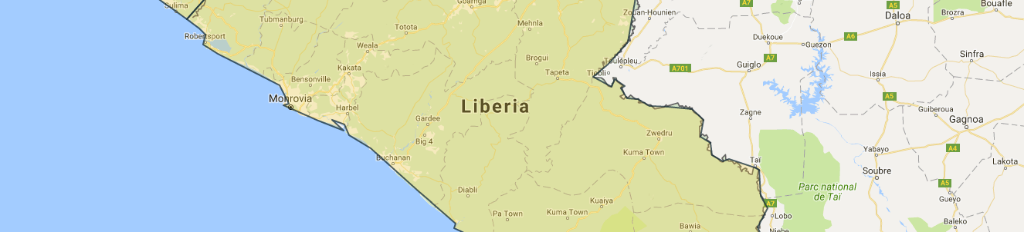
4. Liberia

4.1 The Youth Peacebuilding Context
More recently in Liberia, efforts such as UNICEF’s Peacebuilding Education and Advocacy program, SFCG’s youth peacebuilding programs, and local efforts associated with the UN Security Council Resolution 2250 on youth peace and security, appear to be having some positive influence toward normalizing younger people’s participation in peacebuilding. Many child and youth participation advocates were encouraged in May 2016 when Liberian youth, NGOs, and local youth groups collaborated with the Ministry of Youth and Sports to offer an event promoting Security Council Resolution 2250’s application in Liberia. At the same time, much more work is still needed.
Liberia has a history of recurrent internal armed conflict from 1980 to 2003 that is fairly consistent with other developing contexts with very young populations. Libera has remained a postconflict setting since a peace deal was signed August 2003 and the United Nations Mission in Liberia (UNMIL) was established in September 2003. Many local and international actors are eager to further establish peace and prevent a return to ongoing cycles of violence. Nearly half of Liberia’s population are children. Unfortunately, relatively few state and non-state actors see this youthfulness as an opportunity to be leveraged in order to build more durable peace in Liberia. Parts of the youthful population are more likely to be seen as a risk factor. For many, but not all, it is uncommon for children and youth to be seen in positive places of authority, voice, and influence. This aforementioned cultural norm, more likely to be true of younger children and youth, has posed an obstacle to child and youth participation efforts.
It is also important to recognize varying perceptions of different sub-groups of youth and different age groups of those considered youth. For example, SFCG’s Liberia Director Aaron Weah highlights that, “nearly half of Liberia cabinet ministers, including Assistant, deputy ministers are all youth, in their 30s.”

4.2 Applying the Methodology in Liberia
Liberia was the first country where research tools were tested and data collected for this evaluation. Thus, most methodological adaptations occurred during early implementation in Liberia. This included a shift toward increasing interviews and decreasing FGDs. This shift was largely a result of discovering that very few key stakeholders participated in the project in addition to SFCG, the YRs, and YMCA. A quick start to the evaluation was encouraged yet relatively few background documents were made available to researchers before their arrival in Monrovia. Given these delays and other program challenges, including long program service delays, poor communications, and changing staff, it took months to clearly understand the core activities and project timeline. This negatively impacted researchers ability to collect and interpret data and simultaneously represented a core research finding. Aside from a few phone interviews, all data was collected in or around Liberia’s capital city of Monrovia.
The primary direct beneficiaries of this project were the 24 YRs. Key stakeholders were SFCG staff and SFCG’s local partner on this project, the Young Men’s Christian Association (YMCA). Data collection focused on YRs, key stakeholders, and radio-listeners in the greater Monrovia area.

4.3 Quantity and Quality of Data Collected in Liberia
Youth Researchers, other key stakeholders, and radio-listeners who were impacted by the SFCG Youth Talk radio program participated in FGDs and interviews. There were two FGDs and 10 interviews with YRs that included a total of 17 YRs. Thirteen key stakeholders participated in an interview or a FGD and 5 Youth Talk radio program listeners were interviewed. Thus, there were a total of 35 FGD and interview participants in Liberia. Despite great efforts for gender balance in each category, 24 participants were male and only 11 were female.

4.3.1 TABLE: Liberia Evaluation Participants by Type and Evaluation Method Used
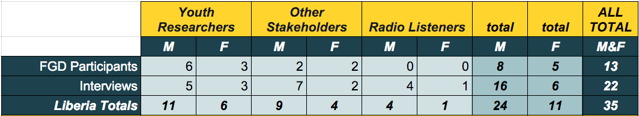

Additionally, a survey of radio-listeners was conducted in socioeconomically diverse regions of the greater Monrovia area. The survey included a total of 386 participants. Of these, 178 were male and 308 were female. More females were surveyed in an attempt to find females who recalled hearing the radio program and were willing to be interviewed. An additional 8 surveys were removed from analysis because the collection method rendered them unrepresentative of the population (5) or transcriptions included incomplete data (3).

4.4 Findings
This project was implemented in Liberia through three phases over the course of 31 months. Phase One focused on equipping YRs to conduct research to identify worst forms of violence against children and youth. Phase Two focused on drawing conclusions and recommendations from the research findings. And Phase Three aimed to mainstream research results and recommendations in order to influence national policy and Liberian society. There were a number of activities associated with the project’s evaluation and this could be considered Phase Four. Each project phase and associated activities are highlighted in the figure below. The project activity map below represents very significant findings of this evaluation as, after much cross checking, it disambiguates contradicting testimony from some evaluation participants.
The findings section continues by describing the activities associated with each of the project phases and the quality of youth participation during those phases. This is followed by highlighting some overarching findings that impacted each sphere of the project. Next, findings focus on both positive and negative impact experienced by the YRs, Key Stakeholders, and the community, including those who heard the Youth Talk radio program produced by this project.

4.4.1 FIGURE: Liberia Project Phases; Timing, Participants, and Quantity of Activities
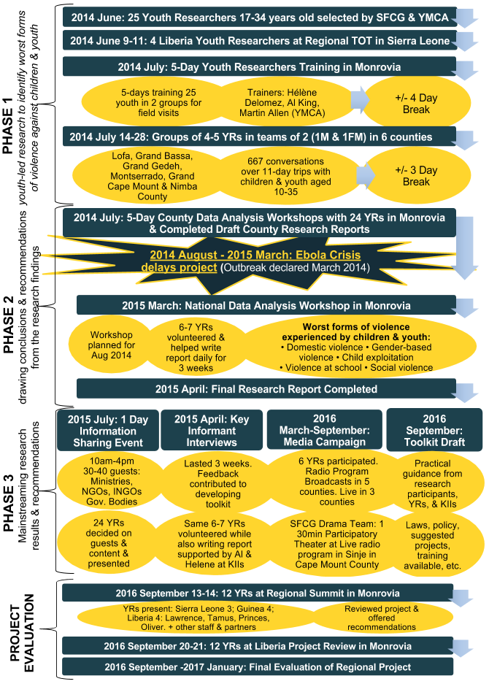
Completed Activities and Youth Participation Quality
Young people truly did appear to be the central actors of this project right from the beginning in June of 2014 when the 25 YRs (YR) were chosen in Liberia by SFCG (13) and YMCA (12). The YRs then ranged from 17 to 35 years old. Soon after selection four Liberian YRs were sent to a training of trainers (ToT) event in Freetown, Sierra Leone where they joined YRs from Guinea and Sierra Leone. These two male and two female Liberian YRs then played a key role in the five-day YR Training event in Monrovia, Liberia in July 2014. After about a four day break, five teams of four researchers, and one team of five YRs, were sent to six different counties (Lofa, Grand Bassa, Grand Gedeh, Montserrado, Grand Cape Mount and Nimba County). Aside from one team of two females and one male, each of the six teams were organized into (11) teams of one male and one female. Each team conducted research on the field for approximately 11 days in order to record a total of 667 conversations with children and youth.
Phase Two began after data collection on the field was complete. Depending upon the research team’s location, YRs had approximately three days of rest before meeting again for a five-day County Data Analysis Workshop in Monrovia. One female YR moved to the USA for studies before the County Data Analysis Workshop and no longer participated in the project. It seemed that three-day County Data Analysis Workshops were originally planned to occur with the small teams in their field station immediately after collecting all data, but, the Ebola Crisis prevented this. A five-day National Data Analysis Workshop was originally planned for August 2014.
The six teams of four YRs appeared to continue to take the lead at the County Data Analysis Workshop in organizing and analyzing the data they collected, and then, drafting and sharing county focused reports of their findings. YRs leadership at this stage was likely due in part to the unexpected absence of the project’s key Research Consultant, trainer, and facilitator. Before the workshop, it was decided that she should not come to Liberia due to the Ebola Crisis unfolding.
Phase One appeared thoughtfully well designed for meaningful youth participation, despite some concerns that will be addressed later. However, beginning with Phase Two, the project was less clear, organized, and thoughtfully inclusive of young people. This appeared largely the result of the EVD crisis and related imposed restrictions, important precautionary measures taken, and the added pressures of the post-EVD crisis context in which the project was implemented. Other factors are discussed in the section above on overarching factors hindering the project’s success. Occasionally, limitations contributed to greater youth leadership where there was less support from adults, as in the case noted above of the EVD crisis preventing Delomez’s participation at the 2014 County Data Analysis Workshop. However, at other times, this just meant that fewer youth were involved and/or they received less support.
Phase Two was then delayed seven months by the Ebola Crisis. Phase Two began again in March of 2015 with a five-day National Data Analysis Workshop in Monrovia attended by all 24 remaining YRs and adult supporters, including SFCG’s project Research Consultant. After this workshop, as opposed to being selected, elected, or hired, 6-7 YRs volunteered to assist with writing the report and performing key informant interviews (KIIs) without compensation. Three YRs (Emmanuel, Tarmus and Elsa) volunteered to assist both with report writing and KIIs as well as with the radio program production. Some YRs seemed to suggest they would have liked to participate more in writing and KIIs, however, they were told that funding was no longer available to pay them a daily rate as they had been paid during Phase One in 2014. Nevertheless, the 6-7 YRs who volunteered did end up receiving some small stipend. The April 2015 Research Report on the Worst Forms of Violence Against Children and Youth in Liberia completed Phase Two of the project.
Phase Three aimed to see the the Research Report’s findings and recommendations impacting the community at large and national policy in particular. This began with the KIIs conducted by the 6-7 YRs and Delomez in April of 2015. During these KIIs the YRs aimed to, (1) use their research findings to influence key actors in hopes of impacting policy at a national level, and (2) receive recommendations for a Guiding Manual intended to offer users guidance for putting research findings to use in practical ways.
The aforementioned Guiding Manual, often called a toolkit by evaluation participants, was eventually called the “Guiding Manual on Engaging Children and Youth as Partners in Preventing Violence against Children.” The first version of the Guiding Manual was deemed of insufficient quality so SFCG hired a second consultant to help complete the manual. Though much progress had been made, the Liberia Guiding Manual was incomplete at the time the evaluation was conducted. Contributions for the Guiding Manual also came from three, two-day, Guiding Manual Summits held in Bong (23 attended), Grand Bassa (24 attended), and Grand Cape Mount (27 attended) Counties. There, a total of 74 child protection actors and children and young people identified: (1) other forms of violence not captured in Phase One research, (2) examples of good practice to protect children from violence or support victims of violence, and (3) main challenges child protection actors face. It was unclear the degree to which YRs participated in the Guiding Manual Summits or in the writing of the Guiding Manual.
Phase Three activities also included a one-day information sharing event in Monrovia and a media campaign focused around the youth-led radio program broadcast in 5 counties. YRs decided on the guest list and content for the information sharing event and also gave the presentations. The event lasted from 10 am to four in the afternoon. Invitees included government ministries and officials, NGOs and INGOs. However, at least one YR attendee suggested that, aside from one USAID representative, only SFCG and YMCA representatives were present. Despite research and requests, no reports or other evidence could be found suggesting greater attendance or event impact. Though the quality of youth participation appears high for this activity, the impact appears quite narrow and internally focused.
The media campaign showed a high level of leadership from 5 YRs who volunteered to support the effort. Five YRs participated for the entire campaign and one female participated for about half the campaign. With coaching and support from SFCG’s radio studio manager, the YRs did appear to lead the development and production of the radio program distributed in five counties. However, SFCG’s West Africa Regional Program Manager expressed that it was “SFCG who [led] the development of the radio programs, and YR were part of the radio program sound collection and production. But there definitely was a SFCG staff guiding those YR.”
SFCG’s Drama Team was subcontracted to conduct one 30 minute participatory action theatre during one live radio recording in one county. While, YRs seemed to have recommended and very much appreciated this performance, they did not participate in it.

Factors Helping the Project’s Success
The factors helping the project’s success that are noted in the overarching findings section above are very consistent with what occurred in the Liberian context.

Factors Hindering the Project’s Success
The Ebola crisis, financial delays and cuts, and communication and coordination challenges were the obstacles to the project's success that were most frequently highlighted by evaluation participants. These three factors are discussed consistently with the Liberian context in the overarching findings section above.
Ebola crisis. YRs in Liberia noted that when they began to do Phase One data collection in the villages people sometimes misidentified YRs as EVD care workers. There was a myth that EVD care workers were actually coming into areas and intentionally infecting people with EVD. Therefore, when the community said a group of unknown people were coming to their village in matching t-shirts, they assumed they were EVD workers and potentially dangerous. Consequently, the YRs were stopped from entering the village and sometimes chased away. Though the original methodology did highlight the importance of first introducing the purpose of the YR’s presence to local leaders, the YRs adapted their approach. They began wearing plain clothes and first going in as singles or pairs to explain to local leaders what the YRs intended to do. The local leaders could then explain the situation to others and welcome the YRs into their town or village.
Financial challenges. In Liberia SFCG seemed in part to get around the donor’s reduction of the maximum sub-grant to YMCA by paying for allowable expense directly rather than having YMCA do so as originally planned. This workaround caused other challenges as the partner was then subject to SFCG’s often very long payment delays.
Communication and coordination challenges. It appeared that the project’s partners in Liberia, YMCA and the YRs, would have been more engaged, active, and supportive of the project had better communications and coordination enabled them to do so. It seemed that a relatively small increase in communications and coordination would have empowered YRs to volunteer significantly more time, which could have resulted in significantly greater project outcomes. Several YRs expressed frustration in the lack of follow-up after completing the Research Report and making recommendations for the Guiding Manual. In February 2016, the Guiding Manual was not yet complete as the first consultant SFCG hired produced work of insufficient quality. A version that looked nearly complete was available at the end of September 2016. At least two regional SFCG staff believed the manual was fully completed, however, no complete copy was produced.
One young participant from the Bong County Guiding Manual Summit was “not happy” that it took too long for SFCG to follow up post summit and respond to summit participants. He emphasized, “It was important that we keep engaging [the young participants]...I would have loved seeing more interaction with the young people...more engagements...But that was not actually happening. Seriously.” SFCG did not support or participate in activities catalyzed by the Guiding Manual Summit, nor was this part of the project’s design. Multiple SFCG staff noted that their 2015 “financial management crisis” and turnover of multiple key staff in 2014 and 2015 exacerbated communication and coordination challenges.

Summary of Reach, Resonance, and Results Among Youth Researchers, Key Stakeholders, and the Community

4.4.2 TABLE: Summary of Resonance, Reach, and Results among Youth Researchers
Reach
- All YRs appeared to have been significantly involved in the from beginning to end aside from one YR who moved to USA immediately after data collection.
- Approximately 7-12 YRs contributed much more time to the project through interviews with key stakeholder, Research Report writing, and radio program production.

Resonance
- YRs consistently noted experiences and skills that they gained as reasons for their deep resonance with the project.
- YRs expressed the project was both beneficial and meaningful for them.
- Resonance was also evidenced by the fact that only of 25 YRs did not remain with the project through its completion despite the project’s many challenges and long delays.

Results
- YRs gained experiences and skills valuable for future peacebuilding, life, and employment.
- YRs discovered, and were proud, that they could work very long days and overcome many challenges to complete the evaluation. Their confidence was built.
- They were impressed by their ability to impact key stakeholders during interviews.
- Some YRs experienced significant untreated vicarious trauma as a result of their participation in the 2014 research phase of the project.
- YRs felt better equipped to advocate for their needs and prevent violence against peers.
- Some YRs felt frustration with the lack of opportunities they were given to take action on the issues they learnt about through the field research.

4.4.3 TABLE: Summary of Reach, Resonance, and Results among Key Stakeholders
Reach
- Approximately 25 interviews were conducted by YRs with Key Stakeholders.
- Two-day Guiding Manual Summits in Bong, Grand Bassa, and Grand Cape Mount Counties included a total of 74 child protection actors and children and young people.

Resonance
- Overall, the project’s uniqueness, youth-led nature, extensive research phase, and variety of outputs, including recommendations and a radio program, seemed to resonate significantly with with most if not all key stakeholders. However, it appeared to resonate much more deeply with a smaller subset of key stakeholders based on their personal interest and not their position, gender, organization, or any other factor identified.
- Insufficient evidence of clear actions taken by multiple stakeholders prevented clearer validation of resonance.

Results
- Key Stakeholders gave recommendations that significantly shaped the Guiding Manual
- Motivated by her interview by YRs and the Research Report, Satta Sheriff, Speaker of Liberia’s Children’s Parliament, began a project to prevent violence against young people. Her project engaged 6 high schoolers and other volunteers to tutor an estimated 440 at risk children during July and August 2015.
- A Guiding Manual Summit participant from Bongo district, who was also a YMCA representative, several key outcomes catalyzed by the summit:
  - YMCA organized an awareness event to engage with lawmakers, including George S. Mulbah (House of Representatives, Bong County#3). Youth also continued individual dialog with lawmakers after the event.
  - Then The Forum was produced on YMCA radio in Gbarnga for youth to discuss key issues.
  - Young people became more involved in community works projects (e.g. latrine building) and the community became more interesting in partnering with young people. Now local leaders in Plato Town (chairman is Mr. Platota) require any new proposed project in the area to first get input from young people via the Senjeh Youth Association.
  - Bong County Student Union President, Musa Sharif attended Guiding Manual Summit, and after encouragement from another YMCA attendant, worked to resolve a conflict.
- The two-day Guiding Manual Summit seemed to help build relationships between participants and communication and collaboration post summit.
- There appeared to be a greater awareness of youth’s role in reporting key forms of violence within policy circles in Monrovia and of young people’s potential roles in addressing key societal challenges, particularly those that affect them, such as violence against children and youth.
- YRs and others interviewed suggested key stakeholders were influenced by interviews from YR and Guiding Manual Summit participation, however, limited evidence was provided to substantiate these claims. Further research could reveal much greater impact than examples provided here.
- 80% of YRs interviewed mentioned a new law on children and youth being proposed in Liberia. Two YRs claimed the Ministry of Education made promises to take action to change policy and pass a new law focusing on the protection of children and youth. Unfortunately, no evidence could be found to support these claims.

4.4.4 TABLE: Summary of Reach, Resonance, and Results in the Community
Reach
- YRs collected 667 conversations in five counties with children and youth aged 17-35.
- The YR-led radio program called Youth Talk aired June through September 2016 in Montserrado on:
  - ELBC 99.9 FM Saturday 8:15-8:45 Sunday 12:15-12:45
  - TRUTH FM 96.1 Tuesday 1:00-1:30 Sunday 6:15-6:45
- Youth Talk broadcast outside Montserrado on: Radio Gbezohn, radio Cape Mount, radio Kergheamahn, radio Nimba, and Smile FM and radio Kintoma.
- Of approximately 1069 people (237 males, 832 females) approached in the greater Monrovia area, eight (6 males or 2.53%, 2 females or .55%) recalled hearing the Youth Talk radio program.
- Male radio-listeners appeared much more likely than female radio-listeners to recall hearing Youth Talk. Additionally, many females claimed to not listen to the radio at all.

Resonance
- Evaluation participants consistently suggested that children and youth who participated in the Listening and Learning conversations greatly resonated with the project vision. This appeared to be a significant motivation for sharing their stories.
- Of the two females and six male radio-listeners who recalled hearing the Youth Talk radio program, three (1f, 2m) resonated very much with the program, four resonated a little (1f, 3m), and only one (1m) did not resonate with the program at all.

Results
- There was not significant evidence of the Phase One child and youth research participants taking actions to prevent violence against children and youth.
- The sample of those who heard the program was too small to confirm representativeness. Anecdotally, of the eight people who recalled hearing the Youth Talk radio program, five (1f, 4m) took one to two actions to prevent violence against children and youth because they heard the program. Two males did not take any actions and one female claimed to take more than four additional actions to prevent violence against children and youth because she heard the program.
- Most YRs and other participants in this evaluation felt the project had limited community impact. Most struggled to identify ways in which community members were empowered except when it related to officials or specific radio-listeners. However, some evidence suggests program activities may have catalyzed a great number of community actions. The limited additional research conducted for this evaluation revealed such activities as a youth radio program and intergenerational collaboration in Bong County resulting from the Guiding Manual Summit and a program started to protect high-risk children in Monrovia started by Satta Sharif after she received the Research Report. Additionally, YRs suggested that the Participatory Theatre in Cape Mount inspired community members to become youth advocates. These examples suggests that additional investigation may reveal much more undocumented impact on the community from the project’s activities.

Liberia Radio-listeners Survey Findings
Of the 386 valid and complete radio-listener surveys conducted in the greater Monrovia area, six (3.4%) of 178 male radio-listeners, and only two (0.96%) of 208 female radio-listeners, recalled hearing SFCG’s Youth Talk radio program. Thus, overall, 2.1% of the radio-listeners surveyed claimed to recall the program. Notably, only 11 children (14-17 years old) participated in this survey and none of them recalled the program. Given the population and sample size, this survey was conducted with a 5% margin of error and a confidence interval at 5.03 with a 95% confidence level. Thus, there is 95% confidence that between 0% and 7.1% of adult radio-listeners in the Monrovia area recall hearing the program.

4.4.5 TABLE: Numbers of Liberia Radio-listener Survey Participants by if They Recalled the Program
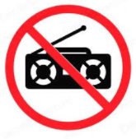
* Denotes estimate
Refers to non-radio-listeners
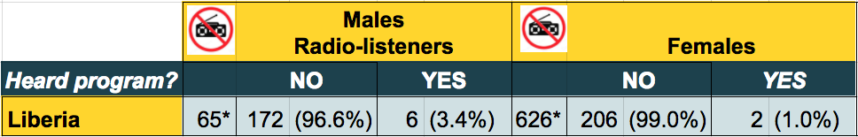
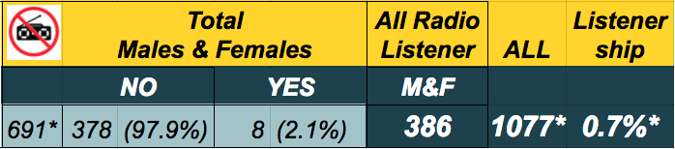

Many people approached in Liberia did not listen to the radio. This was unexpected, and thus, these non-radio-listeners were not counted until some way into the survey process. Though exact numbers were not recorded, approximately 33% of men and 75% of women approached by the interviewer stated that they did not listen to the radio, and thus, were ineligible to take the radio-listener Survey. Thus, approximately 237 males were approached in order to collect 178 surveys and approximately 832 females were approached in order to collect 208 surveys. Thus, if the estimated non-radio-listeners who were approached (n=691*) were included with the radio-listeners surveyed who did not hear the Youth Talk program (n=378), then only an estimated 0.7% of those in the greater Monrovia area are likely to recall hearing the program. This is an estimate only.
Many of the 386 radio-listeners who did complete the survey did not listen to a radio station on which Youth Talk was broadcast. For example, at least 40 people surveyed noted they rather listened to Fabric FM, 35 people surveyed mentioned Hot FM, 30 mentioned Power FM, and 11 noted listening to UNMIL.
The sample subsets of males and females who recalled the program were too small to confirm representativeness. However, Men appeared significantly more likely than women to recall hearing the program. Though further assessment is warranted, this finding may be valuable for considering the audience of future similar broadcasts.

SPOTLIGHT: Radio-listener; Resonating and Taking Action to Protect Children
“The very thing I saw happening in my community, when I started listening to the radio, I started hearing it and I decided to follow the story.” Eve then highlighted abuses of children she saw in her community and continued. “I can relate to [the radio show] because, [it’s] all around. I experience it almost every time, almost every day in my community because my community seems to be a violence community.”
Eve claimed that the Youth Talk radio program motivated her to take the following two actions to prevent violence against children in her community. Firstly, she said, "a little girl from my community, I saw her carrying dirt in the dirt bucket, a dirt that even I should not be able to carry, and I put stop to it. Her mother even came blasting at me but I stood and I fight against it...I took action.” Secondly, Eve explained, “one other child I saw selling, a child, underage child. She was sent by a pastor wife from my community to sell around. We were in group that even contacted the police and the police was involved. The police arrested the child and the child was carried to the station where she went. She was detained and later on she was released.”
Eve Davis, 28, Monrovia, Liberia

Additionally, females were much less likely than males to listen to the radio at all. The two women who did recall the radio program were also reluctant to be interviewed. Thus, despite deciding to survey more females than males in order to seek greater gender balance in radio-listener interviews, only one female was interviewed compared to four interviews with males. Anticipating the potential of a similar reality in Guinea and Sierra Leone, decisions were made to, (1) consider interviewing more females in Guinea and Sierra Leone and (2) record the numbers of people interviewed who did not listen to the radio.

4.4.6 TABLE: Survey Responses of Liberia radio-listeners Who Recalled Hearing the Youth Talk Radio Program
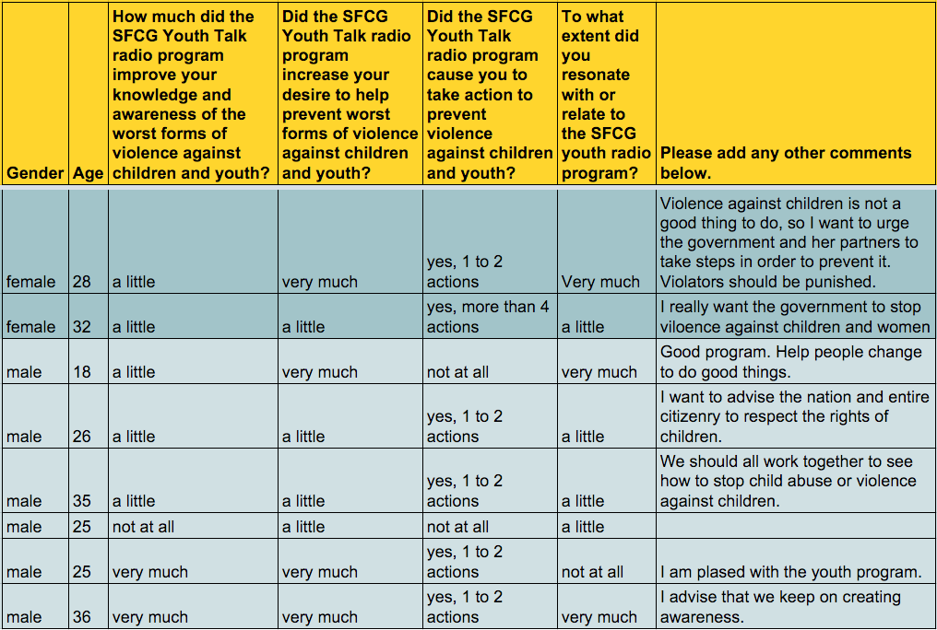

The reach of the radio program was quite narrow, particularly among females. Of the eight survey participants who recalled the radio program three (1f, 2m) resonated very much with the program, four resonated a little (1f, 3m), and only one (1m) did not resonate with the program at all. Though the small sample of 8 people who recalled hearing the Youth Talk radio program is too small to confirm representativeness, it is interesting that all those who recalled the program claimed to have been at least somewhat positively impacted by the program in multiple categories. Only two of the eight did not take additional actions to prevent violence against children and youth as a result of listening to the program. Five people took one to two protective actions and one person claimed to have taken more than four actions to protect children and youth against violence because he listened to the program. Following are highlights from interviews with people impacted by the radio program.

SPOTLIGHT: Radio-listener; From Revenge-Seeker to Peacebuilder
One listener told the story of how an angry mob had mistaken him as a criminal and begin beating him nearly to death. Before they could kill him an acquaintance identified him and rescued him. Later, as he was healing from his injuries, he began plotting to take revenge on his assailants. He happen to hear the Youth Talk Radio Program. As he listened he was deeply impacted and eventually decided not to take revenge but rather work toward building greater peace in his community. He called in to share his experience on the radio program more than once. During his interview it became evident that before his brutal experience he had been somewhat of a peacebuilder in his community. The violent incident nearly motivated him to join a pattern of community violence. However, the Youth Talk radio program seemed to stop his turn toward violence and motivate him to be even more committed to bringing peace.
Derek Whisnant, 35, in Monrovia, Liberia

Nimely Johnson, a 25 year old male, said he listened to Youth Talk, “because some of my friends are out there...they carry out violence against youth or children, and it is not correct. So...I advise my friends who do, not to do so.” He continued,

“Then, it went deep down into my my heart that I should, honestly I should, abide by it too, and change my, my activity and things I do toward children and not do it again.”
~ Nimely Johnson, 25, radio-listener

Johnson also noted that his own personal experiences of violence and abandonment as a child helped him resonate with the show and keep listening. Later in his interview he claimed to have left his violent ways before listening to Youth Talk, however, the program motivated him to encourage others to stop their violent ways, including mob violence.
A 32 year-old security guard offered an example of protective action he took because he listened to Youth Talk. When he saw wounds on a child he investigated and discovered that his aunt was beating her child with a switch. He told her that if she did it again he would take her to the police.

4.5 Summary of Lessons Learned in Liberia
Following is a summary of some of the key lessons learned from the evaluation in Liberia.
Participation
To what extent was the participation of youth beneficial and meaningful for them and for the project?
- Stakeholders, and YRs in particular, highlighted the many benefits of their meaningful participation throughout the project.
- Although many project activities post-ebola-crisis included fewer YRs than those beforehand, virtually all inclusion appeared quite meaningful.
- YR’s commitment and perseverance was key to the project’s success and they would have done much more with additional supports.
- YRs were trusted by peers. YRs were personally committed and persevered despite many challenges. YRs offered credibility to the findings and recommendations.
- The project increased YRs’ experiences, expanded their transferable skills, and informed and strengthened their commitment to peacebuilding action.

To what degree did the project vary in involvement and effects with regards to women vs. men/ girls vs. boys?
- There was a high degree of gender balanced inclusion throughout the project.
- The apparent low female radio listenership in the Monrovia area significantly limited the Youth Talk radio program’s ability to impact females.

Effectiveness
To what extent were the project activities implemented adequately?
- The large majority of the programs energy appeared to have been invested in the first several weeks of the program from June through July of 2014 of Phase One.
- Radio-listener survey responses suggested that the Youth Talk radio listenership could have been greatly increased if broadcast on other stations.
- Many activities appeared adequately implemented despite many challenges. However, there were some challenges verifying the scope of activities given contradicting testimony, limited access to or missing reports, and a few discrepancies between reports and verbal testimony.

What is the level of usefulness of the 'Manuals on Prevention of Violence Against Children' and 'Research Reports on Worst form of Violence Against Children'?
- A number of internal and external hindering factors prevented the completion of the Guiding Manual on Engaging Children and Youth as Partners in Preventing Violence against Children. These included delays resulting from the EVD crisis, financial challenges, and a consultant’s underperformance.
- The Research Report was widely celebrated by diverse stakeholders as both useful and impactful.
- Relatively limited investigation of the report’s impact yielded significant findings of the report catalyzing efforts to prevent violence against children. Additional research is advised.
- Some stakeholders felt the Research Report was the conclusion of the process, others felt it represented a key tool with much untapped potential.

Were the objectives and expected results adequately achieved?
- Project objectives:
  - Identify the worst forms of violence against children and understand the cumulative impact of current approaches addressing them;
    - Phase One research appeared well executed and findings were widely accepted, suggesting the objective was completed successfully.
  - Utilize children and youth recommendations to influence country level programmatic and policy actions to involve children and youth;
    - YRs felt that if local and national authorities were informed of challenges faced by children and youth, then changes in policies could occur. However, no changes in national programs or policy were discovered.
  - Mainstream findings at a societal level to enable communities to prevent worst forms of violence;
    - The radio program represented a significantly underleveraged opportunity. Given that only about 2% of radio-listeners in the Monrovia area recalled the Youth Talk radio program, only 8 in our sample, findings about the program’s impact on listeners were indeterminative. They were, however, suggestive that a small amount of listening to the program could yield significant impact. Further research is advised.
    - Phases Two and Three of the project saw some success largely based on the good work of Phase One, however, much more could have been achieved if the energy and participation of Phase One was more closely matched.
  - Cross Cutting: build capacity of children and youth to advocate for their needs and prevent violence against their peers.
    - This objective was well achieved among the YRs. Stakeholders frequently mentioned they were impressed by the YR’s commitment, energy, and growing skill to research and work for peace. This helped shift, or further reinforce a shift, of stakeholders perceptions away from youth as perpetrators and toward youth as assets.
    - Aside from efforts catalyzed by this project’s activities (e.g. Liberia Children’s Parliament's vacation education project, and a youth-led community radio program sparked by a Guiding Manual Summit), and the youth who called into the Youth Talk radio program, there was little evidence of relevant capacity building beyond the YRs.
- Project’s expected results:
  - Target groups have a clear understanding of the worst forms of violence against children and youth;
    - YR’s understanding was much clearer.
    - About 2% (8) of radio-listeners in the Monrovia area recalled the Youth Talk radio program. Seven of the 8 (88%) felt the program improved their knowledge of the worst forms of violence against children and youth. The sample subset was too small to confirm representativeness.
    - Given the content, at least some stakeholders who participated in KIIs or Guiding Manual Summits were likely to have a greater understanding, however, limited evidence was found to prove this.
  - Recommendations allow for programs and policy in each country to be more children and youth friendly;
    - Research report recommendations appeared helpful for providing such support, however, there was little evidence that report recommendations actually resulted in more child and youth friendly programs and policy in Liberia.
    - Delayed development of the Guiding Manual prevented more focused, and different, recommendations from being more widely available.
  - Children and youth play an active role in ensuring their rights while a society-wide understanding of the issues helps prevent future violence against children and youth.
    - The project in Liberia appeared to deeply impact a limited number of youth who were directly involved in the project. These YRs (none of which were children), through participation in this project, played an active role ensuring their rights. Unfortunately, there was very little evidence suggesting this was the case for any children and little evidence it was the case for youth beyond the YRs.

Which internal and external factors facilitated or hindered the achievements of expected results/ specific objectives?
- YRs were key to the project’s success as they were trusted by their peers and brought credibility to Research Report findings.
- Many children and youth felt their voice was valued for the first time. This helped motivate participation and gleaned authentic stories during Phase One research.
- The project’s youth-led and participatory innovation drew attention.
- The Ebola crisis, SFCG’s internal financial crisis, and staffing changes, all exacerbated coordination and communications challenges and resulted in significant negative effects on the project. The impact of EVD related government mandates and advised precautionary measures should not be underestimated.
- Approximately 33% of men and 75% of women in the greater Monrovia area claim they did not listen to the radio.
- Project activities may have had significant undocumented community impact and further research is warranted.

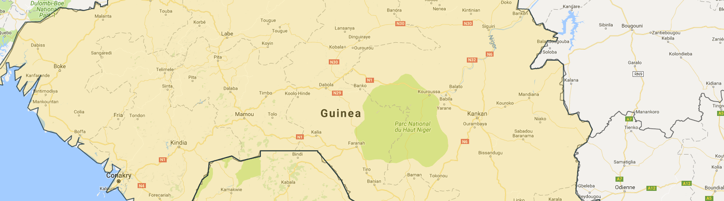
5. Guinea

5.1 The Youth Peacebuilding Context
As one of the poorest countries in West Africa, and after decades of authoritarian rule, this former French colony faces ongoing challenges of poor infrastructure, high unemployment, and a weak education system. Despite strong improvements since democratic elections took place in 2008 support structures for Guinean youth are lacking. Many of the youth interviewed suggested that Guinea’s youth potential has not been tapped into. Some of the issues highlighted among today’s youth are gender-based violence, food deprivation, and high unemployment rates. The Youth Researcher’s (YR) Research Report on the Worst Forms of Violence Against Children and Youth in Guinea offered in-depth analysis and conclusions on the particular challenges children and youth face in Guinea.

5.2 Applying the Methodology in Guinea
Based on adjustments made while testing research tools and collecting data in Liberia, similar adjustments were made for the Guinea. Adjustments were made ahead of the field research a to adapt research tools to a French speaking context. To ensure valid, reliable, and methodologically consistent data collection between all contexts, along with appropriate contextualization, the research team ensured proper testing of research tools and training of the Local Research Coordinator by Pauline Zerla in Conakry. After an initial translation, the research questions were tested during an interview in Conakry, then back translated by a different bilingual researcher evaluating for accuracy. The primary direct beneficiaries of this project were the 36 YRs. However, over half of the YRs no longer lived in Guinea. Since their participation in the project they were offered an opportunity to work or study abroad. This information was only made available to the researchers after arrival in Conakry. It was, however, still made possible, through ongoing efforts of the partner Parlement des Jeunes de l’Union du Fleuve Mano (PJUFM), to conduct three FGDs and 10 interviews with these YR. Key stakeholders included SFCG staff and SFCG’s local partner on this project, PJUFM. This evaluation gathered additional data from key stakeholders within Guinea from authorities recommended by SFCG Guinea. Data collection focused primarily on YRs, key stakeholders, and radio-listeners in the greater Conakry area. In addition to a field mission in Conakry, the remaining data was collected via phone and one in person interview with a YR in Morocco. The aim was to include as many YRs as possible in the evaluation process.
Informed by evaluation experience in Liberia, additional effort was given to ensure a sufficient number of radio-listener interviews. In particular, additional effort was given to ensure female radio-listeners were identified to interview. As a result, five female and four male radio-listener interviews were conducted.

5.3 Quantity and Quality of Data Collected in Guinea
YRs who led the project, as well as key stakeholders and radio-listeners who were impacted by the SFCG Youth Talk radio program, participated in FGDs and interviews. There were three FGDs and 10 interviews with YRs that included a total of 22 YRs. Nine key stakeholders participated in interviews and nine radio program listeners were interviewed allowing a total of 40 FGD and interview participants in Guinea. Despite great efforts for gender balance in each category, 24 participants were male and only 16 were female.
Additionally, a survey of radio-listeners was conducted in socioeconomically diverse regions of the greater Conakry area. The survey included a total of 388 participants, of which 169 were male and 219 were female.

5.3.1 TABLE: Guinea Evaluation Participants by Type and Evaluation Method Used
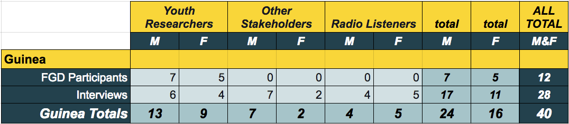

5.4 Findings
This project was implemented in Guinea through three phases over the course of 31 months. Phase One focused on equipping YRs to conduct research to identify the worst forms of violence against children and youth. Phase Two focused on drawing conclusions and recommendations from these research findings, and Phase Three aimed to mainstream research results and recommendations in order to influence national policy and civil society.

There were a number of activities associated with the project’s evaluation and this could be considered as Phase Four. Each project phase and its associated activities are highlighted in the figure below. The project activity map found below represents a significant finding of this evaluation as, after cross-analysis, it provides details on implementation and the ways in which activities differed from the project plan.
Following the project activity map, the Findings section continues describing the activities associated with each of the project phases and the quality of youth participation during those phases. This is followed by highlighting some of the overarching findings that impacted each sphere of the project’s impact. Findings on both positive and negative impact experienced by the YRs, Key Stakeholders, and the community, including those who heard the radio program produced by this project, are described in the last section.

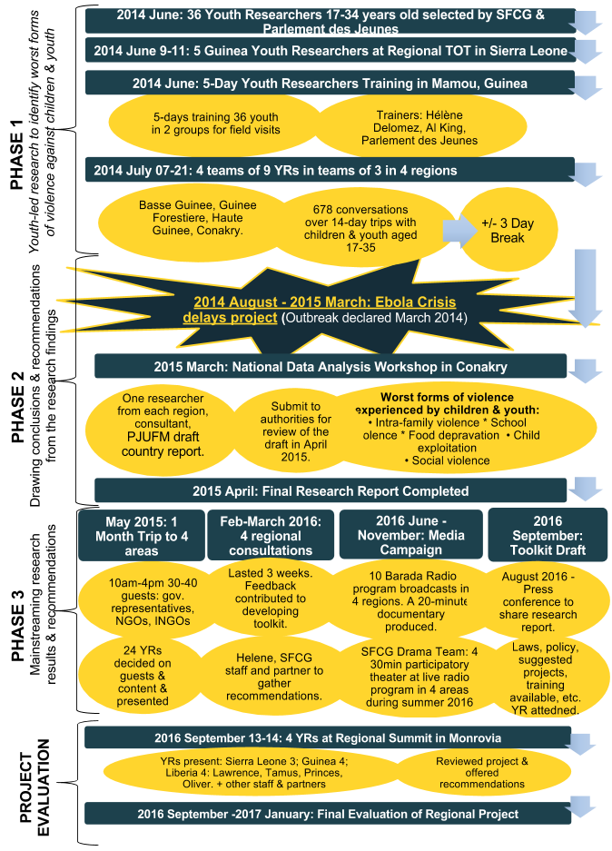
5.4.1 FIGURE: Guinea Project Phases; Timing, Type, and Quantity of Activities

Completed Activities and Youth Participation Quality
As in Liberia, youth that were selected as researchers in Guinea, quickly became the center of the project after its launch in early 2014. The management of the project, however, and its research phase in particular, were supported by the SFCG international team, the Mano River Regional Projects Manager, and SFCG’s hired Research Consultant. The project was implemented in partnership with Parlement des Jeunes, a local youth organization, which managed the coordination of activities. For successful implementation, one focal point person was selected for each organization - Aboubacar Dansoko for Parlement des Jeunes and Youssouf Bamba for SFCG. In terms of coordination, however, little information was communicated to the implementing partner. SFCG declined commenting on this.
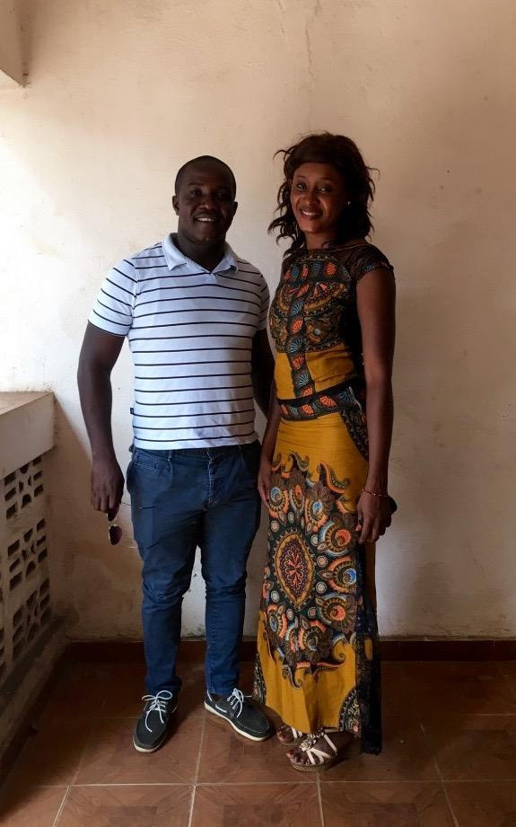
Upon selecting 36 YRs from key universities in Conakry, a training of trainers (ToT), led by the project’s Research Consultant, took place in June 2014 in Mamou, Central Guinea. Field research followed in the four regions of the country through four teams of nine researchers. Each team then split in three sub groups of three YR per region.
In order to collect data on the worst forms of violence affecting children and youth, the YR interviewed 678 youth over the course of 14 days (7 to 21 July, 2014). Data collection was based on the Listening and Learning (L&L) methodology, taught to YR at the ToT, through conversations between the young researchers and the participating children and youth, and 24 key informants (national and international NGOs, State representatives at national and local level, and members of civil society acting in various sectors of child protection and human rights). Certain YRs’ participation was high both in Conakry and certain regions. A YR, Fanta Bah, in Haute-Guinee moved to the area to work on SGBV issues after she participated in the project.
Upon return to Conakry, one report was presented by the YRs and PJUFM for each of the four regions at the National Data Analysis Workshop from the 4th to 8th of August 2014. The YRs based in Conakry throughout the project showcased strong participation while some moved abroad for their studies and became less involved after the complexion of Phase One.
The project was then interrupted for 9 months from August 2014 to March 2015 due to the Ebola Crisis. When the project resumed in 2015, a information-sharing session took place in order to produce the country report. The workshop included one researcher from each region, representatives from Parlement des Jeunes and the project’s Research Consultant. They produced the Guinea country report together while the Research Consultant completed the regional report for the three countries in March 2015. To complete the sharing of the report findings, the YR presented the draft report to authorities one month after completion of the report. Key stakeholders in Guinea participated heavily in the project; through this project one YR became employed by PJUFM and a PJUFM staff became employed by SFCG.

SPOTLIGHT: A YR Makes Lasting Impact in Haute Guinea
“The presence of YR in the field was instrumental in addressing issues faced by children and youth. We were able to talk to community leaders and members and do one-to-one sensitization. And by travelling to the communities we gave legitimacy to the report and recommendations. Then in Haute Guinee - where I stayed for one year - local authorities listened and changes have been made. Now, children feel free. If someone understands the violence against themselves they won’t accept it and it think it has been working well there. There is however much more to do. In Guinea, if we want to bring change, going once or twice to a community will not be enough – we need to continue working on these issues – like FGM. We can campaign on this issue at our level but also meet with women and educate them. There is a lot we can do from this project.”
Fanta Bah, 24, Youth Researcher, Conakry

In Guinea the report-sharing phase took the form of three YRs teams, working with the project’s Research Consultant and PJUFM, going to meet with key stakeholders rather than organizing summits. The goal was to engage as many stakeholders as possible by sharing the research findings with them. The final Research Report was therefore presented by a team of SFCG’s Research Consultant, SFCG staff, and local partners through a one-month trip in the four Guinean regions from the 1st to 29th of May 2015. During this trip they also met child protection actors to talk about and request suggestions for the Guiding Manual on Engaging Children and Youth as Partners in Preventing Violence against Children. The Guiding Manual was often called a toolkit by evaluation participants.
Two research sharing rounds in May 2015 and four regional consultations in 2016 were organized in the four regions from February 28th to March 18th, 2016 to develop a Guiding Manual designed to contribute to the education of actors for the eradication of violence against children. This Guiding Manual development was spearheaded by SFCG’s regional leadership alongside SFCG’s project Research Consultant. The field mission included the Research Consultant and a representative from Parlement des Jeunes tasked to gather recommendations for its content through KII. Children and youth and child protection actors were interviewed. A press conference took place in Conakry on August 24th, 2016 to share report findings. Most YRs attended this event as it kicked off the dissemination of information phase of the project.
Unlike in Liberia, the YR-led radio shows addressing the project were created from the onset and throughout the 2014 data collection stage. The goal was to inform communities of the research project, as well as raise awareness of violence against children and youth. The 10 radio shows ‘Barada’ were later produced throughout the second half of 2016 to share the research findings. Additionally, four participatory theatre sessions took place during the summer of 2016 to illustrate the findings and share them with the community.
To improve dissemination activities a documentary produced by the YRs and SFCG staff was also shared with target communities.

Factors Helping the Project’s Success
The factors that helped the project’s success, which are noted in the overarching findings section above, are very consistent with what occurred in the Guinea context.

SPOTLIGHT: A Youth Researcher Becomes a Peacebuilder
“The project changed me a lot after university and I no longer wanted to work in a company. I wanted to get involved and work for communities. During the project, when it was stopped because of Ebola, I started to volunteer at the Ebola call center for 10 months. I then wanted to stay involved with youth projects and started helping the team at Parlement des Jeunes. When the coordinator post freed up, the whole team recommended me to take it. I was up to the task. Since then I have continued being involved in different initiatives on youth and democracy in Africa.”
Aboubacar Conde, 27, Youth Researcher, Conakry

Factors Hindering the Project’s Success
Both internal factors and external factors hindered the implementation of the project in Guinea.
Ebola crisis. Twentyfive percent of focus group and interview participants expressed that the delays due to the Ebola crisis hindered the project’s success. Four YRs highlighted the challenges faced in the data gathering phase, in particular relating to preconceived ideas, within communities on Ebola workers. SFCG was more cautious than government recommendations advised.
Lack of support for researchers. Twentyfive percent of YRs and stakeholders acknowledged that implementing the program was challenging for them from the onset and it was further challenging due to the Ebola crisis. For example, YR Joseph Bernard Traore shared during a FGD that he had to borrow a taxi from his father in order to travel to his assignment data collection area without support from SFCG. Victor Wendeno, a YR from Conakry, stated that there was very little financial and logistical support when taking part in field research trips. This made data collection challenging based on the short timeframe for conducting the research. 25% of YRs expressed the experience was quite intense, due to this timing challenge in particular. This view was echoed by 30% of key stakeholders interviewed.

Summary of resonance, reach, and results among Youth Researchers, Key Stakeholders, and the Community

5.4.2 TABLE: Summary of Reach, Resonance and Results among Youth Researchers
Reach
- All YRs appeared to have been involved in the project from beginning to end, with a core five active through Phase Three.
- Approximately 5-10 YRs contributed much more time to the project through interviews with key stakeholders, Research Report writing, and radio program production.
- Several youth worked in remote communities and stayed after the project to carry on work.
- All YRs felt invested in representing other youth.
- Over half of YRs involved noted that they took actions in their own lives as peacebuilders while participating in the project.

Resonance
- All YRs insist on the experiences and skills that they gained as reasons for their deep resonance with the project.
- YRs expressed the project was both beneficial and meaningful for them.
- YPs expressed being able to take action on social issues and acquire transferable skills as key impacts of the project.

Results
- YRs gained experiences and skills valuable for future peacebuilding, life, and employment.
- Six YRs found jobs in key institutions as a result of their participation.
- YRs built their confidence as public speakers and representatives of the youth population.
- They felt equipped and invested to advocate for their peers and be leaders in their communities. YRs felt better equipped to advocate for their needs and prevent violence against peers.
- Several YRs gained strong media skills after participation in Phase Three of the project.
- The participation of the YRs made the project successful. Youssouf Bamba from SFCG highlighted, “Youth Researchers are the proudest part of the program.” Indeed YRs took ownership of the project implementation as early as the 2014 data gathering phase. Mariam Kaba, a YR, said “we learnt through that experience that we as youth and children we can do something for ourselves.”

5.4.3 TABLE: Summary of Reach, Resonance and Results among Key Stakeholders
Reach
- Approximately 67 interviews were conducted by YRs with Key Stakeholders.
- 4 trips with 24 participants in 4 four regions to disseminate findings of the report with a total of 115 participants.
- Local and national authorities were involved in the project according to five YR and four stakeholders.
- Reach of the project for stakeholders remained limited to Conakry with some significant exceptions when regional trips took place. Most dissemination activities were organized in Conakry.

Resonance
- The project’s uniqueness, youth-led nature, innovative methodology, and creative approaches resonated significantly with many key stakeholders.
- Fifty percent of key stakeholders interviewed defined the project as representing a valuable resource; a library to support their work.
- Phase One resonated particularly with institutional stakeholders as responding to a need for resources on the state of youth in Guinea.
- Authorities showed interest in the context of the Research Report as well as the Guiding Manual development, and were often impressed by the skills gained by the YR.

Results
- There is little evidence available of clear actions taken by multiple stakeholders despite most YRs identifying interest from stakeholders in taking action.
- Key Stakeholders gave recommendations that will significantly shaped the Guiding Manual, although, it was not yet completed at the time of the evaluation.
- For several stakeholders the project bridged the gap between children and youth and national authorities.
- The project created awareness among policy officials of the role of youth and their potential in representing their peers; including reporting the violence of which they are victims.
- YRs suggested key stakeholders were influenced by interviews from YR and Guiding Manual Summit participation. However, limited evidence was provided to substantiate these claims.

5.4.4 TABLE: Summary of Reach, Resonance and Results in the Community
Reach
- In August 2016 eight press conferences were organized in four regional areas, in order to share with communities the report’s findings. These were publicized through radio talk-shows with YR participation.
- Several YR outline the numerous community members calling the youth-led radio show and coming to meet the YR to share their own experiences.
- To further increase information-sharing with communities, four participatory theatre sessions were implemented in four prefectures in four natural areas (Haute Guinee, Moyenne Guinee, Guinee Forestiere, Guinee Maritime) alongside a documentary, produced throughout the project and shared with communities.
- For Youssouf Bamba, a SFCG staff, this was a great start but the reach was very limited compared to the need. His interview corroborated the potential for further community outreach after the report’s publication. Several YRs add that the current challenge is to ensure prevention mechanisms are established following their media campaigns in the four regions.
- There were no interactive activities with communities but rather media and theatre interventions.

Resonance
- The project resonated strongly with communities in providing children and youth with an avenue to share their concerns and needs.
- Seventy-One percent of evaluation participants outline that prevention starts with awareness and information-sharing. For this reason Phase One and Three of the project were believed to be critical to create behavioral change.

Results
- All YRs stated they hoped the project would continue ensuring impact in communities and violence prevention. For Hawa Toure, there is “so much potential for more awareness raising and campaigning towards communities through schools, media, etc" (in addition to the few events that were organized).
- The radio show allowed the increased impact of the research findings according to four YRs. They presented radio talk shows in different communities to raise awareness about the different forms of violence against children and youth.
- According to many YRs and stakeholders, the report represented a good resource for creating prevention mechanisms.
- Most evaluation participants weren’t able to ensure that prevention mechanisms were implemented by community members. They however dissemination of the research findings to communities took place.
- Sixty-Three percent of YRs interviewed observed - through their field experience - prevention mechanisms seldom occurred. For Aboubacar Conde and three other YRs, indirect sensitization took place without being formally part of the project.
- The report represents the first phase of change by providing needed information to communities and regional and national stakeholders in the child protection sector.
- Two stakeholders among local partners in the project felt there was not a transformation strategy for behavior change but only the research project.
- Fifty percent of stakeholders participating in the final project evaluation felt the project led to prevention but were unable to provide concrete evidence that it already took place.

5.5 Guinea Radio-listeners Surveys Findings
Unlike in Liberia and Sierra Leone, in Guinea, the Phase Three radio program built upon a pre-existing radio program called Barada rather than creating a new program. Barada was already being broadcasted through 25 partner radio stations across the country and SFCG Guinea therefore built on an existing interest in the show to move into this project’s broadcasts starting in 2014. In 2014 and 2015, 17 YR-led shows were produced after the Phase One field research, and an additional 10 YR-led programs were produced in 2016 to present their Research Report findings. Therefore, the radio programming in Guinea started at the same time as the data gathering in Phase One and in the final phase of the project it focused on addressing themes from the Research Report. Barada broadcast only in two prefectures in Phase Three.

SPOTLIGHT: A Youth Radio-listener Impacts His Elders
One listener interviewed outlined how the radio show allowed him and his colleagues to better understand the forms of violence faced by children in his country. He highlighted that it is an important topic to be discussed on the radio because as youth, they are victim of violence. He chose to start discussions with his elders on different forms of violence after hearing the show and he has since then witnessed positive behavioral change in his community as elders are now often avoiding physical punishment.
Anonymous Male, 24, Conakry, Guinea

Of the 393 valid and complete radio-listener Surveys conducted in the greater Conakry area, 54 (31.95%) of the 169 males, and 52 (23.2%) of the 224 females, recalled hearing SFCG’s radio program. Thus, 27% of radio-listeners surveyed claimed they recalled hearing the youth-led radio program. Given the population and sample size (n=393), the radio-listener survey was conducted with a 5% margin of error and a confidence interval at 4.94 with a 95% confidence level. In other words, there is 95% confidence that between 22% and 32% of adult Conakry radio-listeners recall hearing the program. Only one radio-listener survey participant identified as a minor.
Most people approached in Guinea listened to the radio. Only 24 females and 17 males approached did not listen to the radio, and thus, were ineligible to take the survey. Therefore, 186 males and 243 females were approached to gather the 393 surveys.

5.5.1 TABLE: Numbers of Guinea Radio-listener Survey Participants by If They Recalled the Program
* Denotes estimate
Refers to non-radio-listeners
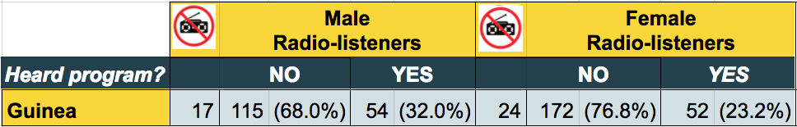
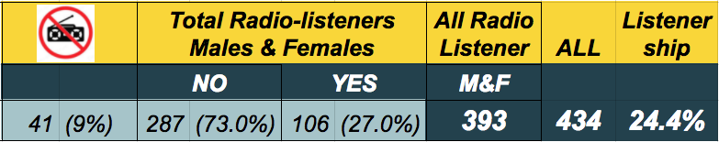

Interestingly, most of those who recalled hearing the program noted that they were at least somewhat positively impacted by the Barada radio program. See the Appendix for the table of responses from Guinea radio-listeners Who Recalled Hearing SFCG Youth Talk Radio.

5.5.2 TABLE: Summary of Responses from Participants Who Recalled the Radio Program
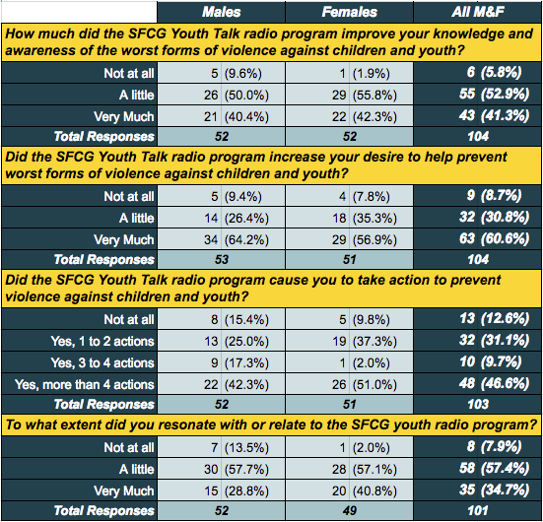

All of the radio-listeners who were interviewed expressed that everyone in the community was concerned by issues of violence facing children and youth and therefore this radio show was very important to the community. They remembered the goal of the show and felt it was successful in raising awareness. In particular, more than half of the radio-listeners interviewed mentioned that the issue of violence against children by parents, as well as within the school system, is a critical issue that needs to be paid closer attention to.
All of the radio-listeners who were interviewed agreed that having a radio show discussing these types of issues benefits the community because it is a great tool for raising community awareness and also for sensitizing the community of the issue. “The message fell in the right ears,” said a journalist from Conakry who listened to the Barada radio show periodically. They outlined being personally touched by these issues and half of those interviewed testified to having advocated in their surroundings on these issues. One interviewee highlighted that these issues are so critical that the sensitization should be achieved through more than one media form or channel.

5.6 Summary of Lessons Learned In Guinea

Participation
To what extent was the participation of youth beneficial and meaningful for them and for the project?
- Youth researchers’ participation in this project was both beneficial and meaningful for them and for the project, with strong female participation.
- In Guinea, YRs were particularly interested in learning about forms of violence in their counties. The issues of female genital mutilation and food deprivation were themes mentioned several times.
- YRs outlined how they were able to take action by reporting both forms of violence against children but also share messages of certain youth and children they met though the campaigns.
- They felt they were able to take action on the forms of violence which inspired them.

To what degree did the project vary in involvement and effects with regards to women vs. men/ girls vs. boys?
- Male and female involvement in the project was similar in terms of YR beneficiaries.

Effectiveness
To what extent were the project activities implemented adequately?
- Almost all activities were implemented adequately, except the Guiding Manual which was not completed.
- Involving local authorities was very effective as they were the entry points to communities. It allowed YRs to better access local groups in the different counties.

What is the level of usefulness of the 'Manuals on Prevention of Violence Against Children' and 'Research Reports on Worst form of Violence Against Children'?
- The Research Report was successfully completed in Guinea with involvement of mainly YRs and several stakeholders.
- Most interviewees and FG participants found the report and sensitization efforts raised awareness on the worst forms of violence against children and youth.
- The Research Report and manual appeared to have strong potential for greater impact if outreach and media activities were further developed.

Were the objectives and expected results adequately achieved?
- Project objectives:
Project objectives were adequately achieved, although Phase Three of the project was still to be completed.
  - Identify the worst forms of violence against children and understand the cumulative impact of current approaches addressing them;
    - Phase One research appeared well executed and findings appeared widely accepted, suggesting the objective was completed successfully.
  - Utilize children and youth recommendations to influence country level programmatic and policy actions to involve children and youth;
    - YRs and stakeholders felt that key actors and communities were better informed based on the report, however, evaluators discovered no country level policy changes resulting from this project.
  - Mainstream findings at a societal level to enable communities to prevent worst forms of violence;
    - The project built on the existing success of the Barada radio show in Guinea. The youth-led radio series for this project was very successful and yielded interest from communities regarding the worst forms of violence against children and youth.
    - Phases Two and Three of the project saw some success, however, much more could have been achieved if the energy and participation of Phase One was more closely matched.
    - Interventions in different regions led to a wider impact on communities’ awareness of the worst forms of violence against children and youth.
  - Cross Cutting: build capacity of children and youth to advocate for their needs and prevent violence against their peers.
    - YRs developed their skills and were identified as ambassadors who could advocate for youth needs and prevent violence against their peers.
    - Evaluators found limited evidence of children and youth’s capacity being built.
- Project’s expected results:
  - Target groups have a clear understanding of the worst forms of violence against children and youth;
    - YRs’ had a very clear understanding.
    - Of those surveyed that recalled hearing the radio program, 94.2% (98) expressed that the program improved their knowledge and awareness of the worst forms of violence against children and youth.
    - Only 13 children participated in the radio-listener survey and only one recalled the youth-led program. This data subset was too small to be conclusive. Therefore, beyond the YRs, here was little evidence suggesting that children and youth had a better understanding of the worst forms of violence against children and youth because of this project.
  - Recommendations allow for programs and policy in each country to be more children and youth friendly;
    - Research Report recommendations appeared helpful for providing such support, however, there was little evidence report recommendations actually resulted in more child and youth friendly programs and policy in Guinea.
  - Children and youth play an active role in ensuring their rights while a society-wide understanding of the issues helps prevent future violence against children and youth.
    - The project in Guinea appeared to deeply motivate and equip YRs to play an active role in ensuring their rights.
    - There was little evidence that other children and youth played an active role in ensuring their rights because of this project.

Which internal and external factors facilitated or hindered the achievements of expected results/ specific objectives?
The Ebola Crisis and overarching operational challenges outlined in this report hindered the project’s results. It led to delays as well as lack of support for YRs in the field. However, the passion of YRs in spearheading the project led to the achievements of most objectives. Project activities may have had significant undocumented community impact and further research is warranted.



7. Sierra Leone

7.1 The Youth Peacebuilding Context
At the end of an 11 year civil war between 1991 and 2002 that resulted in 50,000 deaths, Sierra Leone created a Truth and Reconciliation commission (TRC) set up to deal with issues of accountability on the account of testimonies of victims and eyewitnesses. By 2002, DDR camps had hosted over 70,000 former combatants. Youth played an instrumental role both as victims and perpetrators throughout the war and since 2002. Consequently, youth continue to be frequently perceived as spoilers of peace. Today there are child welfare community services throughout the 149 chiefdoms of Sierra Leone as the key role of youth in development becomes recognized.

7.2 Applying the Methodology in Sierra Leone
Sierra Leone was the last country where data collection was conducted. Logistical support was provided ahead of time but little information on key stakeholders and Youth Researchers (YR) was available. Upon arrival in Freetown, we found most YRs were based out of Freetown as activities were implemented throughout the country. To mitigate these challenges, interviews were conducted with most YRs and a mission outside Freetown to Mile 91 was organized to conduct one Focus Group. Furthermore, radio-listeners’ surveys were gathered in diverse locations.
The primary direct beneficiaries of this project were the 25 YRs. Key stakeholders were SFCG staff and SFCG’s local partner on this project, the Society for Learning and Yearning for Equal Opportunities (SLYEO) and the Center for Coordination of Youth Activities (CCYA). Data collection focused on YRs, key stakeholders, and radio-listeners in the Freetown and Mile 91 areas.

7.3 Quantity and Quality of Data Collected in Sierra Leone
YRs, other key stakeholders, and radio-listeners who were impacted by the SFCG radio program participated in FGDs and interviews. A total of 15 Youth Researchers were included in two FGDs and eight interviews. Thirteen key stakeholders participated in an interview or a FGD and 11 radio program listeners were interviewed. Thus, there were a total of 39 FGDs and interview participants in Sierra Leone. Despite great efforts for gender balance in each category, 25 participants were male and only 14 were female.

7.3.1 TABLE: Sierra Leone Evaluation Participants by Type, Country, Gender, and Evaluation Method Used
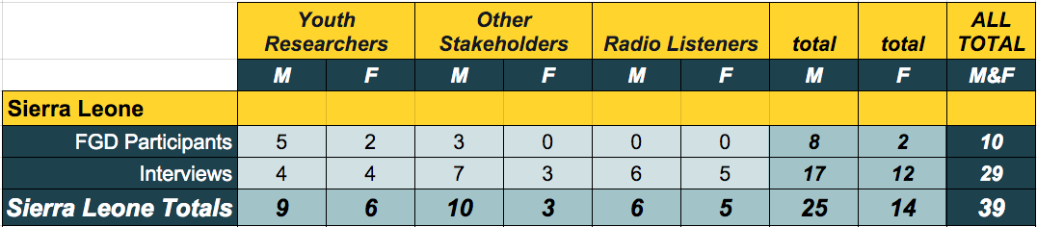

Additionally, a survey of radio-listeners was conducted in socioeconomically diverse regions of the greater Freetown area as well as within the Mile 91 community. The survey included a total of 401 participants. Of these, 161 were male and 240 were female.

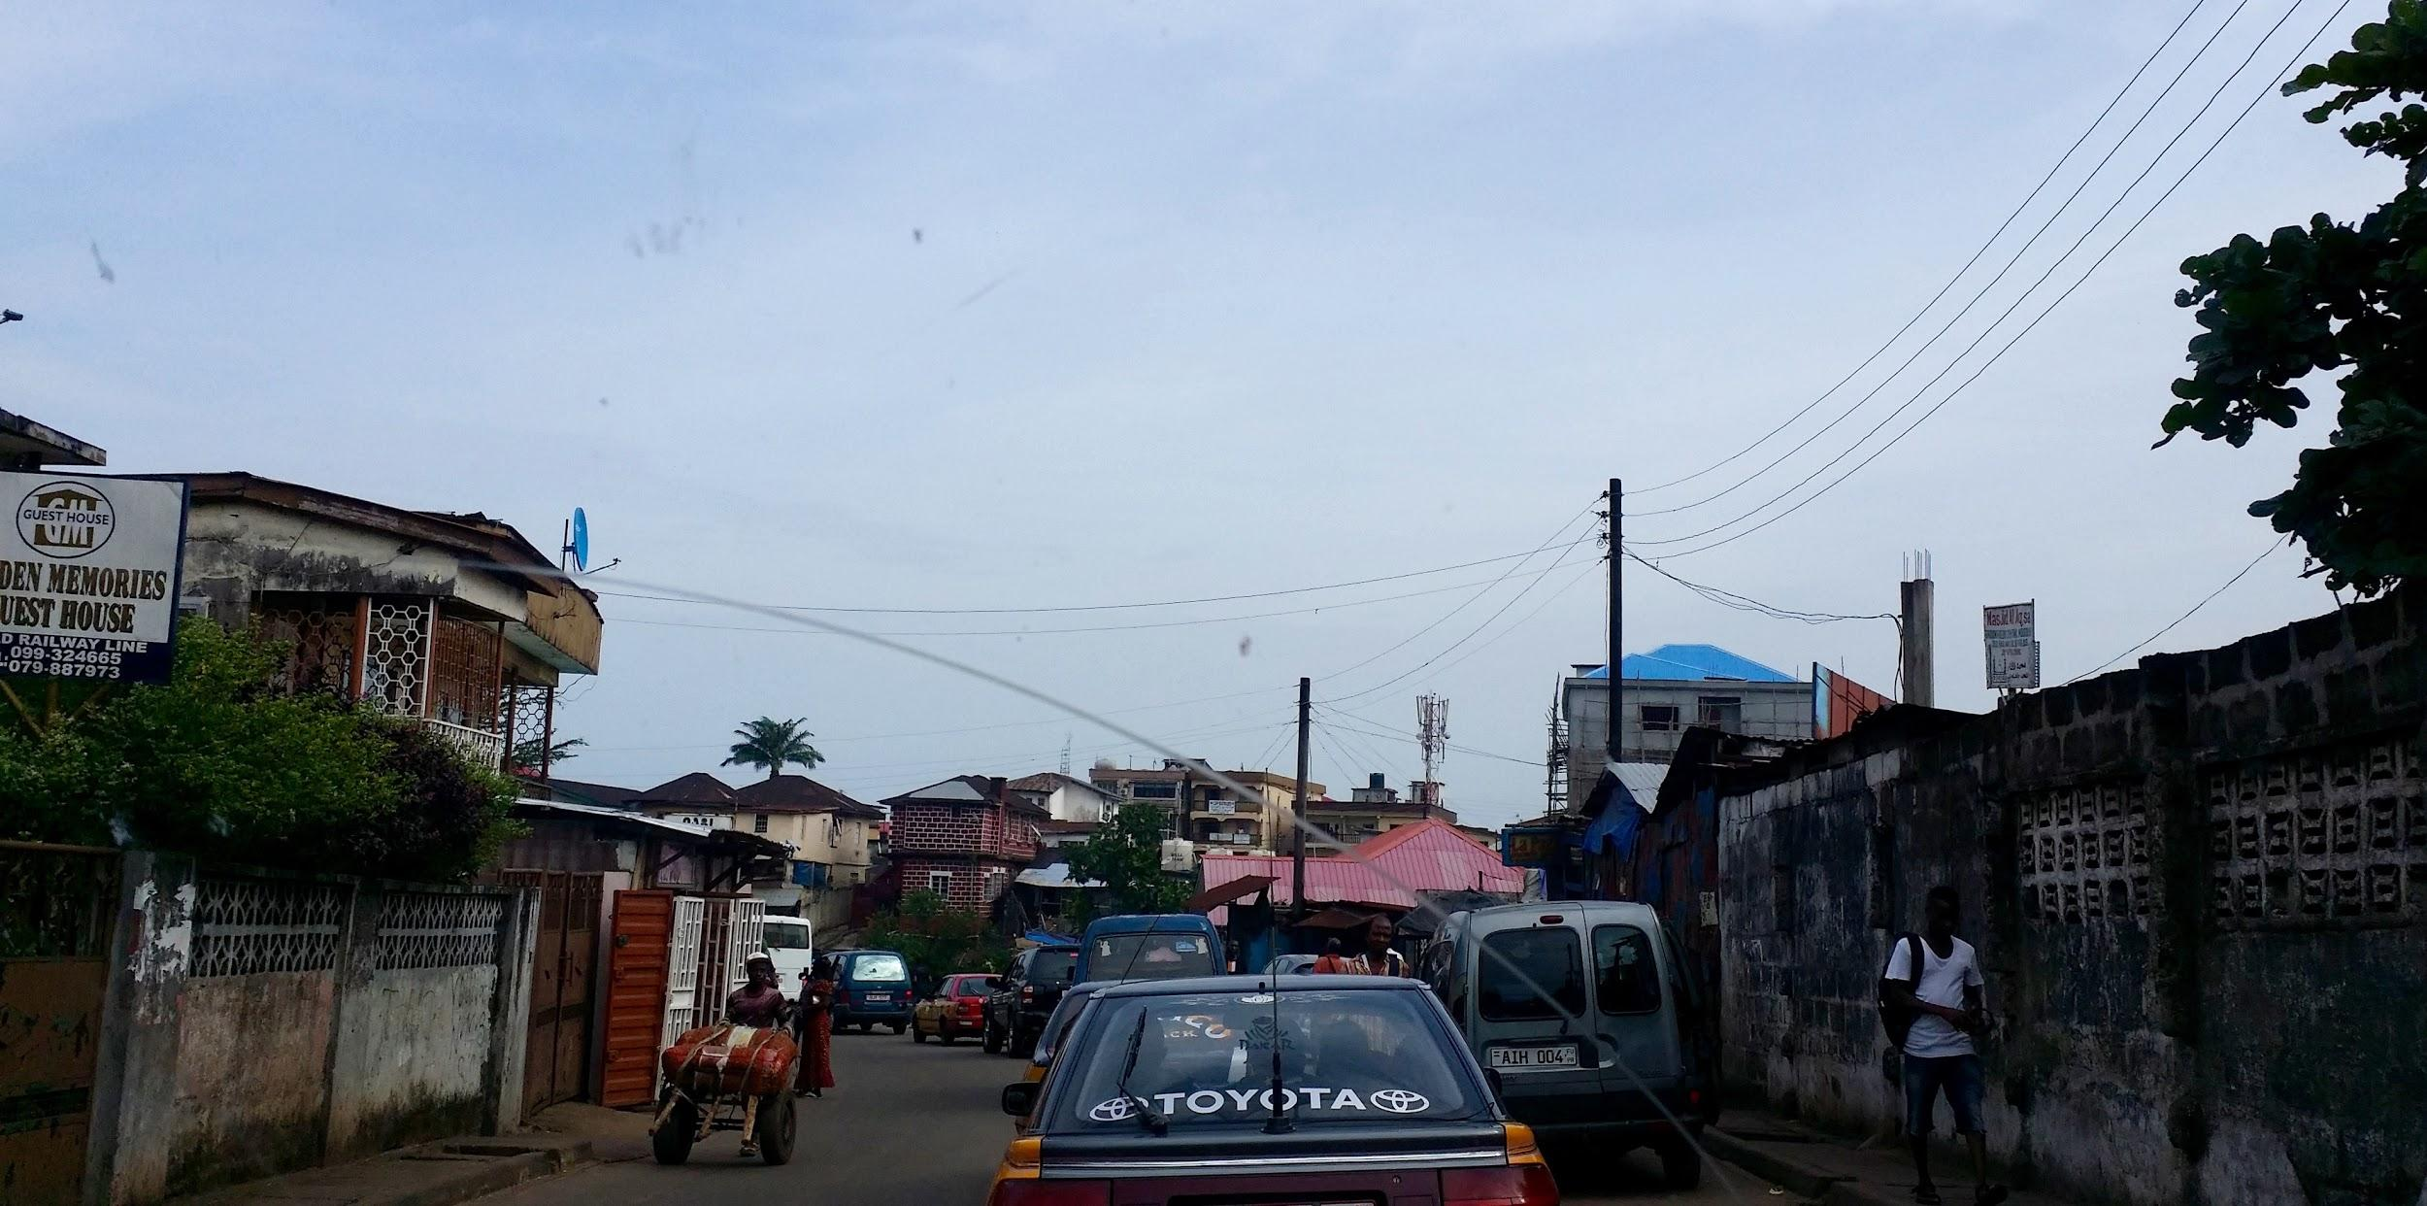
Downtown Freetown.

7.4 Findings
This project was implemented in Sierra Leone through three phases over the course of 31 months. Phase One focused on equipping YRs to conduct research to identify the worst forms of violence against children and youth. Phase Two focused on drawing conclusions and recommendations from the research findings, and Phase Three included sharing these findings with communities and key stakeholders.
Following the project activity map below, the Findings section continues describing the activities associated with each of the project phases and the quality of youth participation during these phases. This is followed by highlighting some overarching findings that impacted each sphere of the project’s impact. Findings that focus on both positive and negative impact experienced by the YRs, Key Stakeholders, SFCG Staff, and the community, including those who heard the radio program produced by this project, are described in the last section.

7.4.1 FIGURE: Sierra Leone Project Phases; Timing, Type, and Quantity of Activities
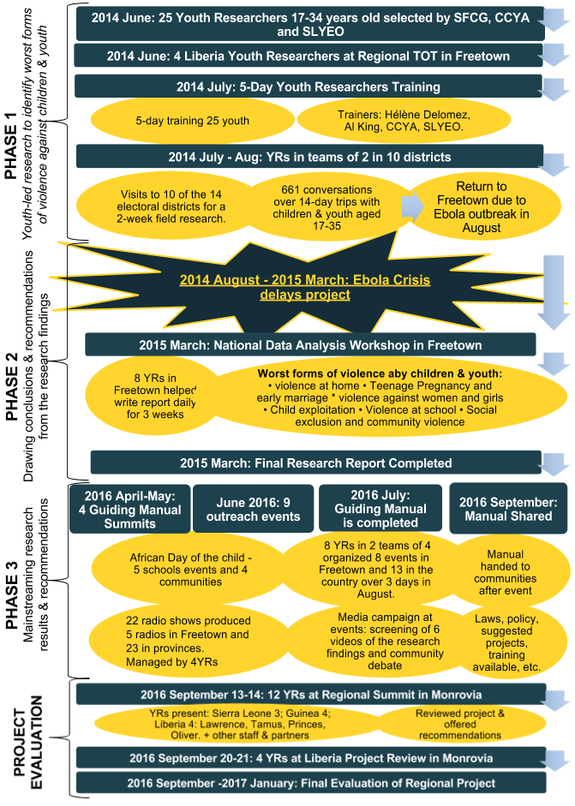
Completed Activities and Youth Participation Quality
As in Liberia and Guinea, youth who were selected as researchers in Sierra Leone quickly became the center of the project after its launch in early 2014. In Sierra Leone, the implementation strategy was for YRs to lead the project while SFCG and two local partners provided technical and logistical support. SFCG oversaw radio programming coordination between the three countries as well as Guiding Manual development. The following two local partners oversaw YRs identification, training and field research trips: the Center for the Coordination of Youth Activities (CCYA) and the Society for Learning and Yearning for Equal Opportunity (SLYEO). In effect, local partners played a mentorship role and deeply participated in Phase One on the project.
The first activity that was implemented for the 25 YRs was the Training of Trainers (ToT) in June 2014. Over the next 27 months there was only one other occasion that saw the participation of all 25 YRs, the national analysis workshop in Freetown in 2015. This is due to only eight YRs living in Freetown; three YRs Samuel, Abigail and Delight were involved in all activities and were accompanied by others at different times. The quality of their participation was the most important.
After the five-day ToT the 25 YRs were sent to 10 of the 14 electoral districts in Sierra Leone for the two-week data collection and interviewed 661 children and youth. Besides the 25 YRs from different Districts of Sierra Leone, the project involved communities of a wide part of the country and led to Phase Two and Three to be implemented throughout the Districts as well. In August 2014 however, the Ebola Crisis started and YRs travelled back to Freetown. National data analysis was conducted in Freetown with all YRs alongside SFCG’s project Research Consultant and Mano River Regional Projects Manager. However, Ebola delayed the analysis and the draft report was only completed in 2015. Beyond field research trips, most activities were attended by eight YRs based in Freetown as other lived in different geographical part of the country.
In April and May 2016 four Guiding Manual summits were organized in Sierra Leone, three regional and one in Freetown, to share findings with local stakeholders and collect recommendations for the Guiding Manual which was completed in July 2016. For Patrick Masuba from SFCG, “input from key stakeholders was instrumental in completing the manual." In June 2016, special outreach events were organized in five schools and four communities in Freetown for the Day of the African Child.
In August 2016 dissemination of the Guiding Manual took place over three days and was overseen by the same 8 Freetown-based YRs. Two teams of four organized eight events in Freetown (schools, colleges, press conference) and 13 in the different provinces (3 in the north, 3 in the south, 3 in the east and 4 in the west) organized a screening of 6 videos on 6 forms of violence in communities followed by a debate with community members present. The goal was to share the research findings and equip communities and stakeholders with resources to address the worst forms of violence against children and youth. These events would be publicized through the radio and the Guiding Manual was distributed at the end.

Factors Helping the Project’s Success
The factors that helped the project’s success, which are noted in the overarching findings section above, are very consistent with what occurred in the Sierra Leone context.
In Sierra Leone the manual was completed in July 2016 and its content disseminated in communities through August. According to all YRs interviewed, the manual helped provide tools to communities who requested support during Phase One of the research. The Guiding Manual and radio shows provided actionable steps that can be taken when the six forms of violence take place. Sylvia Baio was part of the YRs who travelled the country to share the manual with local communities through both radio shows and in-person interventions. “I went to Bo to explain the manual, it was great... We explained how they should use it, what to do when cases arise, what are solutions, recommendations on how to stop it and how to prevent violence against children and youth." Sierra Leone is the only context where all activities were completed.
The Family Support Unit (FSU) - a section of the Sierra Leone Police - became part of the project as soon as stakeholders interviews took place. “The report was very useful, even for us within the FSU. We deal with women and children and we saw in the report some issues we turn a blind eye on,” explained Rita Kamara. The FSU does sensitization both in communities and in schools. They indicate they saw a difference while doing visits in communities before and after the Research Report on the Worst Forms of Violence Against Children and Youth was released. Rita Kamara added, “In the past, communities wouldn’t know about these issues but when we go back, it’s different, I believe it is because of this report." Furthermore, there was an equal involvement in communities outside Freetown, ”one police man in the south said that this was helpful and reducing violence,” explained Charles Lhai, executive Director of SLYEO.

Factors Hindering the Project’s Success
Both internal factors and external factors hindered the implementation of the project in Sierra Leone. These factors were similar to other contexts and are outlined in the overarching findings section.

Summary of Reach, Resonance, and Results among Youth Researchers, Key Stakeholders, and the Community

7.4.2 TABLE: Summary of Reach, Resonance, and Results among Youth Researchers
Reach
- All YRs appeared to have been significantly involved in the data collection phase. Only the 8 YRs based in Freetown continued to be involved for most activities.
- Three core YRs were instrumental in supporting the implementation of the project, in particular Phase Two and Three. ALL YRs took part in part 1 but some left Sierra Leone after the report was completed.
- Most YRs developed an interest in development issues through the project and have since pursued a career in the field.
- YR Abigail Stevens said, “it is the commitment and passion for youth to the research that made the project successful."
- Four YRs were part of the radio show team and felt it was very impactful and had a good response; although insufficient evidence exists to illustrate this was the case.

Resonance
- YRs and stakeholders insisted that the key opportunity the project represented for YRs was to learn new skills and build their confidence. They build their confidence and acquired transferable skills to allow YRs to find employment.
- The project resonated with YRs who felt inspired to take action for the youth of Sierra Leone. They noted experiences and skills that they gained as reasons for their deep resonance with the project.
- YRs expressed the project was both beneficial and meaningful for them.

Results
- YRs gained experiences and skills valuable for future peacebuilding, life, and employment.
- Most evaluation participants changed their perception of youth in Sierra Leone as now leaders of development rather than actors of violence.
- Several successes were met by YRs who took part in the project: One youth won an award from Plan International and YR Abigail now works for the implementing partner organisation CCYA.
- The project represented a very innovative way to build youth confidence and train them as leaders. This is particularly relevant in the Sierra Leone context where youth were frequently considered as spoilers of peace.
- Four of the 15 YRs participating in this evaluation showed significant signs of untreated vicarious trauma resulting from their participation in the 2014 research phase of the project.
- YRs felt better equipped to advocate for their needs and prevent violence against peers.

7.4.3 TABLE: Summary of Reach, Resonance, and Results among Key Stakeholders
Reach
- The Research Report was disseminated through four regional and one national summits.
- The Guiding Manual was completed in Sierra Leone and shared with Key stakeholders. Nine events took place in Freetown and surrounding areas to distribute the Guiding Manual.
- Stakeholders identified the relationship between youth and community as impactful.

Resonance
- The project resonated with key stakeholders in addressing issues that were considered important by the Sierra Leone government at the time the Research Report was released. One stakeholder highlights that it lays the groundwork for compliance from the government on youth issues.
- The project, and the Research Report in particular, resonated with all stakeholders as representing an “eye-opener” on the extent to which youth faced violence in sub regions of Sierra Leone.

Results
- Lively stakeholder’s discussions from state and civil society took place since the report and Guiding Manual were completed. “It showed the recommendations are critical to improve protection of children and youth,” said a NGO stakeholder.
- The project was successful in creating awareness among youth. Now there is a focus on issues faced by youth in national discussions that have been put at the forefront when it wasn’t the case before.
- For most stakeholders, the project has been successful in raising awareness about the worst forms of violence faced by children and youth. However all agree it seems too early to see any concrete changes in policy.
- All stakeholders and YRs seem to agree that the potential for influencing policy and programmatic action exists after the project, but it will take time for concrete evidence to develop.

7.4.4 TABLE: Summary of Reach, Resonance, and Results in the Community
Reach
- Guiding Manuals Summits were organised in August 2016.
  - Screening of 6 videos on 6 forms of violence in communities followed by a debate with community members in villages visited.
  - 13 in different regional districts (3 in the north, 3 in the south, 3 in the east and 4 in the west) + 8 groups in Freetown (schools, colleges, press conference)
  - At the end of session, the manual was distributed to community members.
- 22 radio shows were produced to cover all topics addressed in the report. Four YRs managed the production of the show in partnership with five radios in Freetown and 23 in the provinces.
  - Discussion on a 15 minutes radio program.
  - 5 minutes to explain the findings, then a song related to the program and then recommendations.
- In addition there were radio programs during Phase Three of the project. These five live radios were broadcasted in three districts in the southeast and two in the north (Bo, Pujehun, Port Loko, Kenema, Makeni).
  - Talk shows where community members could call.
  - Gave an insight on the team being in the field.

Resonance
- The program resonated with youth and children as an opportunity for them to share their voice and grievances. Several YRs expressed the passion shown by community members upon the return of YRs during Phase Three of the project.
- For Delight Conneh, a YR, it was extremely positive to share the report’s findings with community members and provide recommendations through radio shows.
- The project gave the community a voice in addressing issues the youth felt strongly about. The report responded to a need to know more about issues faced by youth.
- The use of innovative methodology allowed YRs to conduct in depth conversations with the communities.

Results
- Community initiatives created by youth radio support groups brought youth together to discuss issues of violence.
  - Now there is awareness about the issues of violence and how to take action. Kamanda created a group in his community to create prevention intervention in the mile 91 community.
  - Youth Clubs were created in Karema to address issues brought up by the research and implement recommendations from the Guiding Manual.
  - Youth action network was created by YRs and CCYA mentors them.
- In regards to whether prevention of the worst forms of violence against children and youth is taking place, SFCG staff Patrick Masuba highlighted, “They have received the knowledge but are they applying it? We need to find out."
- Youth came back with comments and questions after hearing the radio when YRs came to present the Guiding Manual. This was followed by campaigning activities spearheaded by YRs; these occurred in schools, churches and mosques and what accompanied talk shows on the 24 partner radios.
- All YRs feel the project needs to continue because of its potential to increase impact for the Guiding Manual and recommendations.

7.5 Sierra Leone Radio-listeners Survey Findings
Twenty-Two radio shows were produced between April and September 2016 to disseminate the research findings and the Guiding Manual, as well as advertise the YRs visits to local communities. In Sierra Leone, radio shows provided legitimacy to findings and acted as a tool for awareness.

“I don’t want the radio program to ever stop." ~ Delight Canneh, YR

A key element is to carry out sharing the recommendations from the manual to advocate for prevention of the worst forms of violence against children and youth. Delight remembers community members highlighting that they heard the radio show and their grievances being discussed, which was of great value to them and led communities to be very welcoming of recommendations for violence prevention. Samuel Konteh, a YR, explains that as a result of their show, a group of youth in Makane city produced a radio show based on the report every week.

SPOTLIGHT: A Youth radio-listener Becomes Inspired
“The radio show impacted me greatly because I have learnt that further violence against youth and children will ignite problems in our society. Listening to this program has taught me so much and in fact, for a while now, I would stop on the street and prevent violence when I see it happening. It has inspired me to take action."
Paul K Mussa, student, Freetown.

Of the 383 valid and complete radio-listener Surveys conducted in the greater Freetown area, 96 (64.4%) of 149 males, and 116 (49.6%) of 234 females, recalled hearing SFCG’s radio program. An average of 55.4% people surveyed in the Freetown area recalled the program. Given the population and sample size, this survey was conducted with a 5% margin of error and a confidence interval at 4.89 with a 95% confidence level. Thus, there is 95% confidence that between 50.4% and 60.4% of Freetown radio-listeners recall hearing the program.
Only one person who heard the radio program (n=212) expressed she was not impacted by the program. Thus, 55.1% of those surveyed claimed they were at least somewhat positively impacted by the radio program.
Forty-eight (12.5%) of the 383 radio-listener surveys were children between 10 and 17 years old. Of these 48 children, 14 (29.2%) recalled hearing the program compared to 59.3% (197) of radio-listeners who were 18 or older that recalled hearing the program (n=332). These sample subsets are too small to be predictive. Further analysis is advised to reveal if children are significantly less likely to be reached by the radio program.
Seventeen surveys gathered in Mile 91 were removed as the sample size was too narrow for accurate analysis. Though Mile 91 findings are inconclusive, of the 17 radio-listener surveys conducted in Mile 91, 12 (71%) recalled hearing the radio show in 2016.

7.5.1 TABLE: Numbers of Sierra Leone Radio-listener Survey Participants by If They Recalled the Program
* Denotes estimate
Refers to non-radio-listeners
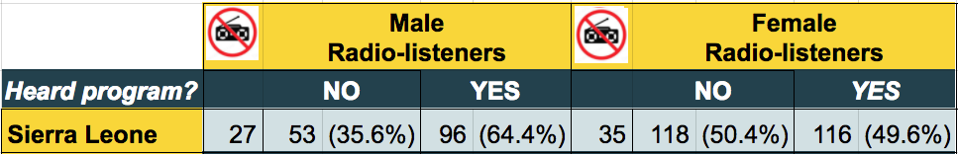
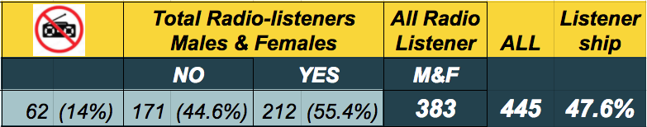

Most people approached in Sierra Leone listen to the radio. Only 35 women and 27 men approached did not listen to the radio. Thus, 185 males and 260 females were approached to gather the 383 surveys. See below the table summarizing responses from Sierra Leone radio-listeners Who Recalled Hearing the program.

7.5.2 TABLE: Summary of Responses from Participants Who Recalled the Radio Program
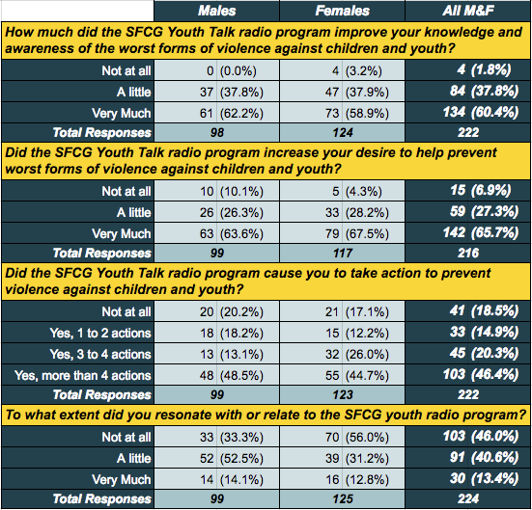

7.6 Summary of Lessons Learned In Sierra Leone

Participation
To what extent was the participation of youth beneficial and meaningful for them and for the project?
The project was beneficial and meaningful for the Youth Researchers who participated. YRs in Sierra Leone were selected from different districts rather than only from universities located in the capital, as was the case in Guinea. Therefore eight YRs were involved in all activities while the rest were mostly focusing on Phase One in the data. Strong participation from YRs and stakeholders was identified. Local authorities and stakeholders were as equally important to be targeted for dissemination as national level ones. The national and local Police was highly involved in the project and provided concrete responses to forms of violence identified in Research Report.
To what degree did the project vary in involvement and effects with regards to women vs. men/ girls vs. boys?
There was a high degree of gender-balanced inclusion throughout the project.

Effectiveness
To what extent were the project activities implemented adequately?
The project’s activities were adequately implemented in Sierra Leone where all project’s component were completed. In Sierra Leone, the scope of dissemination was greater than in Guinea and Liberia which allowed for further reach. Phase One, 2 and 3 were successfully implemented which led Sierra Leone activities to stronger results in terms of dissemination and advocacy.
What is the level of usefulness of the 'Manuals on Prevention of Violence Against Children' and 'Research Reports on Worst form of Violence Against Children'?
Most evaluation participants identified the Research Report to be very useful. The Guiding Manual was completed and very well received by local authorities and local communities. However YRs and stakeholders who took part in the evaluation highlight the importance of furthering dissemination and awareness raising activities for greater impact.

Were the objectives and expected results adequately achieved?
- Project objectives:
Project objectives were adequately achieved in Sierra Leone where all activities were completed to an adequate level despite challenges outlined in this report.
  - Identify the worst forms of violence against children and understand the cumulative impact of current approaches addressing them;
    - This Phase One objective was successfully completed via the youth-led research and resulting report.
    - YRs’ understanding was greatly increased.
  - Utilize children and youth recommendations to influence country level programmatic and policy actions to involve children and youth;
    - The guiding Research Report and Guiding Manual were key in providing country level and local child protection actors and stakeholders with resources to bring about change.
    - The FSU in particular relied on the report and manual to take action on the worst forms of violence against children and youth.
  - Mainstream findings at a societal level to enable communities to prevent worst forms of violence;
    - Stakeholders and YR’s alike felt the Guiding Manual was key in informing communities about the worst forms of violence against children and youth, and how to prevent them.
    - YR’s believed their report and manual dissemination activities were effective in equipping communities to prevent worst forms of violence against children and youth. They believed that expanding such activities throughout the country was key to further enabling communities to prevent violence.
    - An average of 55.4% people surveyed in the Freetown area recalled the radio programs. Nearly half of the 55.4% (46.4%) felt compelled to take four or more actions addressing the worst forms of violence against children and youth after listening to the show.
  - Cross Cutting: build capacity of children and youth to advocate for their needs and prevent violence against their peers.
    - YRs developed valuable and marketable skills and identified themselves as ambassadors who could advocate for youth needs, as well as prevent violence against their peers.
    - Forty-eight (12.5%) of the 383 radio-listener surveys were children between 10 and 17 years old. Of these 48 children, 14 (29.2%) recalled hearing the program compared to 59.3% (197) of radio-listeners who were 18 or older that recalled hearing the program (n=332). Of the 20 children surveyed in Sierra Leone who recalled the program, including the six children surveyed in Mile 91, only 11 (55%) had taken any action to prevent violence against children and youth because they heard the program. However, these sample subsets are too small to be predictive.
    - Beyond minor survey findings, evaluators found limited evidence of children and youth’s capacity being built. Further research is required to assess impact of Phase Three activities of the project.
- Project’s expected results:
  - Target groups have a clear understanding of the worst forms of violence against children and youth;
    - YRs’ had a very clear understanding.
    - Nineteen (95%) of the 20 children who recalled the program stated that it improved their knowledge and awareness of the worst forms of violence against children and youth.
    - Nearly all (98.6% or 208 of 211 who completed the question) Freetown area radio-listeners who recalled the program felt it improved their understanding of the worst forms of violence against children and youth. The program’s national coverage contributed to its success.
    - Beyond the YRs, here was little evidence suggesting that children and youth had a better understanding of the worst forms of violence against children and youth.
  - Recommendations allow for programs and policy in each country to be more children and youth friendly;
    - In Sierra Leone, the involvement of the FSU early on in the project led to a support structure for children and youth facing violence.
  - Children and youth play an active role in ensuring their rights while a society-wide understanding of the issues helps prevent future violence against children and youth.
    - YRs were able to play a key role in Sierra Leone in ensuring their rights.

Which internal and external factors facilitated or hindered the achievements of expected results/ specific objectives?
In Sierra Leone as well, YRs were key to the project’s success as they were trusted by their peers and brought credibility to Research Report findings as well as ensured success of the dissemination activities that took place in that context. Therefore, the project’s youth-led and participatory innovation drew attention.
However, the Ebola crisis, SFCG’s internal financial crisis, and staffing changes, all exacerbated coordination and communications challenges and resulted in significant negative effects on the project. The impact of EVD related government mandates and advised precautionary measures should not be underestimated.

8. Conclusions

8.1 Participation
To what extent was the participation of youth beneficial and meaningful for them and for the project?
One key success of this project has been the involvement of YRs. It has both ensured the successful implementation of the project activities as well as had a strong impact on the YRs themselves. YRs grew personally and professionally. Their participation was deeply meaningful to them and to the project. They provided credibility, commitment, perseverance, energy, compassion, and creativity that helped this project succeed despite many obstacles. Not the least of which was the worst Ebola Crisis in history.

To what degree did the project vary in involvement and effects with regards to women vs. men/ girls vs. boys?
Male and female involvement in the project was similar in terms of gender with a larger investment of youth than children. Though the dataset was too small to be conclusive in Liberia and the margin was small in Guinea and Sierra Leone, it was interesting that males were consistently more likely to have heard the radio program than were females. In Liberia, females were much less likely than were males to listen to the radio at all.

8.2 Effectiveness
To what extent were the project activities implemented adequately?
Phase One of the project was successfully implemented in all three countries, Guinea, Sierra Leone and Liberia. Due to implementation challenges, Phase Two and Three were less smoothly implemented; but were still effective despite taking place on a relatively smaller scale. Internal and external challenges led to the Guiding Manual being completed only in Sierra Leone, though, much progress was made in Guinea and Liberia. The project created strong resources to develop new strategies addressing the worst forms of violence against children and youth.

What is the level of usefulness of the 'Manuals on Prevention of Violence Against Children' and 'Research Reports on Worst form of Violence Against Children'?
The Research Report was widely believed to have been very useful in all three countries. It’s usefulness for education, inspiration, and providing a supportive evidence base was expressed by YRs and stakeholders alike. Most evaluation participants stated both its usefulness as a resource and its potential for creating new projects based on the findings.
The Guiding Manual was only fully completed in Sierra Leone and was identified as useful by most stakeholders interviewed there as a tool to foster awareness and prevention. This was largely due to the dissemination strategy adopted by the YRs, local partners and SFCG team. They were able to organize events in schools, churches, and mosques in the Summer of 2016.

Were the objectives and expected results adequately achieved?
Project objectives:
Identify the worst forms of violence against children and understand the cumulative impact of current approaches addressing them;
The worst forms of violence against children were successfully identified and quality Research Reports were completed in all three countries despite delays due to multiple challenges. Recommendations from children and youth were more successfully shared in Sierra Leone as the Guiding Manual was fully completed in that context. In all three countries, recommendations were shared with key stakeholders.

Utilize children and youth recommendations to influence country level programmatic and policy actions to involve children and youth;
As a result of the project, there was little to no evidence of changes in country level programmatic or policy actions related to children and youth in Liberia and Guinea, however, country level program influence was noted in Sierra Leone. There was significant evidence of some project activities catalyzing significant community action projects to prevent violence against children. For example, findings shared through radio programs and community awareness workshops, in some instances, did enable communities to prevent worst forms of violence.

Mainstream findings at a societal level to enable communities to prevent worst forms of violence;
In each country there was evidence that the SFCG radio programs did help adults to prevent violence against children and youth. In Liberia, this evidence was quite limited as only 2.1% of radio-listeners recalled hearing the youth-led radio program and less than 1% recalled hearing the program when including non-radio-listeners. In Sierra Leone, the radio-listener survey provided some evidence that the radio program motivated children to prevent violence against peers.
The following are percentages of radio listeners around the capital cities of each country who recall hearing the youth-led radio program reflecting on worst forms of violence against children and youth: Monrovia, Liberia 2.1%, Conakry, Guinea 27%, and Freetown, Sierra Leone 55.4%. Following are the percentages of radio listeners around each city who stated that the youth-led radio program improved their knowledge and awareness of the worst forms of violence against children and youth: Monrovia, Liberia 87.5% (7 of 8), Conakry, Guinea 92.4% (98 of 106), and Freetown, Sierra Leone 94.3% (200 of 212). Note the extremely small sample size in Monrovia (8) which is unlikely to be representative.

Cross Cutting: build capacity of children and youth to advocate for their needs and prevent violence against their peers.
YRs were the most transformed through the process. They continued to build upon diverse knowledge, experiences, and skills that they gained through their participation in the project and then use these assets as springboards for pursuing additional good work helping children and youth. They appeared personally more committed to building peace.
Beyond the YRs themselves, some examples of other youth becoming ambassadors for their peers, and some radio-listener survey evidence in Guinea and Sierra Leone, there was limited evidence of having built the capacity of children and youth to advocate for their needs and prevent violence against their peers. This perspective was also broadly held by diverse evaluation participants.

Project’s expected results:
Target groups have a clear understanding of the worst forms of violence against children and youth;
- YR’s understanding was greatly improved.
- Some stakeholders were likely to have a greater understanding after their KII or Guiding Manual Summit participation.
- Of the Monrovia-area survey participants that recalled hearing the radio program, 94.2% (98) expressed that the program improved their knowledge and awareness of the worst forms of violence against children and youth. Nearly all (98.6% or 208 of 211 who completed the question) Freetown-area radio-listeners who recalled the program felt it improved their understanding of the worst forms of violence against children and youth. About 2% (8) of radio-listeners in the Monrovia area recalled the Youth Talk radio program and 7 of the 8 (88%) felt the program improved their knowledge. However, the sample subset was too small to confirm representativeness.
Recommendations allow for programs and policy in each country to be more children and youth friendly;
- In Liberia and Guinea Research Report recommendations appeared helpful for providing such support, however, there was little evidence report recommendations actually resulted in more child and youth friendly programs and policy. The delayed development of the Guiding Manuals in Liberia and Guinea also meant fewer recommendations were available to offer guidance to programs and policy.
- In Sierra Leone, the involvement of the FSU early on in the project led to a support structure for children and youth facing violence.
Children and youth play an active role in ensuring their rights while a society-wide understanding of the issues helps prevent future violence against children and youth.
- In all three countries YRs played a key role in ensuring their rights.
- Further research is required to determine the extent to which the project equipped other youth and children to defend their rights.
- The radio program had the widest community influence in Sierra Leone where 47.6% of those approached, including non-radio-listeners, recalled the program. There was significant influence in Guinea where 24% of those approached recalled the program and very limited reach in Liberia where only approximately 1% of those approached recalled the program.

Which internal and external factors facilitated or hindered the achievements of expected results or objectives?
The following factors helped the project succeed.
- Youth Researchers (YR) were key to the project’s success and were the most impacted by the project. YRs were trusted by their peers. YRs were personally committed and persevered despite many challenges. YRs offered credibility to the findings and recommendations. The project increased YRs’ experiences, expanded their transferable skills, and informed and strengthened their commitment to peacebuilding action. YR’s knowledge, skills, and experience were strongly improved by their participation in this project. YRs represented both an internal and, at times, an external factor (when acting on their own accord), that proof to be the greatest factor helping the project’s success.
- Many children and youth felt their voice was valued for the first time. This reality helped motivate their participation and sharing of their stories. In particular, it helped the youth-led Listening and Learning Methodology to successfully glean authentic stories.
- The project’s youth-led and participatory innovation drew attention from diverse stakeholders.
The following challenges consistently influenced the project’s success.
- Between 2014 and 2016 Liberia, Guinea, and Sierra Leone experienced the brunt of the worst Ebola outbreak in history. This epidemic extended from 2013 and 2016 and, according to the WHO, took 11,297 lives in these three countries alone. For part of the epidemic, schools, offices, universities, organizations, borders, and other public services were ordered closed in response to health protocols. This project was also shut down during the height of the Ebola crisis between August 2014 and March 2015.
- Maybe second only to the Ebola crisis, was evaluation participants’ mention of financial challenges as the primary internal hinderance to the project’s success throughout the project. This included delays resulting from new accounting protocols, adjustments in support to partners, and satisfying donor reporting requirements, among other things. SFCG’s lack of access to capital in 2015 was referred to by multiple evaluation participants as a financial “crisis” that shut down the project for a period of time.
- Poor communication and coordination hindered the project’s success, particularly in phases Two and Three. For example, YRs sometimes struggled to find someone to respond knowledgeably to their desire to continue supporting the project. Many staffing changes throughout the project hindered communications. Project partners and consultants noted sometimes receiving information very late, only second hand, or not at all. In Guinea the converse was true and SFCG felt it received insufficient information from its partner. The degree to which the EVD crisis exacerbated communication challenges should not be underestimated.
- The lack of fully completed and distributed Guiding Manuals in Guinea and Liberia presented a hinderance to the project achieving its objectives.

9. Overarching Recommendations

The following recommendations are aimed at improving the project’s ability to build children and youth’s capacity to advocate for their needs and prevent violence against their peers. Recommendations are also intended to provide guidance for any reproduction of this project or projects having similar attributes. Some recommendations noted below were implemented to some degree by SFCG in this project, but are noted to further highlight their importance and where additional investment appeared likely to yield greater results. With some very low cost improvements to the project design it is likely to produce significantly increased impact if reproduced.

9.1 Youth Researchers
- Give symbolic rewards to YRs, like certificates and physical reports, in order to show appreciation.
- Anticipate YRs wanting to volunteer more of their time and energy. Prepare an additional optional list of meaningful peacebuilding activities and challenges for YRs that require minimal support from SFCG.
- Develop a process within the project that allows the knowledge, experiences, and skills that YRs gain through their participation in the project to contribute the vision and objectives of SFCG in an ongoing way. For example, through the project YRs could be given the opportunity to become Certified SFCG Youth Advocates with a clear set of responsibilities and privileges.
- YRs should be well prepared emotionally and psychologically before going to the field, while in the field, and after returning from the field.
  - The potential risks of Vicarious Trauma (VT) and other harms should be assessed, identified, and addressed during the project design phase.
  - All future SFCG project proposals related to child and youth participation in peacebuilding, violence reduction, research on violence, and the like, should be reviewed by a qualified mental health professional with contextually relevant child and youth participation experience.
  - Traumatic impact always varies from one person to the next. In projects where young researchers are gathering information about extreme violence, an assessment should be conducted to identify researchers who may need additional psychological support.
  - Ensure better preparation and coordination for responding to abuse disclosures during Phase One data gathering. For example, before conducting similar research, collaborate with other government agencies, NGOs, FBOs, and CBOs to prepare for likely referrals resulting from the research process. Prepare YRs to refer appropriately.
- Organize meetings with YRs to record lessons learnt and provide an opportunity for YRs to take the project further and submit recommendations for SFCG and local partners as well as potentially to be involved in future related projects.

9.2 Key Stakeholders
Key stakeholders include SFCG, partner agencies, YRs, those who participated in KIIs, and others directly involved with this project, or similar actors implementing a similar project.
- Increasing country level programmatic and policy influence through: Assigning five key political actors to groups of two YRs and challenge them to continue to follow up with these actors and share impact with others.
- Increase the usefulness of Research Reports on Worst form of Violence Against Children by expanding awareness, distribution, and use.
- Rely on the research report for advocacy and policy-making in Liberia, Guinea and Sierra Leone as well as build upon Guiding Manual in Sierra Leone for further awareness raising campaigns. The manual complexion in Guinea and Liberia should be followed by advocacy events as it was the case in Sierra Leone.
- Develop approaches that better support children and youth’s ongoing participation in the project by ensuing SFCG and partners provides ongoing support while YRs remaining leaders of the project.
- In similar cross-border projects, hire a staff dedicated to this project in each country to better address communication and coordination challenges. “This would have improved ownership by the country teams, and increased the quality and quantity of communication with local partners,” said SFCG’s West Africa Regional Program Manager.

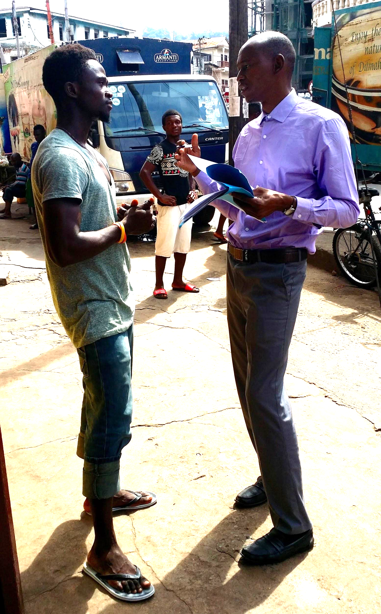
9.3 Media Related Recommendations
- Increase distribution and the number of radio stations on which it is broadcasted.
- Improve resonance, reach, and results of the youth-led radio programs through:
  - Building on the Research Report to create wider communication and media campaigns on the worst forms of violence against children and youth.
  - Continue to build on YRs network and experience.
- Create additional radio shows and increase coverage and interactive opportunities to better leverage the potential impact of the Research Reports and Guiding Manuals.
- Expand further participatory community theater activities in all three countries based on materials and project activities developed through this program. The reach and resonance can be increased through expanding the number of participants and locations visited.
- Develop further partnerships with educational institutions in Guinea and Liberia based on events organized in Freetown where media produced in correlation with the project was shared in schools and universities as a strategy to raise awareness on violence faced by children and youth in Sierra Leone.
Young Peacebuilders Evaluation Coordinator, Ali Abouba, conducting a radio-listener survey in Freetown.

9.4 Other Community Members
- Work toward consistent follow up with and meaningful inclusion of all involved in the research process (e.g. interviewees, summit participants, key stakeholders).
- Many of the hundreds of children and youth who offered their stories in Phase One did so, at least in part, because they wanted to help prevent worst forms of violence against children and youth. During the research phase these young people could be given low-cost tools for ongoing participation in the process. For example:
  - Give them small cards that help them advertise the youth-led radio program in their community.
  - Give them a list of peacebuilding activities they could undertake.
  - Give a small booklet on how to start a child peace club in their community.
  - Collect their contact information and via text, email, imo, or other application, deliver group messages such as: where to access the research report, when and where to listen to the radio program, how to organize a community conversation on the report, how to start a child peace club preventing violence against peers, excerpts from the Guiding Manual and link to access it online, and so forth.
- Providing research participants with updates on the report, actions taken post research, and so forth, could also assist with diminishing effects of potential retraumatization experienced by participants from disclosing violence and and abuse they experienced while receiving limited support. Some evaluation participants suggested this helpful support was received in Guinea via the radio updates.
- In order to “do no harm,” take extra precautions to ensure YRs can better identify:
  - if a child or youth may be at greater risk of harm from his/her abuser(s) after having disclosed the abuse to the YRs.
  - And, if risk may be increased because of his/her disclosure, ensure YRs feel confident accessing the protective supports to prevent harm from coming to the evaluation participant.

9.5 Gender Related Recommendations
- At each stage of the project consider additional culturally appropriate methods for overcoming obstacles and ensuring the inclusion of female voices.
- Consider additional culturally appropriate methods for physically and verbally highlighting the leadership roles of young females as female YR were sometimes less respected.
- Ensure radio programs, or other media campaigns, are tailored to the unique gendered reality of the audience. For example, if relatively few women listen to the radio, as was the case in Liberia, consider other media tools that will be more likely to capture a female audience.

Appendices

Code Of Conduct And Evaluator’s Behavior Protocol
All members of the evaluation team, including data collectors, evaluation coordinators and visitors, are expected to sign and abide by the following behavior guidelines in all contexts during the evaluation and its follow up. These are not exhaustive or exclusive lists.

ALWAYS
- take care to be culturally sensitive, in speech, behavior and clothing by observing and asking when situations are in doubt and by discussing dress and discussion codes
- respect children, youth and adult’s privacy
- be aware of situations which may present risks and manage these
- plan and organise the work and workplace so as to minimise risks
- as far as possible, remain visible to other adults when working with children
- ensure that a culture of openness exists to enable any issues or concerns to be raised and discussed
- ensure that a sense of accountability exists between staff and volunteers so that poor practice or potentially abusive behaviour does not go unchallenged
- as directed by evaluation participants, and children’s guardians, protect children, youth and adult’s privacy, dignity and identity in any published materials in any form of media
- gain informed consent from all research participants and children’s guardians before their participation or taking photographs or videos and also explain the purpose for which content will be used
- invite open discussions whenever tensions are felt or expressed
- abide by the principle of “Do No Harm”
- ensure data is stored safely at all times, so that it cannot be read by people other than data collectors, evaluation coordinators, and Dr. McGill

NEVER
- hit or otherwise physically assault or physically abuse children, youth or adults
- use inappropriate physical or sexual conduct with children or youth, such as culturally inappropriate or unwanted touching, hugging, kissing, or blocking of normal movement
- behave physically in a manner which is inappropriate or sexually provocative
- develop relationships with children which could in any way be deemed exploitative or abusive
- act in ways that may be abusive or may place a child at risk of abuse
- use language, make suggestions or offer advice which is inappropriate, offensive or abusive
- have a child with whom you are working stay overnight at your home unsupervised
- sleep in the same room or bed as a child with whom you are working
- condone, or participate in, illegal, unsafe or abusive behaviour with children
- act in ways intended to shame, humiliate, belittle or degrade children, or otherwise perpetrate any form of emotional abuse
- discriminate against, show unfair differential treatment to particular children to the exclusion of others
- arrange to be alone with an individual child
- use adult power or promises to force children or youth to participate in evaluation activities
- make promises to help children or youth with gifts or money
- represent children or youth as passive victims

I read, understand and agree to adhere to the Code of Conduct Evaluator Behavior Protocol.

Participant Information and Consent Form
Evaluating Search For Common Ground’s (SFCG) project:
“Engaging Children and Youth as Partners in Preventing Violence against Children”
Part A: Participant Information Participant Code _______ (leave blank) First Name ___________________ Family Names ____________________ Circle One: Male / Female

Date of Birth (day/month/year) _________________ Level of Education completed: ____________

Have you participated in peacebuilding initiatives or training other than this SFCG Program? YES / NO
For example, you may have received you may have received nonviolent conflict resolution training from UNICEF.
Peacebuilding is work to prevent, stop and heal the occurrence of any form of violence. Peacebuilding can be done at the individual, family, community, sub-national, national and global level.

When did your peacebuilding work or training start? (month/year) __________

Total years/months peacebuilding, including SFCG ______

Types of peacebuilding experience ______________________________________________________

Phone ____________________________ Email (print BLOCK letters) ____________________

(optional) Disability: Yes / No If yes what what disability ______________________________________
Informed Consent: In furtherance of the aims of the evaluation of the SFCG “Engaging Children and Youth as Partners in Preventing Violence against Children in Guinea, Liberia and Sierra Leone” I give consent as noted below without expectation of compensation or other remuneration now or in the future. This consent is given without expiration and do not require additional permission from me.

Part B: Child, youth or adult consent to evaluation participation
(initial each box)
The purpose and nature of the evaluation has been explained to me.

Any questions that I asked about the evaluation have been answered to my satisfaction.

I agree to participate in evaluation activities, but I have the right to withdraw at any time.

I agree that my views, stories, drawings, poetry or other contributions that I share may be used in whole or in part in publications such as reports, journal articles or newsletters, but that my identity will be anonymous unless I request otherwise.

I agree that training and/or evaluation activities may be recorded by audio, video and/or photos.

I agree that audio, video and/or photos which I am in may be shared in public meetings or publications such as reports, journal articles or newsletters, if they portray positive images of children, youth and/or adults and are unlikely to cause harm.

Check ONE that applies: Reveal my identity. Do NOT Reveal my identity.

Signature ________________________ Date ___________ Location _______________________
Part C:
Parent or guardian authorized to give consent IF PART A is completed by a child under 18 years

The purpose and nature of the evaluation has been explained to me.

Any questions that I asked about the evaluation have been answered to my satisfaction.

I agree to allow the child named to participate in the evaluation.

The child’s views, stories, drawings, poetry or other contributions may be used in whole or in part in a publication, but the child’s identity will remain anonymous unless I request otherwise.

I agree that the group discussions or interviews that my child is part of may be electronically recorded, and that pictures may be taken during training and/ or evaluation activities.

I agree that audio, video and/or photos including the child may be shared in publications or public meetings if they portray positive images of children/ youth and are unlikely to cause harm.

Check ONE that applies: Reveal child’s identity. Do NOT Reveal child’s identity.

First Name ________________________ Family Names ___________________________________

Circle One: Male / Female

Relationship to Child __________________________________________

Phone _____________________________ Email _________________________________________

Signature: _____________________________ Date _________ Location _____________________

Participant Code of Child under 18 years _________________

Standard Observation Form

Evaluation Activity Code (EAC) ____________________

Activity Type (circle one) FGD / Interview Brief Participant(s) Description ___________________________________________________

Data Collection date _______ Collection time From ________ To ________ Location ________

Data collected (circle) Audio, Video, Written, Art/drawings, other ____________________

Number of participants:_______ Group (circle one): radio-listeners / Key Stakeholders / Youth Researchers / Other ________________

Participant code(s): ____________________________________________________________________________________
e.g. LYML19M = 19 year old male named Michael Lee who is a Youth Researcher in Liberia. Include all FGD participant codes on one Standard Observation Form.

Interviewee Name:

Others present: ___________________________________________________________________________________

Attach a record of key discussions not already in the uploaded audio file. including individual codes of who said what.

What factors may have influenced the collection of data during this session?

- Researcher(s)

- Participant(s)

- Characteristics of the place where data were collected

- Interruptions, distractions, dangers, or threats, including weather

- Other

Radio-listener Survey (Liberia example)
- Do you remember hearing the Search for Common Ground (SFCG) Youth Talk radio program?
Youth Talk was produced by Search for Common Ground"s (SFCG)Talking Drum Studios and YMCA. The program was always focused on violence against children. It aired June through September 2016 in Montserrado on:
- ELBC 99.9 FM Saturday 8:15-8:45 Sunday 12:15-12:45
- TRUTH FM 96.1 Tuesday 1:00-1:30 Sunday 6:15-6:45
Youth Talk is NOT: Blay-Tahnla radio drama soap opera nor the Learning By Radio show with a teacher and students in a classroom aired March - August 2015.
Youth Talk broadcast outside Montserrado on: Radio Gbezohn, radio Cape Mount, radio Kergheamahn, radio Nimba, and Smile FM and radio Kintoma.

Yes No → Skip to #6

- How much did the SFCG Youth Talk radio program improve your knowledge and awareness of the worst forms of violence against children and youth?

Not at all A little Very much

- Did the SFCG Youth Talk radio program increase your desire to help prevent worst forms of violence against children and youth?

Not at all A little Very much

- Did the SFCG Youth Talk radio program cause you to take action to prevent violence against children and youth?

not at all yes, 1 to 2 actions

yes, 3 to 4 actions yes, more than 4 actions

- To what extent did you resonate with or relate to the SFCG youth radio program?

Not at all A little Very much

- Gender: Male Female Other

- Age:

- Email/Phone Number:

- Comments:

TABLE: Survey Responses of Guinea radio-listeners Who Recalled Hearing the Youth Talk Radio Program
How much did the SFCG Youth Talk radio program improve your knowledge and awareness of the worst forms of violence against children and youth? | Did the SFCG Youth Talk radio program increase your desire to help prevent worst forms of violence against children and youth? | Did the SFCG Youth Talk radio program cause you to take action to prevent violence against children and youth? | To what extent did you resonate with or relate to the SFCG youth radio program? | gender | age | Please add any other comments below.
A little | Not at all | Not at all | A little | Female | 32
A little | Very much | Not at all | A little | Female | 19
A little | Very much | Not at all | Very much | Female | 23 | This radio program is a good initiative because youth and child are not well traited .
A little | A little | Yes, 1 to 2 actions | A little | Female | 22 | this program must continue as it touch the thru problem
A little | A little | Yes, 1 to 2 actions | A little | Female | 30
A little | A little | Yes, 1 to 2 actions | A little | Female | 31 | Education and sensitising are the best to avoid violence ,continue this project in way to touche more population
A little | A little | Yes, 1 to 2 actions | A little | Female | 32
A little | A little | Yes, 1 to 2 actions | A little | Female |  | Continue in this way
A little | Very much | Yes, 1 to 2 actions | A little | Female | 20 | Abnormal Phenomenon
A little | Very much | Yes, 1 to 2 actions | A little | Female | 22 | Juste continue this program
A little | Very much | Yes, 1 to 2 actions | A little | Female | 26 | l like this program
A little | Very much | Yes, 1 to 2 actions | Very much | Female | 20 | Being the future Leader of the country, parents must take care of children
A little | Very much | Yes, 1 to 2 actions | Very much | Female | 21
A little | Very much | Yes, 1 to 2 actions | Very much | Female | 21
A little | Very much | Yes, 1 to 2 actions | Very much | Female | 23 | Education is not necessarily by the whip
A little | A little | Yes, more than 4 actions | A little | Female | 20 | Project to be encouraged
A little | A little | Yes, more than 4 actions | A little | Female | 28 | By listen this program it give some idea of awareness and help parents to avoid violence against their children
A little | A little | Yes, more than 4 actions | A little | Female | 42
A little | Very much | Yes, more than 4 actions | A little | Female | 19
A little | Very much | Yes, more than 4 actions | A little | Female | 25 | Encourage the project to continue radio program
A little | Very much | Yes, more than 4 actions | A little | Female | 26
A little | Very much | Yes, more than 4 actions | A little | Female |  | It is not normal to do violence against children. Congratulation to this project which fight make people aware on form of violence
A little | A little | Yes, more than 4 actions | Very much | Female | 23 | You do good job as you make us aware
A little | A little | Yes, more than 4 actions | Very much | Female | 33 | I think to bit is not a solution , but i will do it when necessary
A little | A little | Yes, more than 4 actions | Very much | Female | 23
A little | Not at all | Yes, more than 4 actions | Very much | Female | 18 | Violence against children and youth has to be banish
A little | Very much | Yes, more than 4 actions | Very much | Female | 20 | I would like that Guinea's people realise that youth are our future and must be educated and not doing violence against them
A little | Very much | Yes, more than 4 actions | Very much | Female | 21 | Very good project
A little |  |  |  | Female | 20
Not at all | Not at all | Not at all | Not at all | Female | 20
Very much | A little | Not at all | Not at all | Female | 68
Very much | A little | Yes, 1 to 2 actions | A little | Female | 21 | I like this program it will help me to understand a lot of things
Very much | Very much | Yes, 1 to 2 actions | A little | Female | 23 | We learned good actions during this program
Very much | A little | Yes, 1 to 2 actions | Very much | Female | 24
Very much | Very much | Yes, 1 to 2 actions | Very much | Female | 19 | This project is good for population et help to kick out form of violence and sensitizing parents.
Very much | Very much | Yes, 1 to 2 actions | Very much | Female | 22
Very much | Very much | Yes, 1 to 2 actions | Very much | Female | 23 | This is true even though they have duties, children also have rights that adults must respect at all costs.
Very much | Very much | Yes, 1 to 2 actions | Very much | Female | 28 | This program increase awareness of people and i for one share this message in all local languages when i have occasion.
Very much | Very much | Yes, 3 to 4 actions | A little | Female | 22 | This project allow to parents in particularly women to stop violence against children
Very much | A little | Yes, more than 4 actions | A little | Female | 21 | Fight against youth violence
Very much | A little | Yes, more than 4 actions | A little | Female | 25 | Good initiative, to be Encourage
Very much | Very much | Yes, more than 4 actions | A little | Female | 18 | La violence est une chose abejecte
Very much | Very much | Yes, more than 4 actions | A little | Female | 19 | Violence is an abject thing
Very much | Very much | Yes, more than 4 actions | A little | Female | 20 | Many way to educate youth,Education by the whip is not the best
Very much | Very much | Yes, more than 4 actions | A little | Female | 22
Very much | Very much | Yes, more than 4 actions | A little | Female | 23 | This program sensitise a lot on violence on the road and school area
Very much | Very much | Yes, more than 4 actions | A little | Female | 26 | I like this program
Very much | Very much | Yes, more than 4 actions | Not at all | Female | 22
Very much | A little | Yes, more than 4 actions | Very much | Female | 24
Very much | A little | Yes, more than 4 actions | Very much | Female | 25
Very much | Not at all | Yes, more than 4 actions | Very much | Female | 53 | This kind of project must continue to fight against violence
Very much | Very much | Yes, more than 4 actions | Very much | Female | 28 | This kind of Program must continue to fight against violence
A little | Very much | No | Very much | Male | 25
A little | Very much | Not at all | A little | Male | 19
A little | A little | Not at all | Not at all | Male | 24 | It is a good program
A little | Not at all | Not at all | Not at all | Male | 21 | I follow this program one o two time
A little | A little | Not at all | Very much | Male | 21
A little | Very much | Yes | Very much | Male | 25 | This Radio program allow me to participate in project of reconciliation in community of Coya Through Lonniguiné
A little | A little | Yes, 1 to 2 actions | A little | Male | 22
A little | A little | Yes, 1 to 2 actions | A little | Male | 34 | No comment, thanks
A little | A little | Yes, 1 to 2 actions | Very much | Male | 23
A little | Very much | Yes, 1 to 2 actions | Very much | Male | 20 | I am aware with this program on most sorts of violences
A little | Very much | Yes, 1 to 2 actions | Very much | Male | 21 | He like this program because it developed act of civism
A little | Very much | Yes, 1 to 2 actions | Very much | Male | 29 | They have great concept of Barada in their area
A little | A little | Yes, 3 to 4 actions | A little | Male | 27 | hitting to educate also is not a bad thing. hitting child which is not ours and under our responsibility is wickedness.
A little | A little | Yes, 3 to 4 actions | A little | Male | 40 | Hit children by simple enjoyment exists and hitting to educate also is not a bad thing for incredulous children. Do not hit children is a thing of the white people
A little | Very much | Yes, 3 to 4 actions | A little | Male | 24 | To solve the problem of child maltreatment it is at 2 level: to educate the parents and to educate the children well.
A little | A little | Yes, 3 to 4 actions | Not at all | Male | 29
A little | A little | Yes, more than 4 actions | A little | Male | 24
A little | A little | Yes, more than 4 actions | A little | Male | 25
A little | Not at all | Yes, more than 4 actions | A little | Male | 23 | Take care of children and youth
A little | Very much | Yes, more than 4 actions | A little | Male | 20
A little | Very much | Yes, more than 4 actions | A little | Male | 20
A little | Very much | Yes, more than 4 actions | A little | Male | 28
A little | Very much | Yes, more than 4 actions | A little | Male | 29 | Projet à soutenir car tres important pour la bonne compréhension de tous
A little | Very much | Yes, more than 4 actions | Not at all | Male | 22 | This is tragic , found another solution to kick out this phenomenon
A little | Very much | Yes, more than 4 actions | Very much | Male | 22
A little | Very much | Yes, more than 4 actions | Very much | Male | 25 | We thanks the initiators
Not at all | Not at all | Not at all | Not at all | Male | 17 | yes, I have hear to this program one time only.
Not at all | A little | Yes, 1 to 2 actions | A little | Male | 22 | Project to be encouraged
Not at all | Very much | Yes, 1 to 2 actions | A little | Male | 24
Not at all | Not at all | Yes, more than 4 actions | A little | Male
Not at all | Very much | Yes, more than 4 actions | A little | Male | 26 | Education of child can't be done via violence
Not at All | A little | Yes, more than 4 actions | Very much | Male | 26 | Children should not be mistreated in spite of their day-long bliss. They are being unconcerned and innocent.
Very much | Very much | Yes, more than 4 actions | Very much | Male | 27 | Child abuse is a matter for all. So we will all have to fight for it
Very much | Very much | No | Very much | Male | 31
Very much | Very much | Not at all | Very much | Male | 21 | It is good things to be interested to this initiative
Very much | A little | Yes, 1 to 2 actions | A little | Male | 35 | Continue to sensitize in this way
Very much | Very much | Yes, 1 to 2 actions | A little | Male | 28 | This program help me to understand form of violence against children
Very much | Very much | Yes, 1 to 2 actions | Very much | Male | 18 | He found good ideas, He fell directly concern by this program
Very much | Very much | Yes, 1 to 2 actions | Very much | Male | 20
Very much | Very much | Yes, 3 to 4 actions | A little | Male | 24 | We must do our best to end this, because children is the future.
Very much | Very much | Yes, 3 to 4 actions | Not at all | Male | 22 | children write is not respected in Guinea
Very much | Very much | Yes, 3 to 4 actions | Not at all | Male | 23 | We received good advices
Very much | Very much | Yes, 3 to 4 actions | Very much | Male | 19
Very much | Very much | Yes, 3 to 4 actions | Very much | Male | 63 | I encourage you , Bit & Brutalize will resolve nothing. My wife use to faced our children but since hear this program, I managed to diminish the fact that she faced our children
Very much | A little | Yes, more than 4 actions | A little | Male | 20
Very much | A little | Yes, more than 4 actions | A little | Male | 21 | Practice to banish
Very much | Very much | Yes, more than 4 actions | A little | Male | 20
Very much | Very much | Yes, more than 4 actions | A little | Male | 22 | Strengthening the texts of laws relating to children
Very much | Very much | Yes, more than 4 actions | A little | Male | 23
Very much | Very much | Yes, more than 4 actions | A little | Male | 23 | Very good thing , continue
Very much | Very much | Yes, more than 4 actions | A little | Male | 26
Very much | Very much | Yes, more than 4 actions | A little | Male | 27
Very much | Very much | Yes, more than 4 actions | A little | Male | 27 | Many action conducted in neighborhood, encourage this program
Very much | Very much | Yes, more than 4 actions | A little | Male | 32 | I encourage this initiative which aware community on some practices.

List of Interview and Focus Group Participants
Liberia Participants
* Missing names designate a request for confidentiality.
FGD or IV | Gender | Interviewee or FGD Key Contact First Name | Interviewee or FGD Key Contact Family Name | Key Contact Official Title | Description of IV/FGD participant(s). Why are we including this person?
IV | M | Oliver N. | Butty | Youth Researcher | Direct beneficiary. Radio program volunteer
IV | F | Jonathan | Barmen | Youth Researcher | Direct beneficiary
IV | F |  |  | Youth Researcher | Direct beneficiary
IV | F |  |  | Youth researcher | Direct beneficiary
IV | M |  |  | Youth Researcher | Direct beneficiary
IV | M |  |  | Youth Researcher | Direct beneficiary
IV | M |  |  | Youth researcher | Direct beneficiary
IV | M |  |  | Youth researcher | Direct beneficiary
FGD | F | Catherine B. | Garduor | Youth researcher | Direct beneficiary
 | M | Boakai | Nyehn Jr. | Youth researcher | Direct beneficiary
 | M | Theophilus T. | Toby | Youth researcher | Direct beneficiary
 | M | Emmanuel | Jarkonah | Youth researcher | Direct beneficiary
 | F | Kumba | Tengbeh | Youth researcher | Direct beneficiary
FGD | M | B. Edwin | Smith | Youth researcher | Direct beneficiary
 | F | Diana S. | Ross | Youth researcher | Direct beneficiary
 | M | Simeon | D. Neufville | Youth researchers | Direct beneficiary
 | M | James N. | Cooper | Youth researchers | Direct beneficiary
IV | M | Aaron | Weah | SFCG Country Dir. | Oversight of the program implementation
IV | F | Geraldine | Gooding-Freeman | SFCG Consultant | Consultant who attended summit
IV | F | Satta | Sheriff | Speaker | Ministry of youth and sports - Children Parlement
IV | M | Al | King | SFCG Program Manager | previously managed the program for a season
IV | M | Tvogs | Wrobeh | SFCG Staff | Current Program Manager
IV | M | Tim | Kamaboakai | Local Partner | Development Secretary - YMCA
IV | M | Saji | Prelis | Director of Children & Youth Programs | SFCG. Helped design and start project
IV | M |  |  | Summit Participant | Summit Participant/Bongo district, YMCA Radio Station Manager
IV | M |  |  | Local Partner | Young Men's Christian Association - Focal Point
FGD | F | Rachel | Gbengan | YWCA | Sent by YWCA to FGD; no involvement or knowledge of project
 | M | Draper | Torbor | Radio staff | Radio Partner. Helping produce documentary related to project
 | M |  |  | SEARCH Staff | Sent for FGD because she was a KII
 | F | Roselyn | Korleh Theoway | DM&E officer | SFCG Staff involved with project
IV | F | Eve | Davis | radio-listener | Surveys at university, market, school
IV | M | Derek | Whisnant | radio-listener | Called into radio saying Youth Talk program prevented him from taking revenge on his attackers
IV | M | Nimely | Johnson | radio-listener | 16th street behind Royal Hotel
IV | M |  |  | radio-listener | Surveys at university, market, school
IV | M |  |  | radio-listener | Security guard at supermarket

Guinea Participants
* Missing names designate a request for confidentiality.

FGD or IV | Gender | Interviewee or FGD Key Contact First Name | Interviewee or FGD Key Contact Family Name | FGD/ IV type: Youth Researcher, Key Stakeholder, radio-listener | Key Contact Official Title
IV | M | Aboubacar | Condé | Youth Researcher | Coordinateur de projet PJUFM
IV | F | Achai | Cissoko | Youth Researcher | Youth researcher
IV | M | Aboubacar Fote | Souma | Youth Researcher | Youth researcher
IV | M | Moise | Ifono | Youth Researcher | Youth researcher
IV | F | Fanta Madjou | Bah | Youth Researcher | Youth researcher
IV | M | Adama | Konaté | Youth Researcher
IV | F |  |  | Youth Researcher
IV | F | Hawa | Touré | Youth Researcher | Maroc! Youth researcher
IV | M | Abdoulaye | Cissé | Youth Researcher
IV | M | Didier | Gomou | Youth Researcher
IV | M | Mustafa | Dialo | SFCG Adult | Show producer
IV | F | Aminata | Tounkara | SFCG Adult | Coordinatrice Médias SCFG
IV | M | Aboubacar | Dansoko | SFCG Adult | Chargé de projet/parlement des enfants
IV | M | Youssouf | Bamba | SFCG Adult | Chargé de projet DFCG
IV | M | Julien | Joseph | SFCG Adult | DME
IV | M | Akoue | Hector | Other Stakeholder | Ministere des affaires sociales
IV | M | Ousmane | BALDE | Association des Jeunes pour la Cooperation et le Developpement | Summit Toolkit
IV | F | Honorable | Idrissa | Other Stakeholder | Directrice Parlement des Enfants
IV | M | Sekou | Conde | Other Stakeholder | Coordinateur CIP
FGD | F | Djaka | CAMARA | Youth Researchers | Haute Guinée
 | m | Aboubacar | Conde
 | M | Yéké | BONAMOU |  | Guinée Forestière
 | M | Gassim | SYLLA |  | Basse Guinée
FGD | M | Abdoul Wahab BANGOURA |  | Youth Researchers | Basse Guinée
 | F | Oumou CAMARA |  |  | Haute Guinée
 | M
 | F | Mariam KABA |  |  | Moyenne Guinée
 | M | Sekou Sidibe |  |  | Moyenne Guinée
FGD | M | Victor | Wendeno | Youth Researchers
 | F | Mamy Blandine | Blemou
 | M
IV | F | Kadiatou | Tiam | radio-listeners
IV | F | Fatoumata | Djallo | radio-listeners
IV | F | Sidibè | Conde | radio-listeners
IV | F | Hawa | Keita | radio-listeners
IV | F | Guirasey | Djenaba | radio-listeners
IV | M | Roger | Guemou | radio-listeners
IV | M | Diakanté | Sékou | radio-listeners
IV | M | Ibrahim | Khalil Sherif | radio-listeners
IV | M | Tchierno | Diallo | radio-listeners

Sierra Leone Participants
* Missing names designate a request for confidentiality.

FGD or IV | Gender | Interviewee or FGD Key Contact First Name | Interviewee or FGD Key Contact Family Name | Key Contact Official Title | Description of IV/FGD participant(s). Why are we including this person?
IV | M | Samuel | Konteh | Young Researcher | Engaged in project implementation
IV | F | Mary | Thornton | Youth Researcher | Engaged in project implementation
IV | F | Sylvia | Baio | Young Researcher | Engaged in project implementation
IV | M | Delight | Conneh | Young Researcher | Engaged in project implementation
IV | M | Kabineh | Bengeh | Young Researcher | Phone interview
IV | F | Abigail | Stevens | Young Researcher | Works for partner org so can do info on that.
IV | M | Tamba | Ngaujah | Young Researcher | Via phone
IV | F | Hawa | Kaikai | Young Researcher | Via phone
IV | M | Charles | Lhai | Executive Director of SLYEO | Engaged in project implementation.
IV | M | Jimmy | Sankaituah | Country Director | Engaged in project implementation
IV | M | Patrick | Masuba | Programme Coordinator | Engaged in project implementation
IV | M | Saa | Bandala | Former Project Manager | He is in Canada
IV | F | Hélène | Delomez | Researcher Consultant | Lead researcher and TOT
IV | M | Ngolo | Katta | Executive Director Partner CCYA | One of the implementing partners
IV | M | Anthony | Koroma | Youth Commission | Attended the Summit
IV | M |  |  | Sierra Leone Police | Attended the summit
IV | F | Rita | Kamara | Family Support Unit | She will call back for time
IV | F | Monika | Galiwa | Hope For The Blind | Engaged in project implementation
FGD | F |  |  | Young Researcher | Mile 91
 | M | Saidu | Thullah | Young Researcher | Mile 91
 | M |  |  | Youth Researcher | Mile 91
FGD | M | Dauda | Massaquoi | Young Researcher | Engaged in project implementation
 | M | Ansumana | Kabba | Young Researcher | Engaged in project implementation
 | F | Lovetta | Bangura | Young Researcher | Engaged in project implementation
 | M | Samuel | Konteh | Young Researcher | Engaged in project implementation
FGD | M | Abdul Rhaman | Diallo | SFCG - Producer radio show | done
 | M | Jerry | Tarbolo | Mano River Union | confirmed
 | M | Bashiru | Thullah | MSWGCA | confirmed
IV | M |  |  | POlice Officer | radio-listener
IV | M | Lansana | Foinah | Merani Store | radio-listener
IV | M | Sori | Fona | Students | radio-listener
IV | M | Elhaj | Vandi | Trader | radio-listener
IV | F | Mabintou | Sissey | Trader | radio-listener
IV | F |  |  |  | radio-listener
IV | M | Emmanuel | Dartin | Student | radio-listener
IV | M | Paul | K. Mussa | Student | radio-listener
IV | F | Fatmata | Kamara | Student Mile 91 | radio-listener
IV | F | Kadidiatou | Fofanah | Student Mile 91 | radio-listener
IV | F | Fatmata | Kanu | Student Mile 91 | radio-listener

Lists of Youth Researchers

Liberia Youth Researchers
B. Edwin Smith; Blama Goll; Boakai A. Nyehn, Jr.; Catherine Garduah; Cyrus Mataley; Diana F. Ross; Elsa Neblett; Emmanuel P. Jarkonah; James Kollie; James N. Cooper; Joanna Redd; Jonathan Barmen; Justin Paye; Kindness Nehwon; Kumba B. Tengbeh; Lawrence J. Wilson; Marwine Reeves; Miatta T. Sicarr; Oliver Butty; Patience P. Tengbeh; Philomena Aggrey; Princess V. Merriam; Sara Dahn; Tammus Bockarie; and Theophilus T. Toby

Guinea Youth Researchers
Abdoulaye Cisse, Aboubacar Fote Sounah, Adama Konate, Aicha Cissoko, Aldoul Wahab Bangoura, Amadou Bailo Balde, Bilgui Diallo, Dider Gomou, Djaka Camara, Djaka Makassa Kkoro, Fanta Madjou Bah, Gabriel Haba, Gassim Sylla, Idiatou Keita, Kadiatou Cheick Bangoura, M’bemba Moise Ifono, Mamadie Lansana Bangoura, Mamadou Kourouma, Mariama Kaba, Mohamed Daouda Sounaoro, Oumou Camara, Siaka Ramata Kourouma, Victor Ouendeno, Yeke Bonamou, Sekou Sidibe, Abass Konneh, Abdoulaye Barry, Aissat Diallo, Alphonsine Koulema, Faya Benjamin Kotembedouno, Germaine Tea, Hadja Salimatou OUmar Barry, Hawa Toure, Joseph Bernard Traore, Mamy Blandine Blemou, Aboubacar Conde.

Sierra Leone Youth Researchers
Adamsay Turay, Abdul H Collier, Jamilatu Bangura, Kamanda S Kamara, Ansumana Kabba, Silvia Baio, Dauda Massaquoi, Saidu Thullah, Boima Massaquoi, Frederick Ngabeh, Mariam J Dumbuya, Abigail Stevens, Hawanatu Sankoh, Samuel Momodu Konteh Jr, Delight Abdul Wahab Konneh, Edwina S. Fatoma, Johnny E. Parkinson, Mary Thornton, Tamba Ngawjah, Jeneba Mondeh, Mamusu H. Turay, Suliaman K. Bockari, Kabineh M. Bengeh, Hawa A. Kaikai.

Participants at 2014 Training of Trainers Event in Sierra Leone (per event report)
Seventeen persons attended the ToT: 7 participants from Sierra Leone, 6 from Guinea and 4 from Liberia. Gender repartition was 11 males and 6 females. 3 participants were working for SFCG/TDS (1 Sierra Leone, 1 Liberia and 1 Guinea). Four participants were working with the partners organizations for the project (Sierra Leone: SLYO and CCYA, Liberia: YMCA, and Guinea WAYN). The rest of the participants (10) were Youth Researchers.
Name | Country | Organization | Gender | Age
Justin Paye | Liberia | Researcher | M | 34
Martin Allen | Liberia | YMCA | M | 38
Al King | Liberia | SFCG | M | 33
Susan A. Sumo | Liberia | Researcher | F | 29
Hadja Salimatou | Guinea | Researcher | F | 23
Youssouf Bamba | Guinea | SFCG | M | 37
Joseph Bernard Traore | Guinea | Researcher | M | 21
Germaine Tea | Guinea | Researcher | F | 21
Aboubacar Dansoko | Guinea | WAYN | M | 26
Mohamed Daouda Soumaoro | Guinea | Researcher | M | 25
Boima Massaquoi | Sierra Leone | SLYEO | M | 32
Frederick Isaac Ngebeh | Sierra Leone | Researcher | M | 33
Mariam Y. Kamara | Sierra Leone | Researcher | F | 25
Hawanatu Sankoh | Sierra Leone | Researcher | F | 24
Abigail Yvana Stevens | Sierra Leone | CCYA | F | 32
Samuel Mamodu Konteh | Sierra Leone | Researcher | M | 21
Moses Kaikai | Sierra Leone | SFCG | M | 33

Biographies of Evaluators

Dr. Michael McGill, PhD
Young Peacebuilders Director. Traverse City, MI, USA
Dr. McGill is an experienced scholar-practitioner passionate about linking, improving, and increasing support to child and youth peacebuilders and increasing young people’s pro-social civic engagement and democratic participation, particularly in high-risk contexts. Since 2000 he has been designing and implementing research in conflict-affected contexts, training youth researchers, and facilitating productive interagency and international partnerships. He is a strategic problem-solver with a demonstrated commitment to reflective practice and evidence-backed action.
Dr. McGill invested several years founding a global partnership addressing child sexual exploitation and trafficking. His experiences in conflict affected countries lead him to see the need to better engage more young people as peacebuilders in order to prevent and break cycles of violence. His PhD research helped discover how to do so more effectively. For over a decade his work and research have focused on child and youth participation in peace processes. Toward this end, he developed the Peacebuilding and Reconciliation Initiative of the World Evangelical Alliance (representing 129 national alliances and 100+ organizations), and subsequently, founded Young Peacebuilders. Young Peacebuilders Consulting Team specializes in developing child and youth peacebuilding and civic engagement related programs, policy, projects, partnerships, products, and research for others.
Dr. McGill served in many roles including as a Global Lead Evaluator of a multi-country, multi-agency, multi-donor (3M) participatory evaluation of child and youth participation in peacebuilding (www.sfcg.org/3m). Data collection and analysis included 122 child, youth, and adult evaluators and 1,567 evaluation participants. The process included designing and facilitating evaluator training and analysis workshops, including children, and developing cross-sector partnerships in each country where the evaluation was conducted.
Dr. McGill has invested time in 55 countries, including living in Uganda from 2012 to 2015. He has trained groups in Asia, Africa, Middle East, Europe, and North America. He co-developed a university graduate methods course on international research with children in especially difficult circumstances, and has practiced as a child psychologist.
Dr. McGill’s PhD in Intercultural Studies focused on developing a descriptive moral framework for mobilizing effective and ethical child participation in peace processes. He also holds a Masters degree in Counseling and a Bachelors degree in Communications.

Pauline Zerla, MA
Young Peacebuilders, Consultant. Brussels, Belgium
Pauline Zerla is a peacebuilding, youth empowerment and storytelling professional with over six years project design and management experience in fragile and conflict-affected states including the DRC, CAR, South Sudan, Rwanda and Somalia. She focuses on the LRA, DDR, youth engagement, peace and conflict research, reconciliation, community-based conflict transformation, trauma healing and storytelling.
She worked across a variety of contexts focusing on innovative ways by which young people can become peacebuilders and agents of social change. Specifically, she is interested in seeing how young people who have grown up in conflict zones can become leaders in their communities and foster reconciliation. Pauline designed community-based reintegration trainings for former underage combatants and cultural exchange opportunities for vulnerable youth in the DRC and CAR.
Most recently, she has been acting as a deputy coordinator on DDR and community resilience programs in the Central African Republic with Invisible Children. Programs seek to increase the protection and resilience of communities from the violence of the Lord’s Resistance Army (LRA) and other armed groups, and help dismantle the LRA through peaceful defection programming. Innovative projects also focus on trauma healing of LRA-affected communities and support to the successful reintegration of former abductees and soldiers of the armed group.
In the past Pauline also participated in several research projects focusing on youth, conflict, trauma and reconciliation. She supported several research organizations working on local peacebuilding efforts and youth role in peacebuilding which further improved her strong capacity-building and M&E skills. In the DRC she supported local capacity-building by getting involved with the Leadership Academy in the DRC and train their students on the relationships between media, conflict and leadership.

(n.d.). Truth-Telling as Talking Cure? Insecurity and Retraumatization in the .... Retrieved January 26, 2017, from http://sdi.sagepub.com/content/39/1/55.refs

