
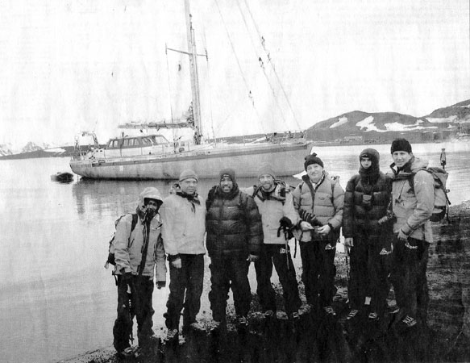

Scaling the Middle Ground
D.C.-Based Group to Honor Climbers, Choir
and Activists for Conflict Resolution Initiatives
By Bill Broadway
Washington Post Staff Writer
Saturday, March 6, 2004; Page B09
On New Year's Day, a team of four Palestinians and four Israelis sailed from the southern tip of South America to Antarctica to explore and name a mountain no one had climbed.
The purpose of the journey was less scientific than collegial. The team, called Breaking the Ice, was formed to prove to itself and the world that representatives of warring Middle East factions could work together to achieve a common goal.
Cooperation often proved difficult.
The team nearly came to blows after one member, an Israeli lawyer, took offense that another, a member of the revolutionary group Fatah, accepted a phone call from Palestinian leader Yasser Arafat. That exchange, according to an online diary of the expedition, led to verbal attacks and counterattacks over such issues as control of the West Bank and religious sites in Jerusalem.
Ultimately, the physical challenge of conquering a 3,300-foot mountain commanded the attention of the six men and two women, most of them amateur climbers. Working in unity, often roped together on icy slopes, they attained their goal. The group summited Jan. 16 and named its conquest "The Mountain of Israeli-Palestinian Friendship."
The team's success was noticed by the Washington-based Search for Common Ground, a non-governmental organization and international leader in conflict resolution. On March 18, at the Embassy of Austria, Breaking the Ice and five other groups or individuals will be recognized for their peace initiatives. All will receive Common Ground Awards in the seventh annual presentation of the prizes.
The usual number of five recipients was chosen before Indian Prime Minister Atal Vajpayee and Pakistani President Pervez Musharraf renewed peace negotiations between their countries. So they were added to the list and will receive a joint award, said John Marks, who founded Search for Common Ground in 1982. The organization now has 400 staff members in 13 countries.
Marks spoke by telephone from Jerusalem, where he and his wife, Susan Collin Marks, opened a Search for Common Ground office two years ago. They are preparing a five-hour television special that examines how the Israeli-Palestinian conflict can be resolved without threatening the integrity of either group.
The film, scheduled for release this summer, will be shown to Palestinians in Arabic and to Israelis in Hebrew, he said.
Recent winners of Common Ground Awards include Archbishop Desmond Tutu, journalist Ted Koppel, the Daniel Pearl Foundation and the Alliance of Concerned Men, an organization that mediates gang rivalries in Southeast Washington.
This year's other award recipients:
• The Pontanima Choir, formed in 1996 in Sarajevo after the war in Bosnia, is composed of Christians, Muslims and Jews from the Sarajevo area. The 75-voice choir, which has performed in several countries, sings a range of songs from Christian, Jewish, Muslim and Far Eastern traditions. Twenty-seven members of Pontanima -- Latin for "spiritual bridge" -- will perform at the awards ceremony March 18 and at area churches Friday and March 19.
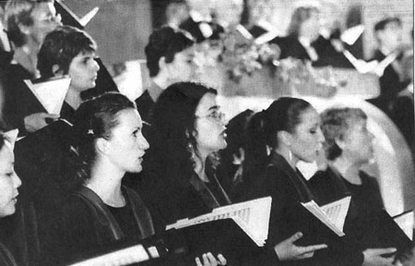
• The Community of Sant'Egidio, a Catholic lay movement, was founded in Italy in 1968 and has become one of the most influential conflict resolution groups in the world, with 40,000 members in 60 countries, Marks said. The organization has been credited for its peace efforts in Mozambique, where fratricidal conflicts have lasted 30 years. It also has played prominent roles in AIDS prevention and treatment in Africa and has provided aid to war and famine refugees in Southern Sudan, Burundi, Albania and Kosovo.
• Evangelist James Movel Wuye and Imam Muhammad Nurayn Ashafa, co-directors of the Inter-Faith Mediation Centre in Kaduna, Nigeria, once led religious youth leagues whose members directed violence against one another in a years-long civil conflict that cost thousands of lives. The two men met at a state-sponsored gathering for which they had mutual distrust. After getting to know one another and sharing grief about family members injured or killed in the conflict, they became friends and co-activists in promoting community dialogue and peace. In one recent project, they brought together pairs of Christian and Muslim youth leaders from 30 of Nigeria's states for a five-day workshop for peace.
• The Charlotte-based Regional AIDS Interfaith Network provides HIV/AIDS care for individuals and families, through a network of 2,500 volunteers and more than 50 congregations representing 20 denominations and faith traditions. The network -- created in 1992 by the Rev. Deborah C. Warren, a Baptist minister -- trains pastors and seminarians; assists congregations in developing HIV prevention education programs; and develops congregation-based care teams that provide practical, emotional and spiritual support to people with HIV or AIDS.
• Harold Saunders, director of international affairs at the Kettering Foundation, will receive the Common Ground lifetime achievement award. Saunders, who has written several books, has taught international relations and conflict resolution at George Mason and Johns Hopkins universities and is a member of the International Negotiation Network at the Carter Presidential Center. Saunders, a former member of the White House National Security Council staff (1961-74) and assistant secretary of state for Near Eastern and South Asian affairs (1987-81), was part of a team that mediated five Arab-Israeli agreements in the late 1970s, including the Camp David Accords, and helped negotiate the release of U.S. hostages from Tehran in 1981.

